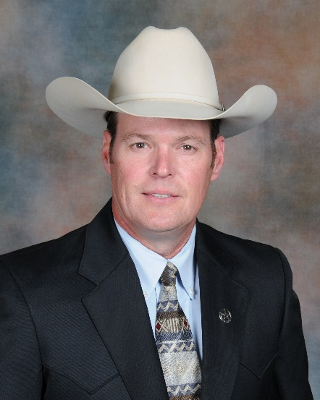
Trampas Gooding, Staff Lieutenant, Texas Rangers HQ
SAKI Cold Case Investigation and Prosecution Coordinator

Trampas Gooding has been in law enforcement since 1993 where he served as police officer in Central Texas. In 1998, he joined the Texas Department of Public Safety as a State Trooper and later promoted to Texas Ranger in 2004. During his career as a Texas Ranger, he has investigated and assisted in numerous active and cold case homicide and sexual assault investigations and has assisted in numerous skeletal remains excavations. He has provided assistance to Texas Rangers and other agencies with case and crime scene review, evidential review and prioritization, DNA and analyses review, and provided consultation for further investigative strategies. In 2020, he was promoted to Staff Lieutenant and assigned to Texas Ranger HQ to assist and coordinate a federal grant, called Sexual Assault Kit Initiative (SAKI). The grant was awarded to the Texas Rangers beginning in 2019 from Department of Justice, Bureau of Assistance, to assist with furthering cold case investigations involving unsolved sexual assaults and sexually related homicides by utilizing advanced DNA testing and genetic genealogy methods. Since then, an additional two grants have been awarded to the Texas Rangers to assist in these types of investigations across the state. Lt. Gooding serves as the SAKI Site Coordinator and Investigation Coordinator to review qualifying cases and coordinate with laboratory officials, district attorneys, investigative agencies, and Texas Rangers statewide to further these cases in hopes of bringing justice to the victims and their families. He is a current member of the Texas Sheriff’s Cold Case Team, a member of the International Homicide Investigator’s Association, and a law enforcement consultant to the Forensic Anthropology Center at Texas State.

