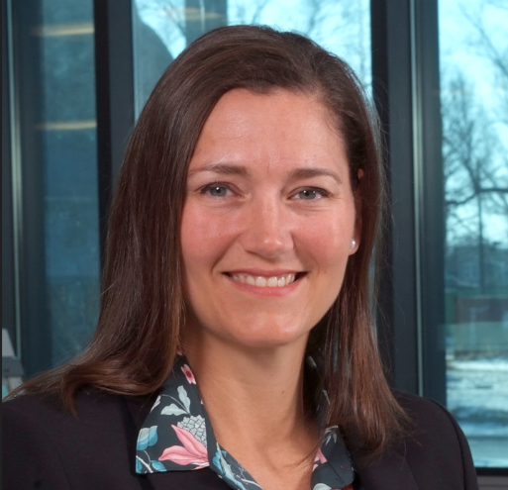
Jarrah R. Kennedy, MSFS, ABC-MB
Forensic DNA Expert
Kansas City, Missouri
jarrahkennedy@gmail.com

Jarrah Kennedy is an Assistant Supervisor in the DNA section at the Kansas City Police Crime Laboratory located in Kansas City, Missouri. Jarrah has also served as an advisor to the Texas Forensic Science Commission over the past year.

Jarrah has extensive experience totaling over 18 years as a forensic biology practitioner performing screening and DNA analyses. During her tenure in Kansas City, she has helped validate and implement new instrumentation and technologies. Jarrah also has over 6 years of casework experience with probabilistic genotyping (STRmix™). She is a graduate of the University of Notre Dame (Go Irish!) and received her Master of Science in Forensic Science from the University of New Haven. Jarrah is certified through the American Board of Criminalistics as a Molecular Biologist.

Mrs. Kennedy is the current chair of Human Forensic Biology subcommittee (of the Organization of Scientific Area Committees for Forensic Science) tasked with helping to develop standards to improve forensic science practices. Jarrah has also participated in the Human Factors in Forensic Science Sourcebook, the OSAC Human Forensic DNA Analysis Process Map, and most recently has served on an expert working group tasked with writing a report through NIST/NIJ regarding Human Factors in Forensic DNA Interpretation.

Jarrah is mom to 10-year-old twins (Keithan and Kiyah) and partner with husband, Jason, who is the Chief Criminalist (Supervisor) of the Chemistry Section at the Kansas City Police Crime Laboratory. You can often find the family split between sports practices and events either watching or coaching!

