Prior-Year Asset Addition – Basic Add
Purpose: The Add PY Property (PAPPFY) screen allows agencies to add the following prior year transactions to the SPA system: New Property, Surplus Property Not Tracked on SPA and Property Held in Suspense
Assumptions:
- SPA is still open for the prior fiscal year
- CAPPS SPACLOSE Parameters are set to match SPA (Open)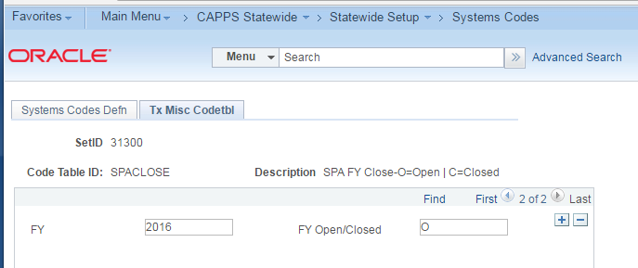
- Navigate to: Main Menu > Asset Management > Asset Transactions > Owned Assets > Basic Add
- Click on the Add a New Value tab. Enter Business Unit and an Asset Identification (as asset tag number). Click Add.
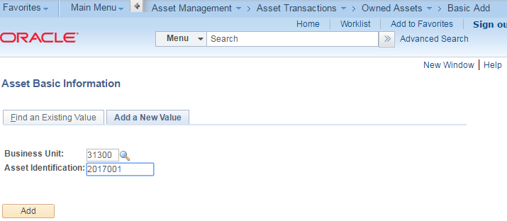

- On the General Information tab, select a Profile Id. The asset profile ID populates the Asset Class, Description and Asset Type. Each asset Acquisition Code defaults to “State Sources”. Select the appropriate value from the drop down list.
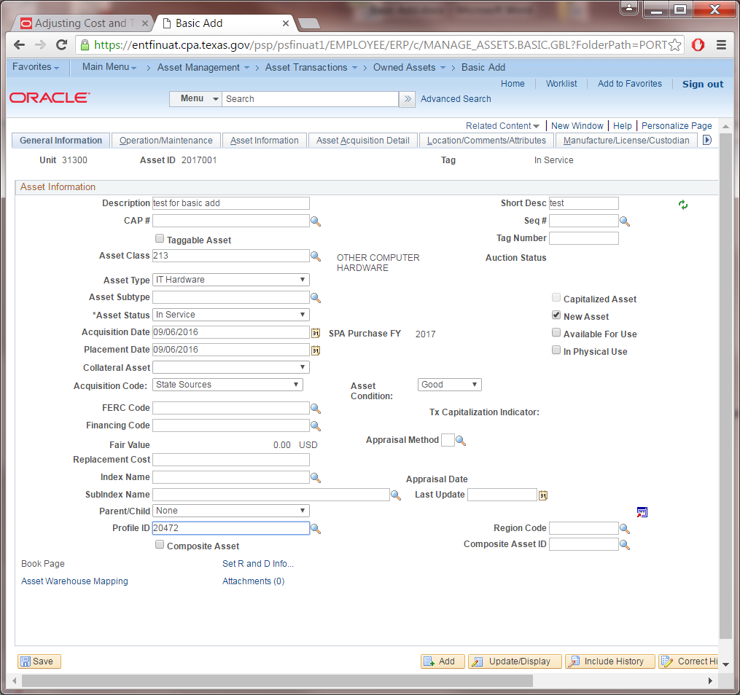
- Navigate to Asset Information tab to enter Serial ID, Location code of the asset and Custodian information.
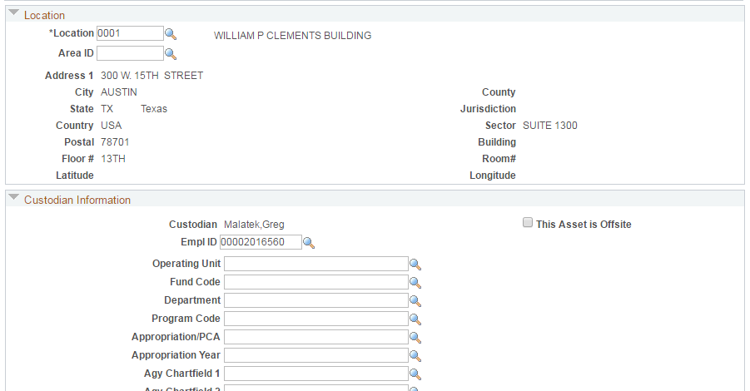

- Click the Asset Acquisition Detail tab. Enter the cost of the asset in the Amount field. Click on the Acquisition Detail Chartfields link and enter the Fund, Appropriation Year and other required chartfields values. Click the OK button.

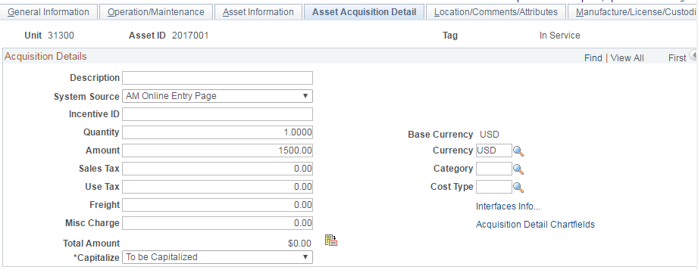

- The Transaction Date and Accounting Date default to the current date. Change these dates to desired prior fiscal year date. Click the Capitalize button and verify values entered.
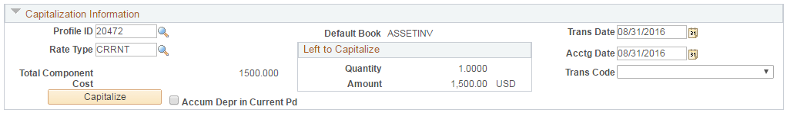

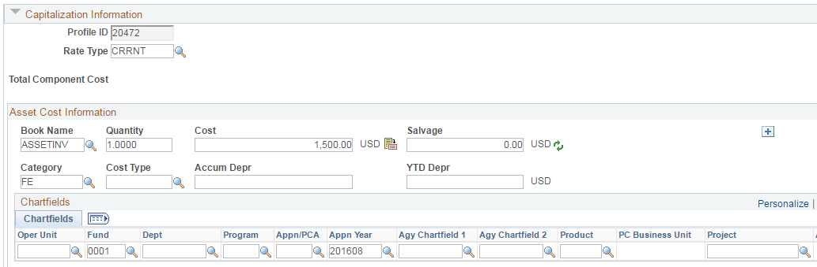

- Click the Save button at the bottom left of the page to save the asset.
- Review the Asset General Information page and note the SPA Purchase Fiscal Year of 2016.
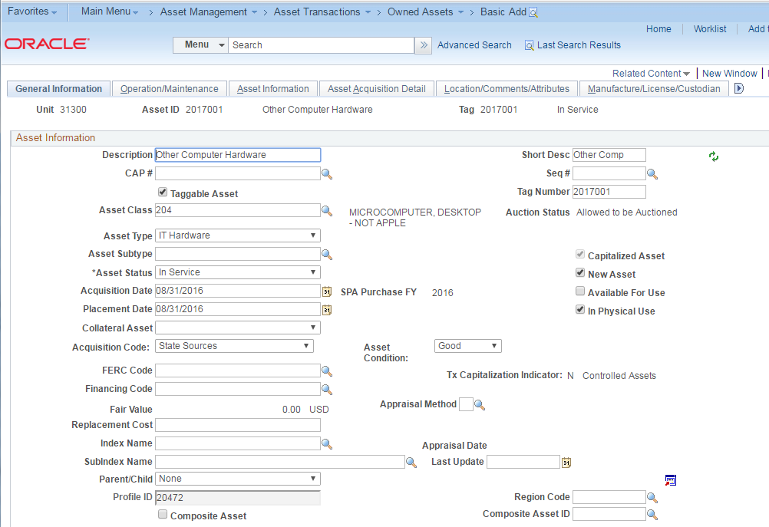

SPA Staging Table Impact:
Navigation: Main Menu>CAPPS Statewide>Statewide Interfaces>SPA Interfaces>SPA Staging Table
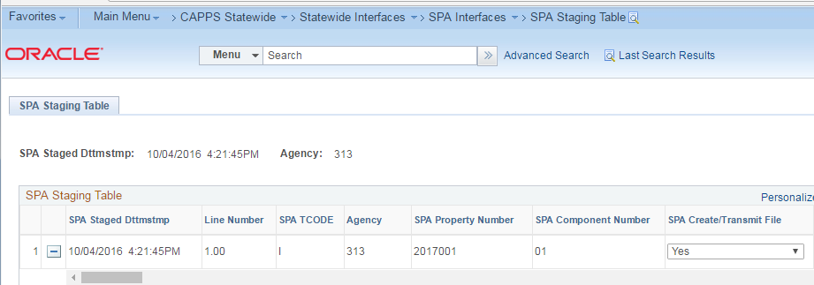
SPA Effective Date of 08/31/2016 and Purchase FY of 2016
