CAPPS to SPA Integration
- Navigate to CAPPS to SPA Interface- Run in Test Mode
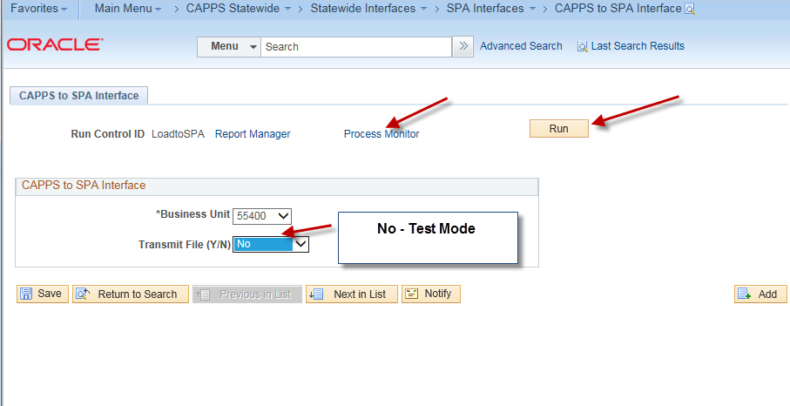
Select No- Test Mode
Then, Run the Process

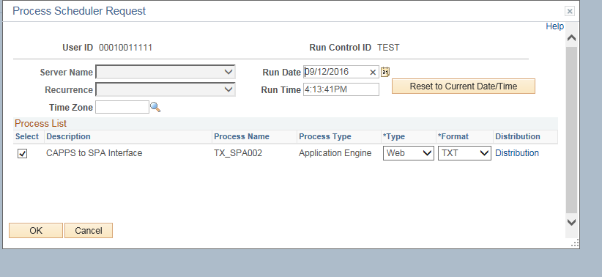

- Review Process Monitor
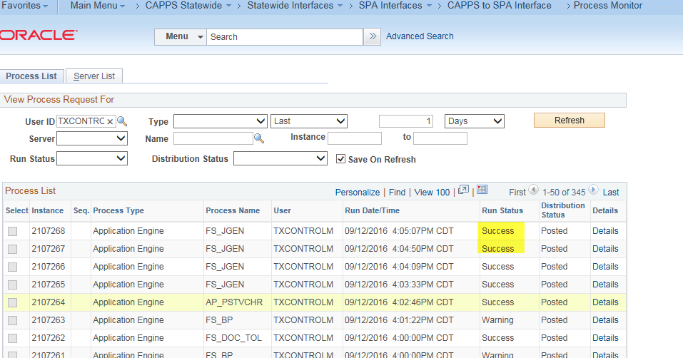

Success, Job is Complete.

- Review SPA Staging Table transactions in Test Mode.
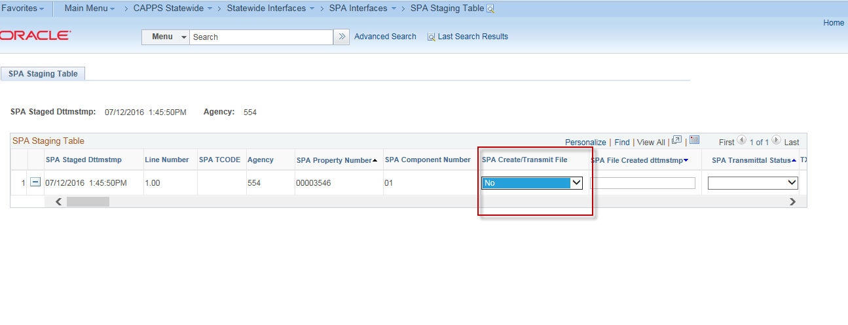
Note: The SPA Transmit Status = N.
Important: You will want to ensure all Parent/Child assets components are defined for assets prior to running the CAPPS to SPA integration in Yes mode.

- Navigate to CAPPS to SPA Interface to run in Transmit Mode. This will stage asset transactions for the evening SPA outbound process.
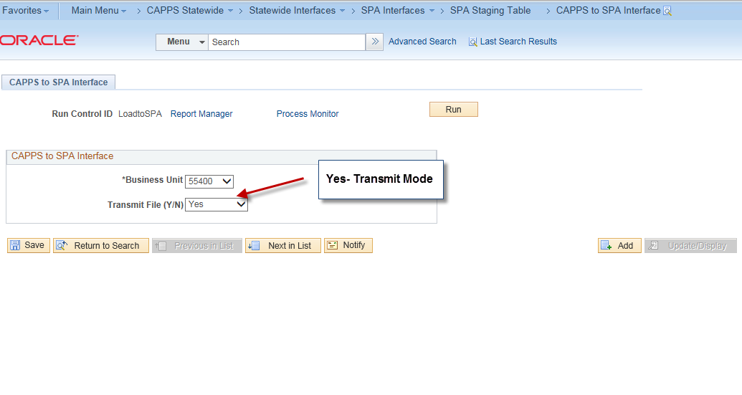
Select Yes- Transmit mode
Click Run
And, review the results on the Process

- Review SPA Staging Table- Transmit Mode
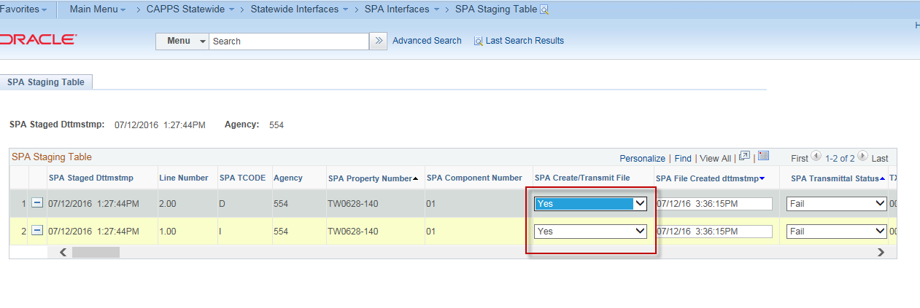
Note: SPA Transmit Status is Yes.

- Optional- You may delete transactions from the SPA Staging table prior to running the SPA transactions in Transmit Mode. You may delete assets that you do not want to go to SPA.

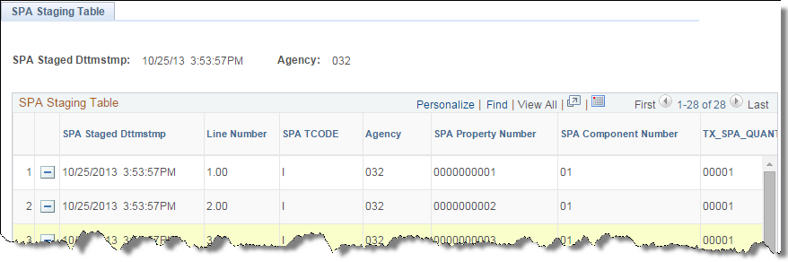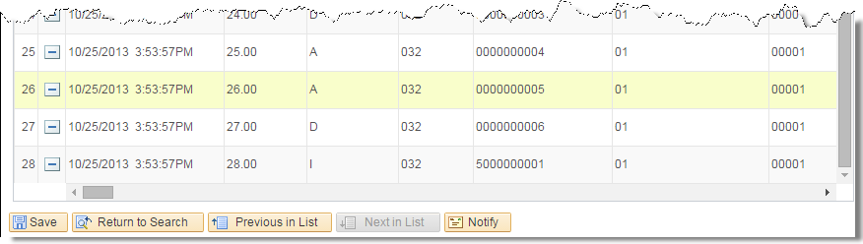
Note the row deletion buttons and the scrollbars indicating that more fields are visible.

- ** Automatic scheduled process** Next, the daily scheduled SPA004 (CAPPS to SPA Integration) runs to process asset transactions to SPA.
- ** Automatic scheduled process** On the following day, the scheduled SPA005 (SPA Transaction update) runs to update asset transmittal status with Pass/Fail.

- Navigate to the SPA Staging Table to review transaction status updates to SPA whether they Pass or Fail. This verifies if the CAPPS to SPA integration created assets in SPA.

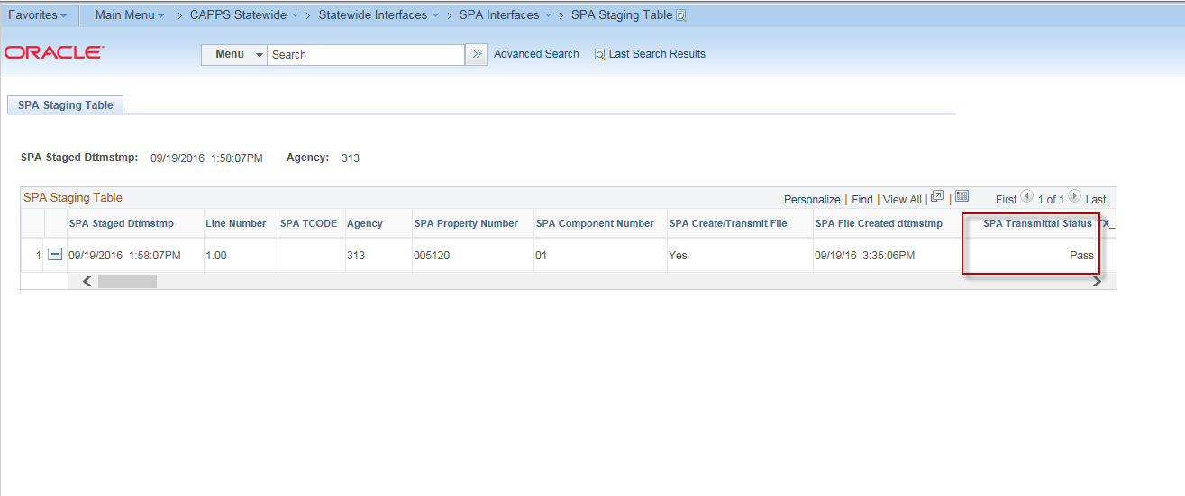
- To review error messages and control totals, you can navigate to the SPA PRINT Error
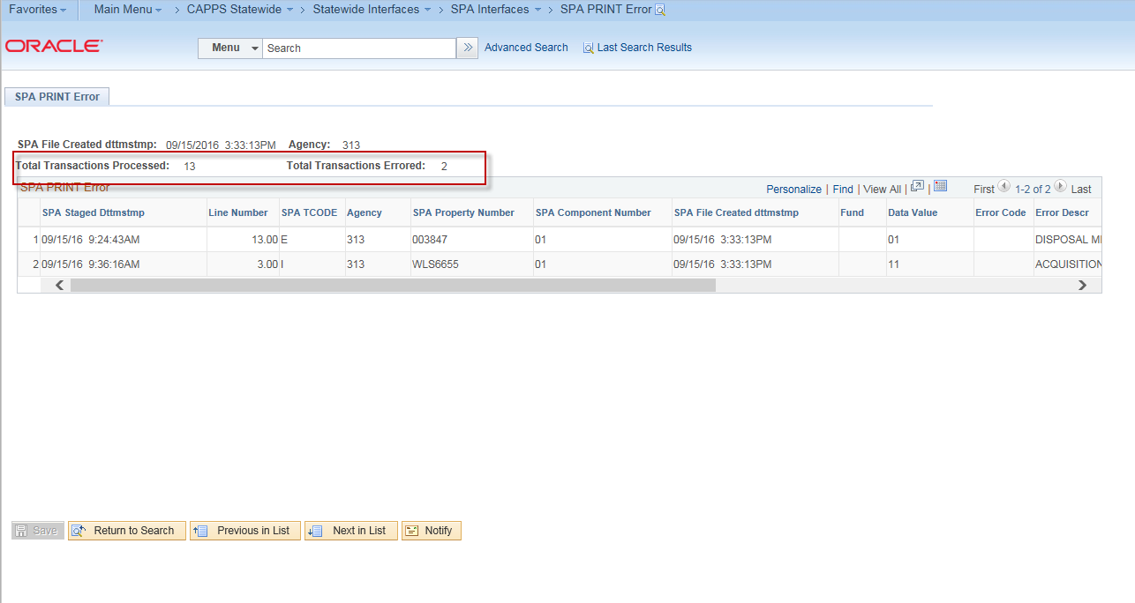

This page displays the total processed counts and total transaction errors from the SPA interface.

