Objective | Create a CAPPS Deposit to USAS/Edit & Budget Check/Post
Process | Gl_020-110
Transaction | 195D Deposit to USAS
Navigation | Main Menu>General Ledger>Journals>Journal Entry>Create/Update Journal Entries

Step1 | Create a journal entry to be posted from the online page.
Action | Business Unit = 03200; Journal ID = NEXT; Journal Date = Today’s Date
 | Press ‘Add’

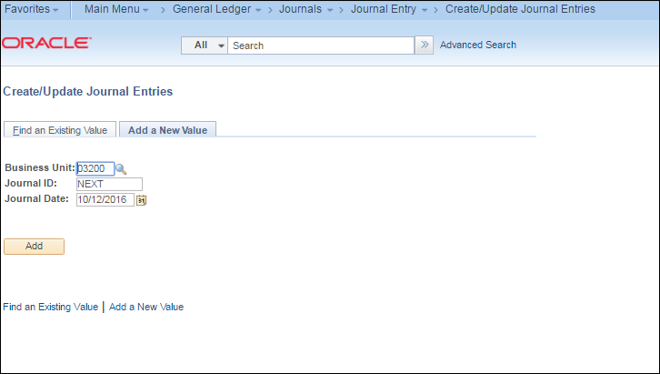

Step2 | Complete the Header information
 | Ledger Group (ACTUALS) and Source (ONL) Default from the User Preferences
Action | Complete Long Description (optional)
 | USAS Document Number (required)
 | Click on DLT Comments (optional based on USAS)
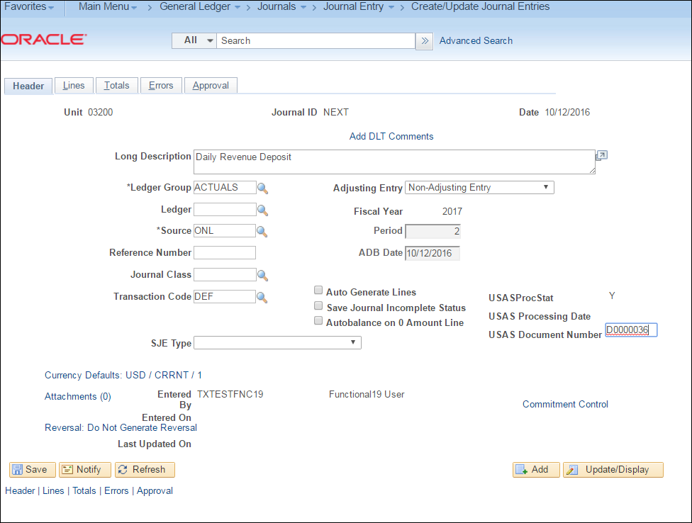

Action | Click on ‘Use Standard Comments’
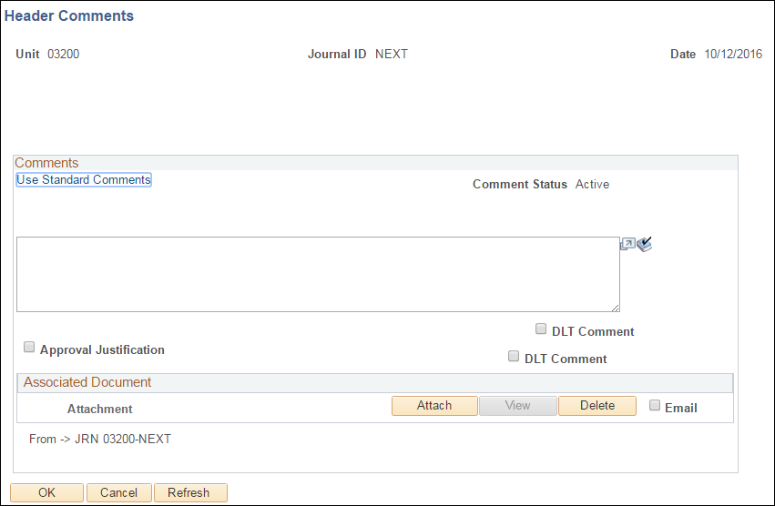

Action | Comment Type= DLT and Comment ID = DLT
 | This uses pre-determined DLT comments to load into Comments box.
 | Press OK twice and Click on Journal Lines Tab

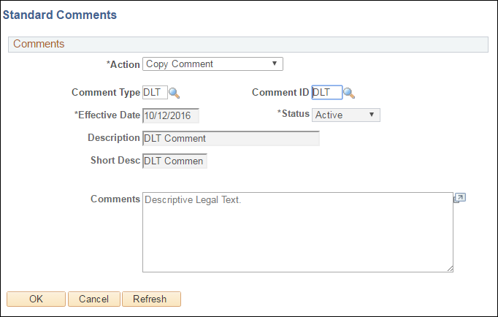

Step3 | Lines Tab: Complete Lines information and Save the Journal Entry.
Action | Add Account, Fund, Dept, PCA, CF1, AY and Amount
 | T-Code = 195D
 | Press ‘+’ sign to add line: Copy down feature will populate most fields

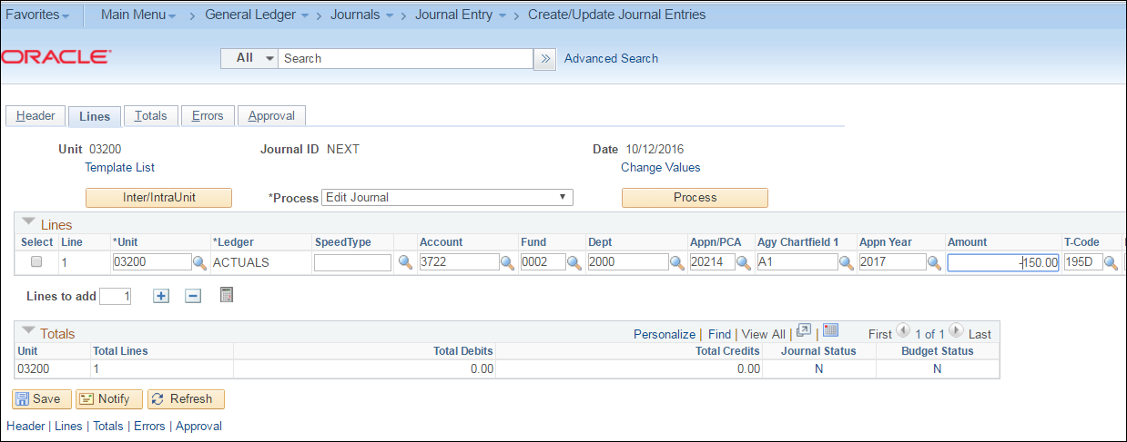

Action | Add Account 0045 (Cash) and Save

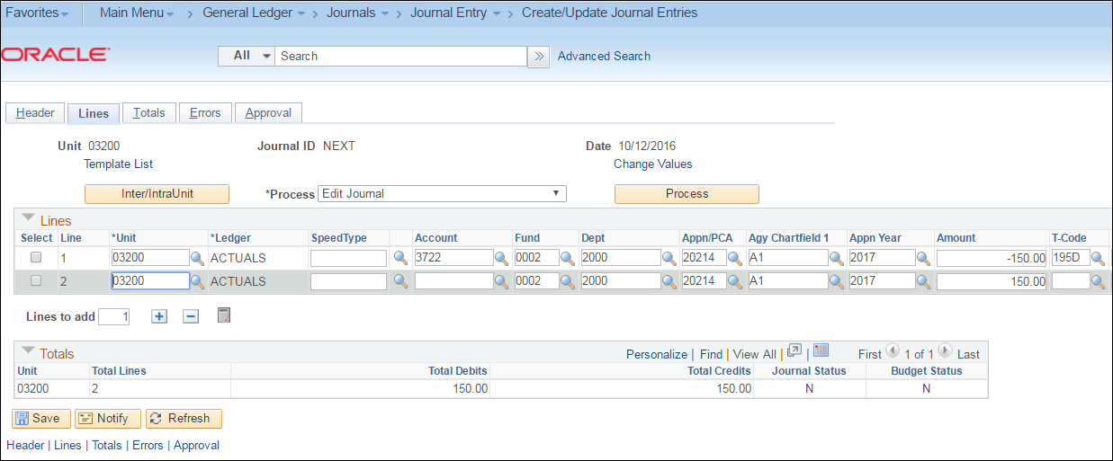

Step 3 | Select the “Edit Journal” process and click the Process button for 'Edit Journal'.
Action | Verify that the Journal Status = V and the Budget Status = V.

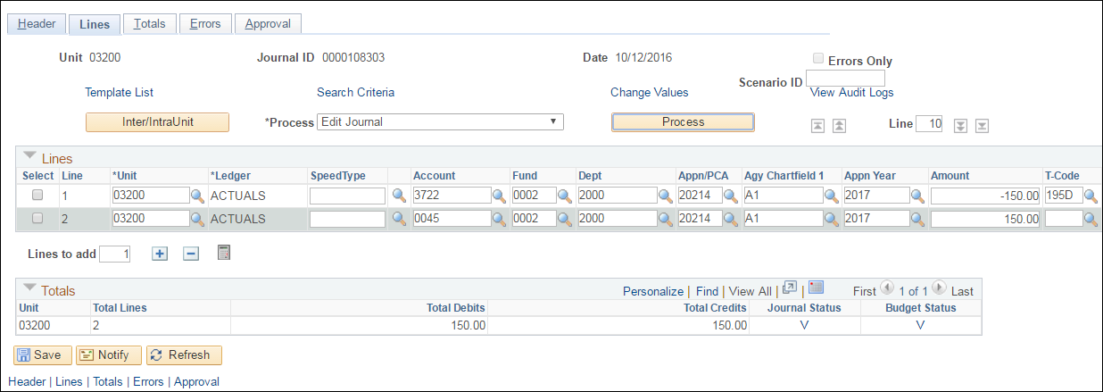

Step 4 | Select the “Post Journal” Process and click the Process button.
Action | Click OK to the question 'Are you sure that you want to post this journal?’. Verify that the Journal Status is now 'P'
.
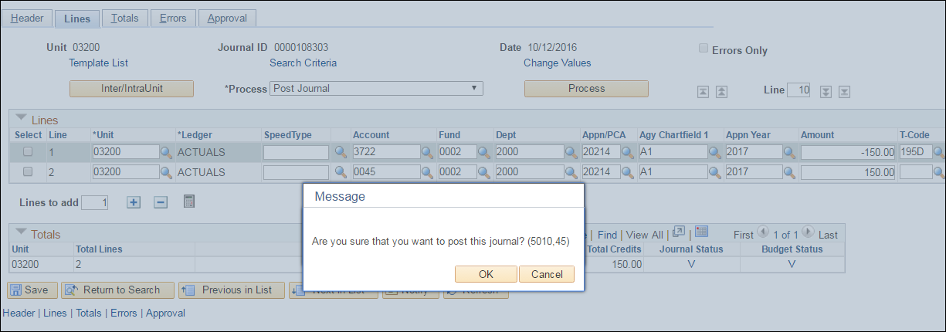

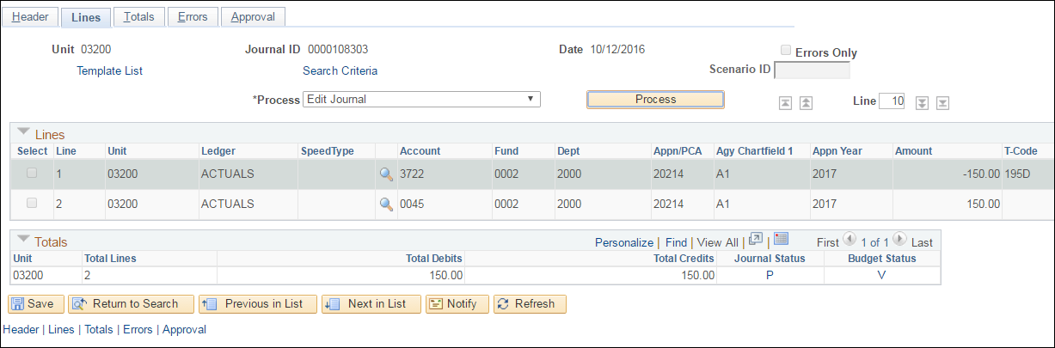

Step 5 | You may also run the posting process from the menu
Navigation | General Ledger> Journals> Process Journals> Mark Journals for Posting.
Action | Enter the Journal ID, or Enter Journal Date From and Journal Date To, and click "Search". Check the Process box to select the journal for posting and then click the "Post Selected Journals".

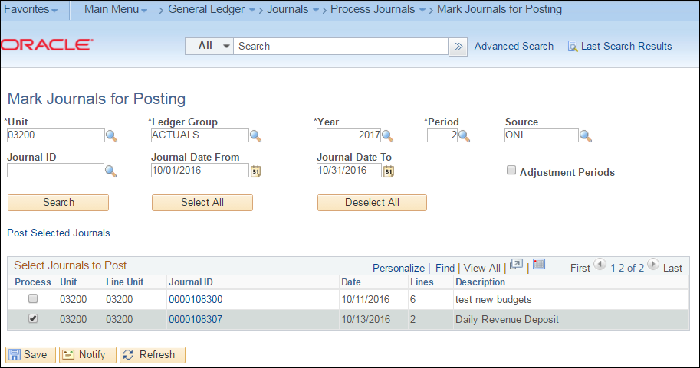

Select OK
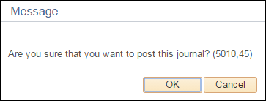

Action | The PS_AUTO run control is auto populated with the journals you have chosen from the first page. Verify and check Run.
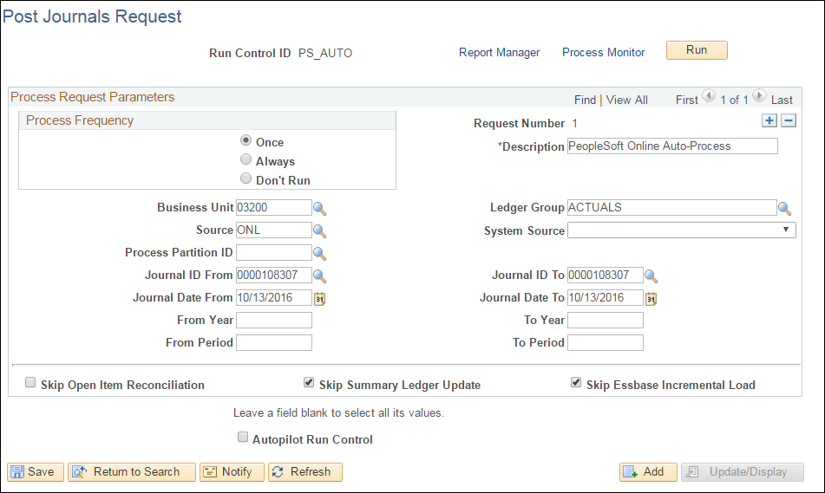

Action | Check GL Journal Posting and OK
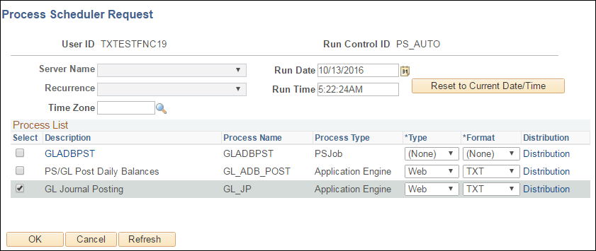

Action | Process Monitor: Process will go to Success.

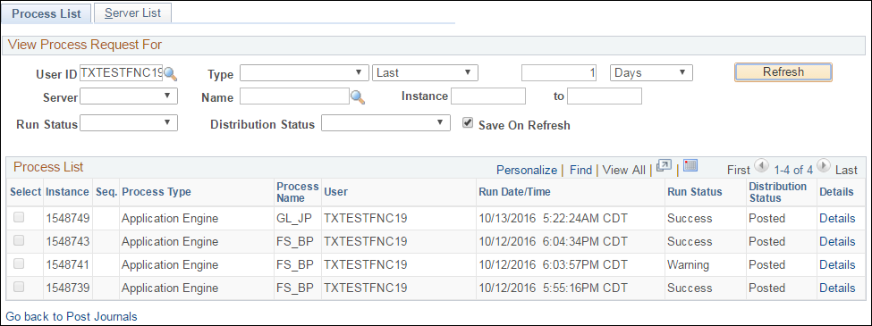

Step 6 | Return to Journal to verify it is posted.

