Supplier - Add A New “7” Supplier in CAPPS
- Suppliers > Supplier Information > Add/Update > Supplier
- Tab: Add a New Value
Enter: SetID
Enter: Supplier ID (Must be a valid TINS number)
Enter: Persistence (should always be “Regular”)
Click: Add
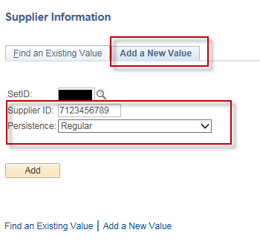
- Tab: Identifying Information
Enter: Supplier Name, Supplier Short Name
Verify: Classification is “Outside Party”
Verify: Persistence is “Regular”
Verify: “Open for Ordering” box is checked on
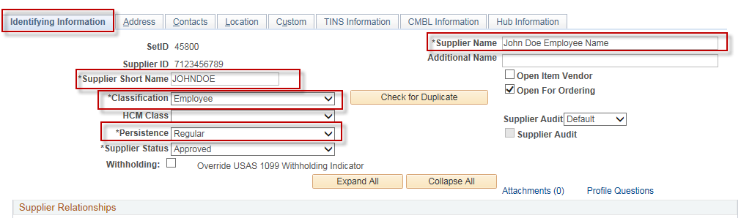
- Tab: Identifying Information
Section: Additional ID Numbers
Verfiy: That “Customer SetID” is populated with your agency setid
Type: SSN (for employee) or TIN (for Sole Proprietorship). Do not enter dashes in the SSN field.
*** VERY IMPORTANT: You MUST enter a valid SSN/TIN number. CAPPS will check across all agencies to make sure that the SSN/TIN you enter is not in use by another vendor under any other agency. Do NOT enter a “place holder” or “test” SSN/TIN in this field. Make sure that you have their valid SSN/TIN before you set up their vendor id in CAPPS.
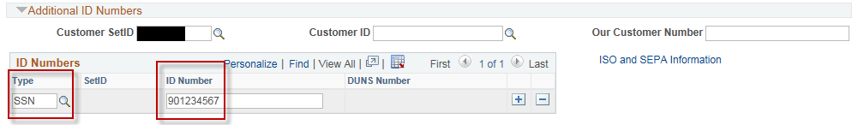

- Tab: Address
Enter: Description (Optional), Address 1, City, Postal (Zip), State
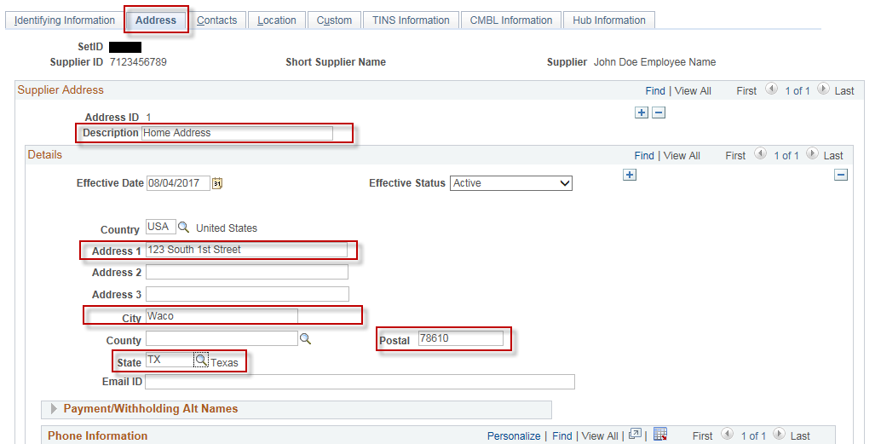

- Tab: Location
Enter: Location (Mailcode), Description (you will see this description when entering vouchers in CAPPS)
Verify: Address box is populated with “1”
Verify: Default box is checked on.
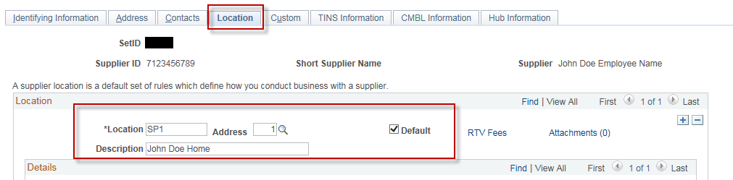

- Tab: TINS Information
Enter: In the “Vendor Ownership Information” section, enter Ownership Type and other required fields as required by Ownership Type
In the “Vendor Location Information” section, enter Location Name (name that will be displayed on the printed Voucher).
Enter: Payment Type

NOTE: If Payment Type is “D”, you will be required to enter “Bank Type” and “DD Bank #” and “DD Routing #”. These are required fields, however, CAPPS does not use “Bank Type” and “DD Bank #” and “DD Routing #”. This information is already in TINS and USAS will pull it from TINS when processing a payment for this vendor, so our recommendation is to populate “Bank Type” and “DD Bank #” with dummy numbers since this is sensitive information and not used in CAPPS.
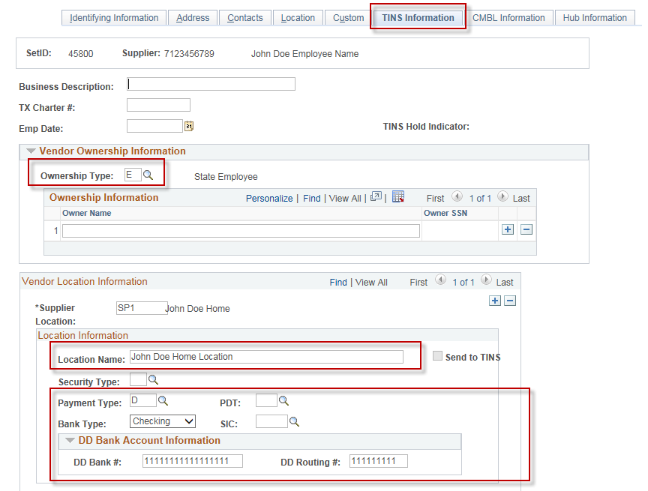
- Click: Save.
NOTE: If you are entering a vendor with Ownership Type = “S”, you will be required to enter “Owner Name” and then “Owner SSN”. In the “Owner SSN” field you will need to prefix the “Owner SSN” value with a “2”.
Example of Ownership Information for a “Sole Owner” in CAPPS on the “TINS Information” tab:
