**How USAS Document Types are Assigned when Vouchers are Sent to USAS**

It is very important to understand how the USAS Document Type is assigned to your vouchers.

The combination of the USAS T-Code (assigned by the Accounting Entry Template on the voucher) and the PCC Code entered on the voucher will determine the USAS Document Type that will be assigned to your voucher when it is sent to USAS.

We have configured all of the USAS T-Codes your agency will likely use on the USAS T-Code Lookup table.  The example below shows a combination of T-Code 225 and PCC Code ‘0’ will assign a USAS Document Type of ‘9’.  Clicking the right arrow, as shown below, will scroll through the T-Code 225, PCC code combinations:

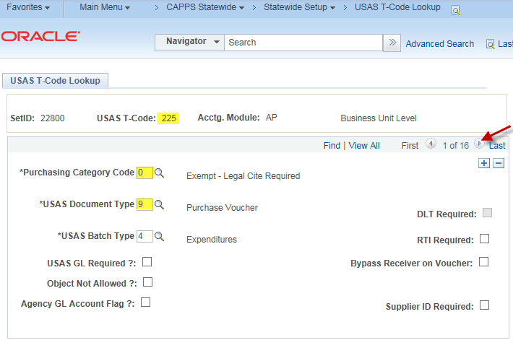

All other combinations of USAS T-Code 225 with other various PCC codes will assign a USAS Document Type of ‘2’:

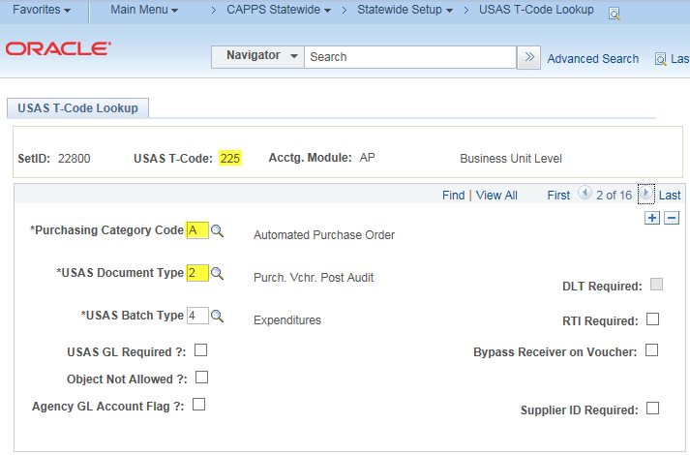

Each T-Code has its own set of valid PCC Codes. T-Code 247 for example, is only configured to use 3 PCC Codes.

T-Code 247, PCC 0 assigns document type 1 (click the right arrow to review the other PCC codes for this T-Code):

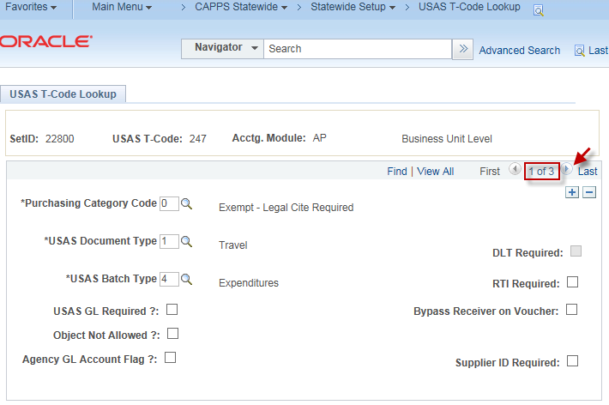

T-Code 247, PCC E assigns document type 2:

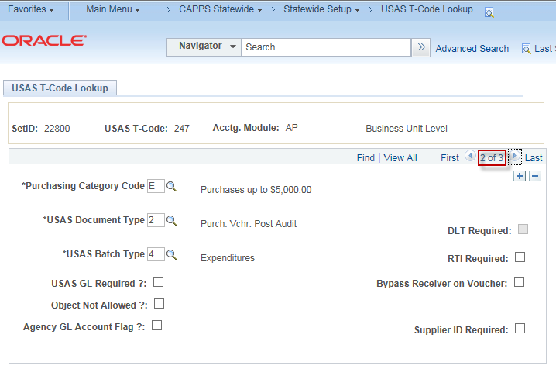

T-Code 247, PCC H assigns document type 2:

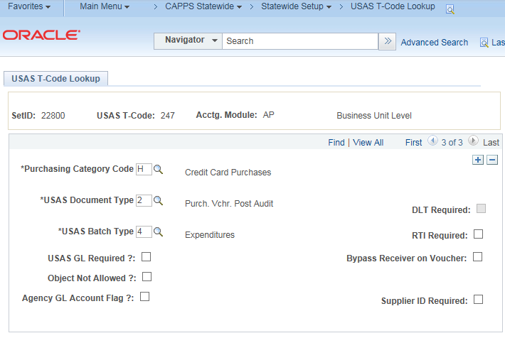

**Very Important:**

Keep in mind the accounting entry template assigned the voucher can override the USAS Document Type assigned the voucher when it is sent to USAS.  For example, accounting entry template ‘TRV 225’ will always override the USAS Document Type with ‘1’ regardless of the PCC assigned the voucher:

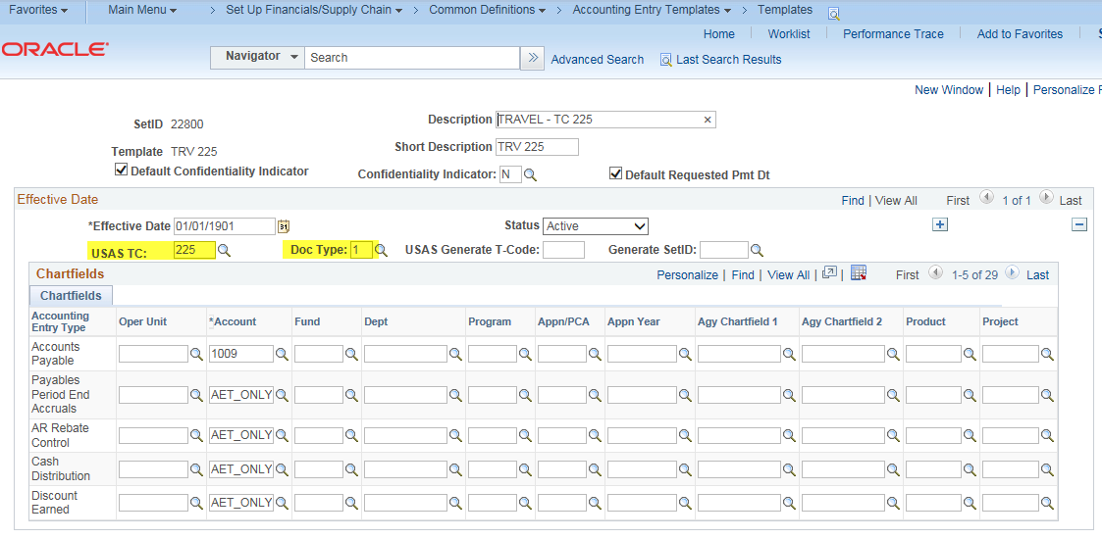

As you can see here, accounting entry template STD 225 does not override the Doc Type, meaning, the combination of T-Code and PCC will assign the Doc Type:

