Voucher Entry- Refund of Expenditure
- Main Menu > Accounts Payable > Vouchers > Add/Update > Regular Entry.
'Add a New Value'
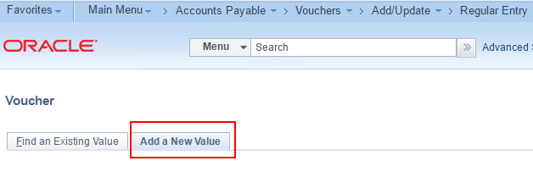
- Enter:
Voucher Style: Reversal
Supplier
Invoice Number
Invoice Date
Click: Add
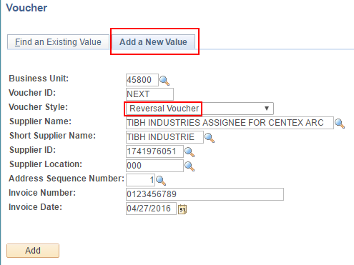
- Open the 'Copy From Source Document' section and enter the Voucher ID.
Not Needed: You do NOT need to check the Reverse Voucher checkbox.
Click 'Copy to Voucher'.
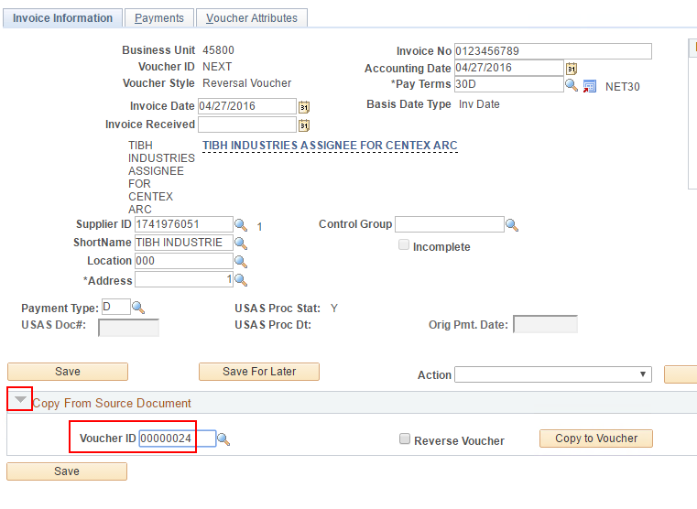

- On the Invoice Line
Enter:
Inv Receipt Dt
Service Date
Reqsted Pmt. Date
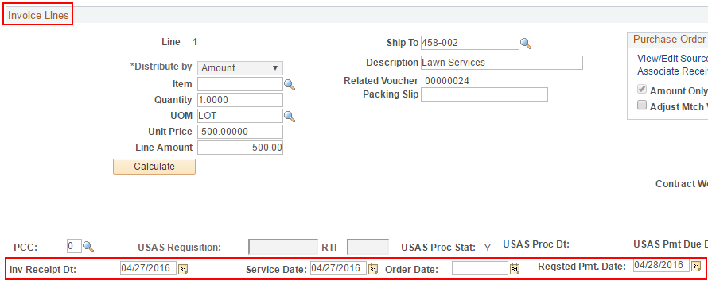
- On the Voucher Attributes tab choose a Template that will generate a 180 Tcode.
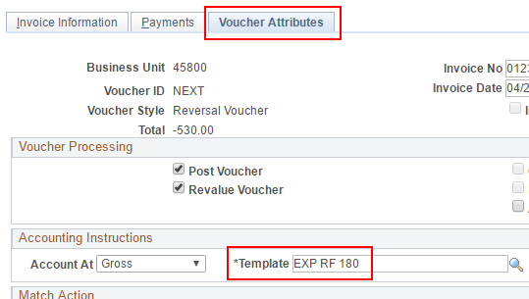
- Click Save.
- Go to the Invoice Information tab to select 'Budget Check' in the Action dropdown.
