Voucher Entry- MVV – Multi-Vendor Voucher
- Main Menu > Accounts Payable > Vouchers > Add/Update > Regular Entry.
'Add a New Value'
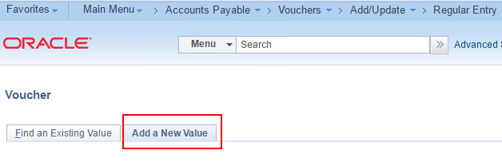
- Enter:
Voucher Style = Multi-Vendor Voucher
Supplier
Invoice Number
Invoice Date
Gross Invoice Amount
Click: Add
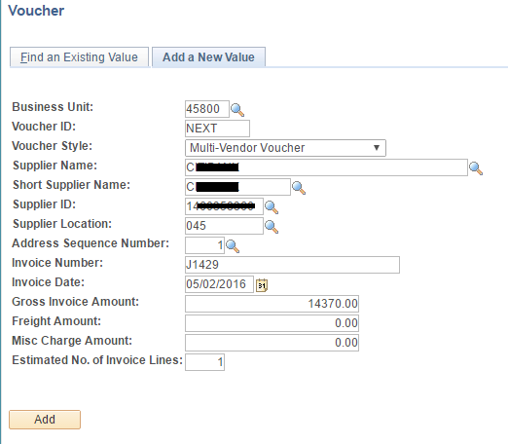

- In the Invoice Lines sections, click the button at the right side of the page
to add a new line.
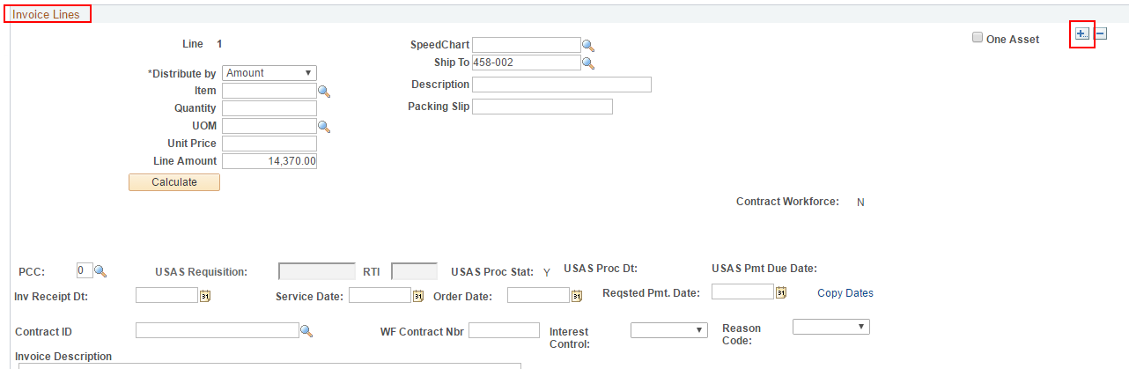
- Use default "1" for number of rows to add and click OK.
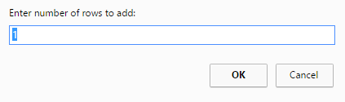
- In the Invoice Information section for Line 1
Enter:
Line Amount, Description, Invoice Description, Invoice, Ref Supplier ID
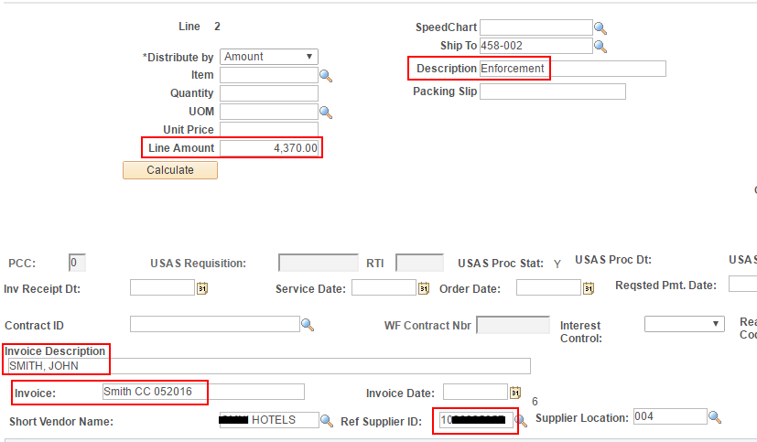
- In the Distribution Line section:
Enter the GL chartfield values (Or select a Speedchart from the “Invoice Lines” section of Line 1).
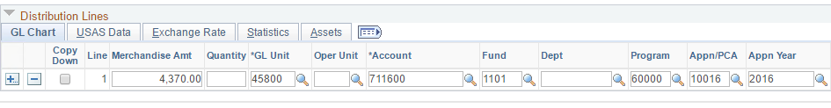
- In the Invoice Information section for Line 1, click the 'Copy Dates' link.
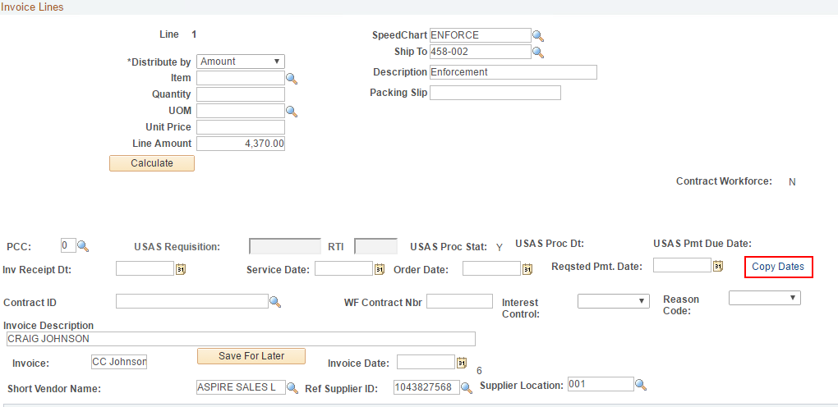
- Enter: Invoice Receipt Date, Service Date, Rqsted Pmt. Date, Invoice Date
Click: OK
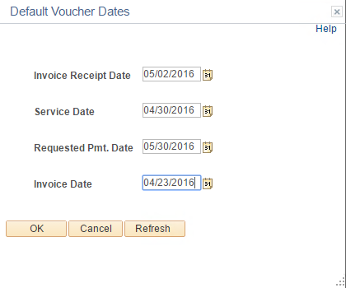
- In the Invoice Information section for Line 2
Enter: Line Amount, Description, Invoice, Invoice Description, Ref Supplier ID.
- In the Distribution Line section for Line 2
Enter the GL chartfield values. (Or select a Speedchart from the “Invoice Lines” section of Line 2)
- Add as many lines as needed (Steps 3-6) to use the total voucher amount.
- Go to the 'Voucher Attributes' tab. Enter an accounting template that will generate a 264/905 tcode.
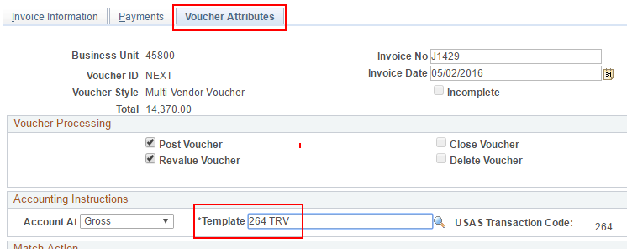
- Click OK on the Confidentiality warning message.
- Click Save.

