Voucher Entry- Enter a Non PO Voucher
- Main Menu > Accounts Payable > Vouchers > Add/Update > Regular Entry.
'Add a New Value'
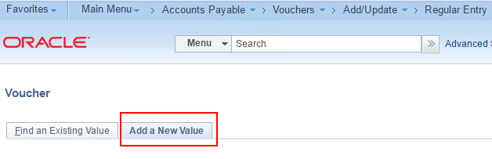
- Enter Supplier ID, Invoice Number, Invoice Date, and Gross Amount
and click Add.
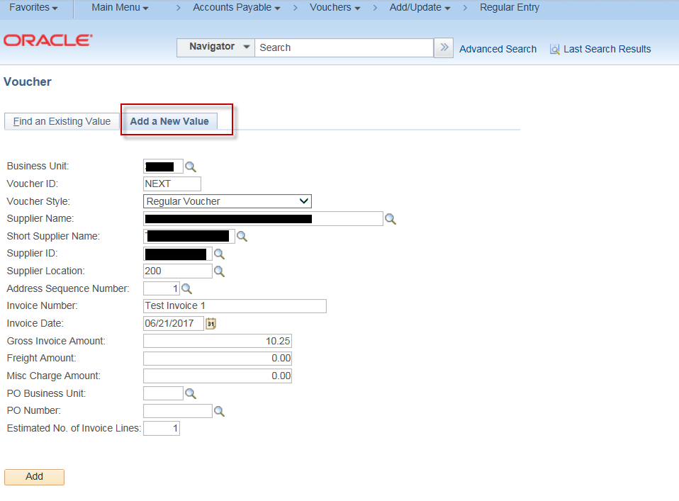
- On the “Invoice Information” tab, scroll down to the “Invoice Lines” section.
Enter the Inv Receipt Dt, Service Date and Invoice Description.
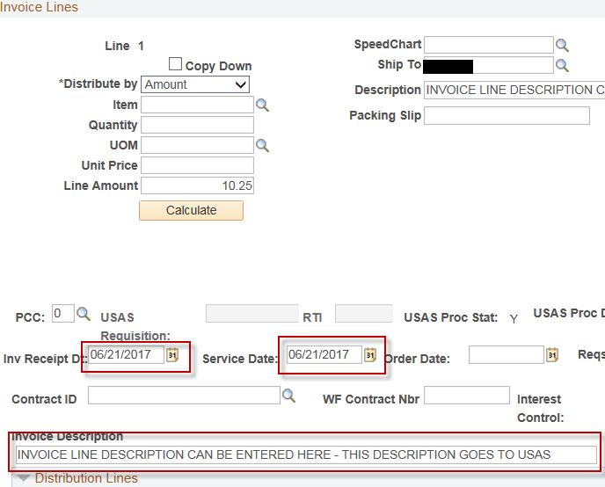
- Scroll down to the “Distribution Lines” section to the “GL Chart” tab and enter the GL Coding (i.e., the GL Chartfield values) information.
** Note: The required GL Chartfield values and combinations vary by agency.
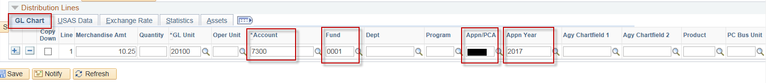

- On the “Voucher Attributes” tab, verify that the value in the “Template” field is the correct value and correct TCode is displayed
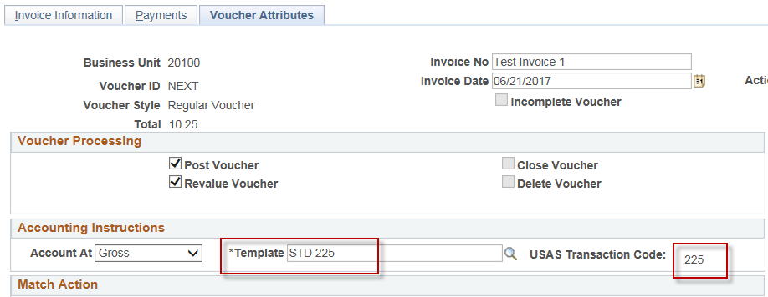

- Click “Save”
- On the “Invoice Information” tab, Select “Budget Checking” in the 'Action' dropdown list and click Run.
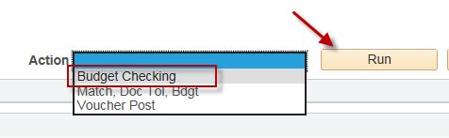
- Click the Refresh button to determine when the process has completed.
- When the “Budget Checking” process has completed, go to the Summary page to verify the voucher's Budget status.
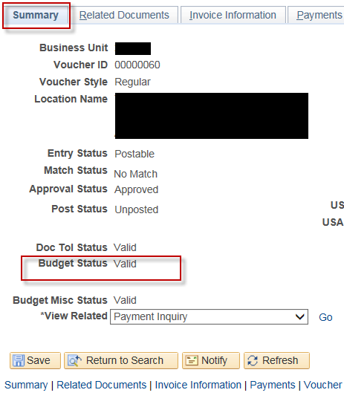
NOTE: The Voucher must be posted before it can be journal generated and sent to USAS.

