Voucher Entry- Amount Only PO Voucher (i.e., Blanket PO)
- Main Menu > Purchasing > Purchase Orders > Add/Update POs
Enter an Amount Only PO –The key thing to remember about an Amount Only PO is to make sure that the “Amount Only” checkbox on the “Attributes” tab of the PO line is checked on. This will force the PO Qty = 1 and allow you to only enter an amount in the “Price” field for that PO line.

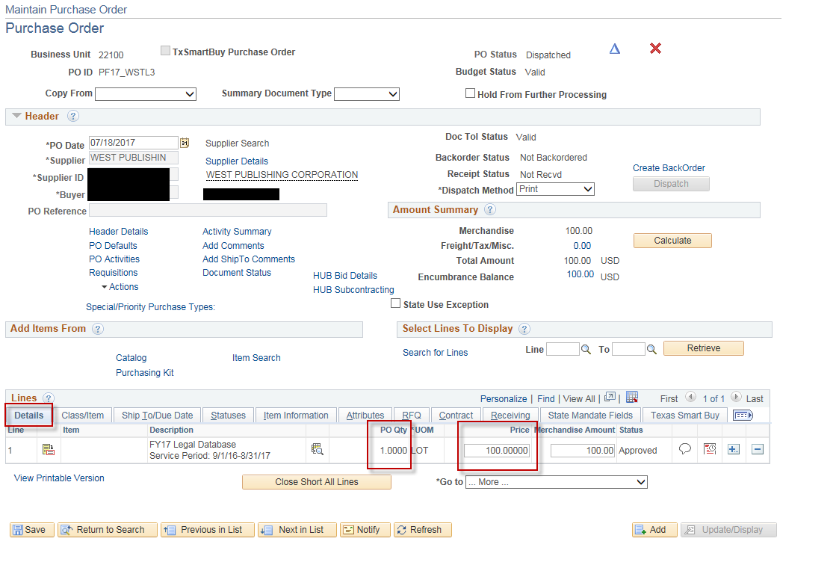

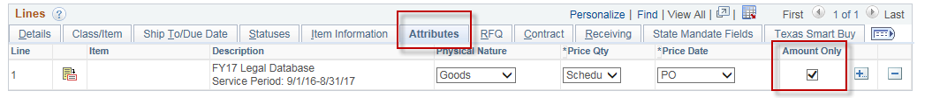

- When it is time to make a payment on that PO, navigate to:
Main Menu > Accounts Payable > Vouchers > Add/Update > Regular Entry.
'Add a New Value'
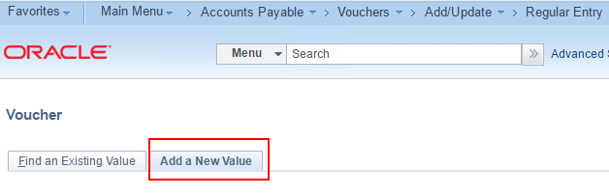
- Enter Supplier ID or Supplier Name, Invoice Number and Invoice Date
and click Add.
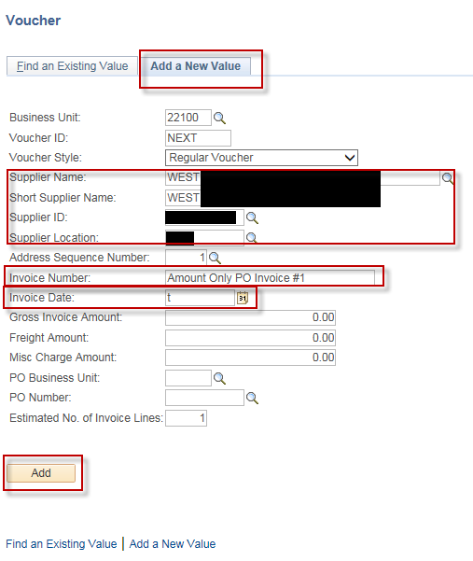

- On the Invoice Information page, click the triangle button to open
Copy From Source Document
In the 'Copy From' dropdown list, choose 'Purchase Order Only' and click Go.
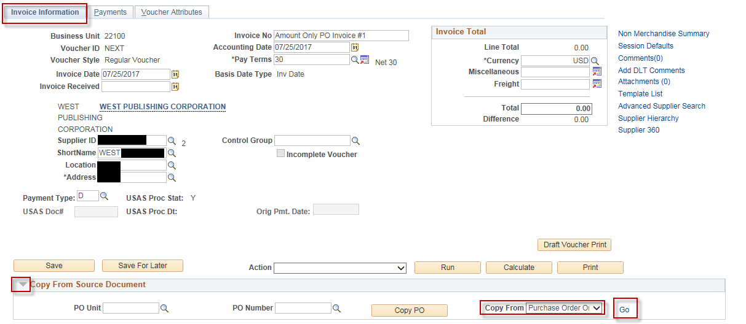
- In the Copy Worksheet page, enter PO Business Unit and PO Number From and click Search.
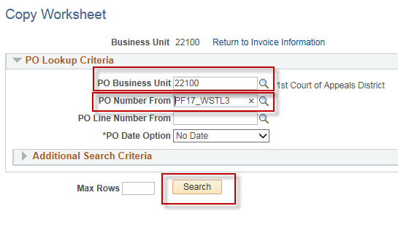

- Select the line or lines needed
Enter the amount you are paying in the “Merchandise Amount” field
Click the Copy Selected Lines button
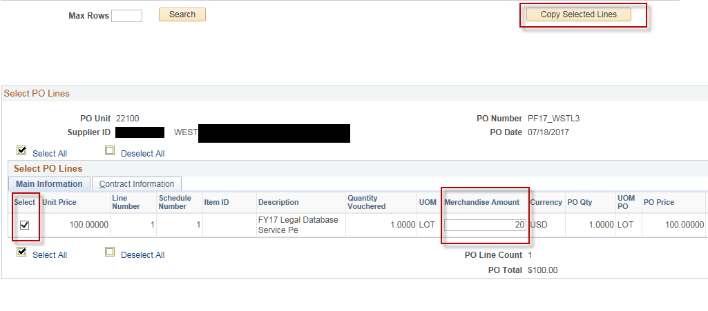
- Enter the Inv Receipt Dt, Service Date and Invoice Description.
Click “Save”
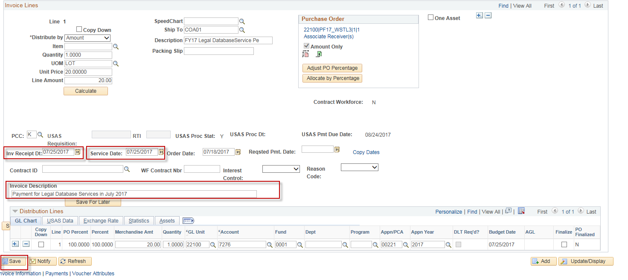

- Select Match, Doc Tol, Bdgt in the 'Action' dropdown list and click Run.
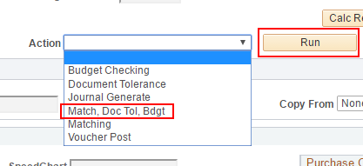
- Click the Refresh button to determine when the process has completed.
- When the processes have completed, go to the Summary page to verify the voucher's Match, Doc Tol and Budget status.
