PO– Source Req to PO
- Go to Main Menu > Purchasing > Purchase Orders > Add/Update POs and
either
(a) click ‘Add’ if your agency uses auto numbering for POs
or
(b) replace the word NEXT with whatever PO ID you want to create if your agency does not use auto numbering for POs.
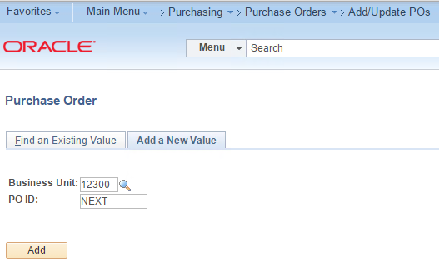
- Enter a Supplier and choose ‘Requisition’ in the Copy From dropdown list.
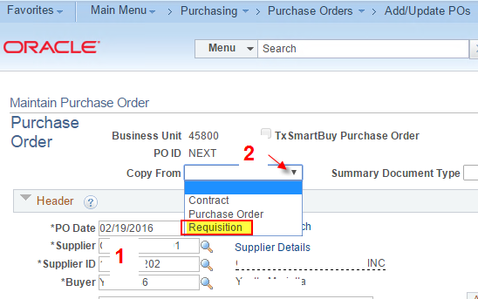
- Enter a Requisition ID or use the other search fields to find the Requisition(s) you want to source. Click ‘Search’ to bring the line(s) into the ‘Select Requisition Lines’ section on the bottom of the page.
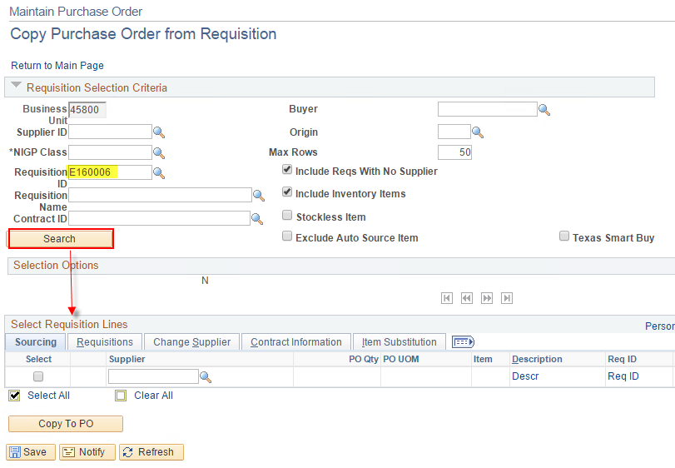
- Select the line(s) you want and click ‘Copy TO PO’.
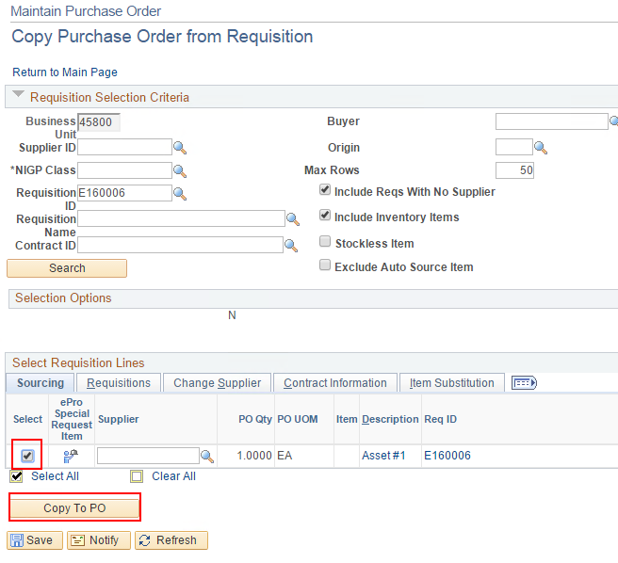
- Go to ‘HUB Bid Details’.
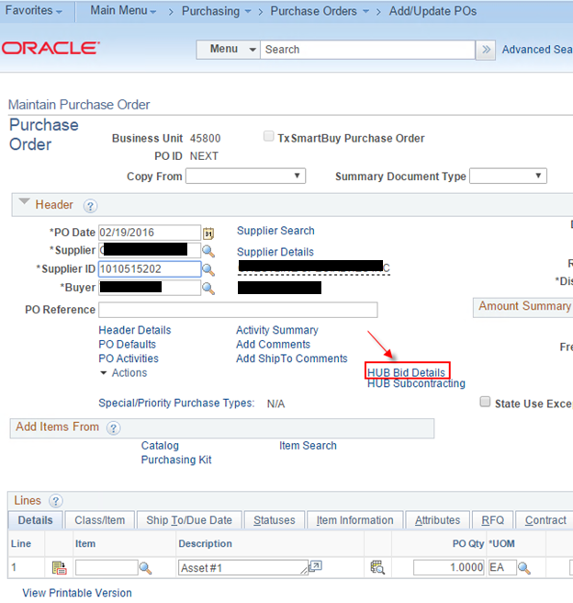

- Choose ‘No’ if the order is not competitive. Choose ‘Yes’ if you want to record bids sent and received.
Click OK.
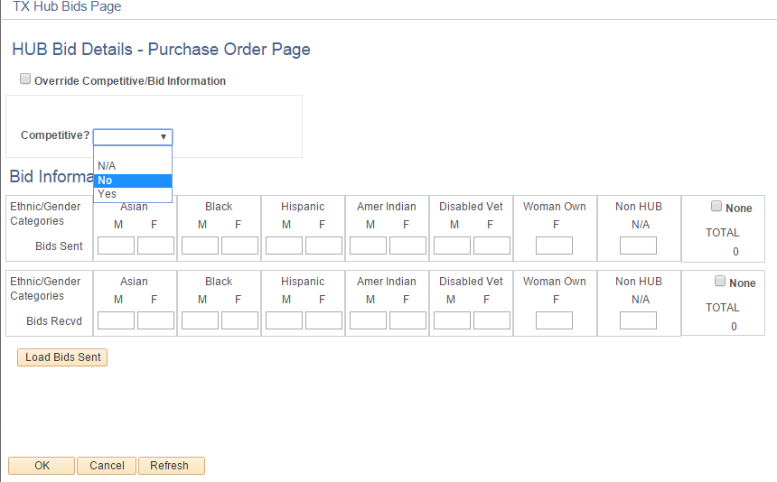
- Go to the Class/Item tab.
Verify or correct the NIGP Class/Item that came in from the Requisition.
Enter the PM/PCC (Purchasing Method and Purchasing Category Code).
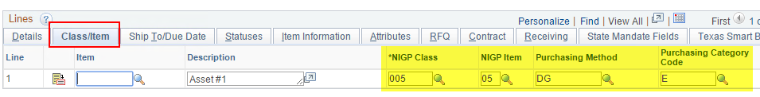
- Under the ‘Receiving’ tab is a dropdown list that controls how the voucher can be entered. If receiving is required, the voucher cannot be entered without a receiver. You may find that you’re happy with the default and therefore won’t need to check this every time you enter a new PO.
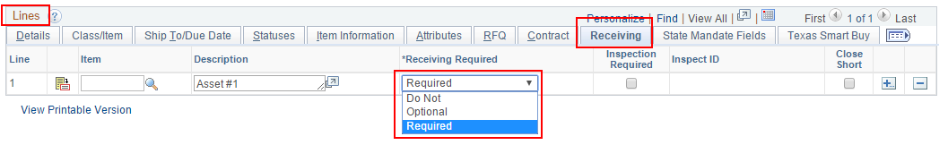
- If the order has a Quantify of 1 and will be received or vouchered multiple times, go to the Attributes tab and check the 'Amount Only' checkbox. This will allow Total Received Qty and Total Vouchered Qty to exceed the PO Qty.
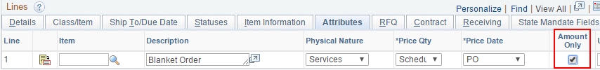
- Save the PO.
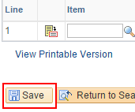
- A ‘Saved’ note will briefly appear in the upper right hand corner when the PO saves successfully.
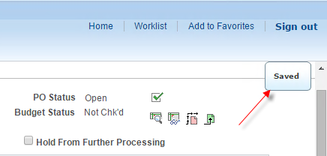
- If you’re using auto numbering, the PO ID will display.
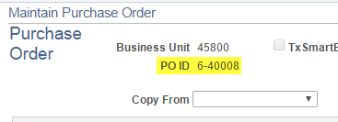
- If the PO goes into workflow for approval, it will save with a status of ‘Pending Approval’. You must wait for Approval before the PO can be budget checked, and the PO must be budget checked before it can be Dispatched.
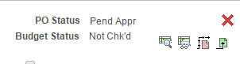
- When the PO has a status of ‘Approved’, it can be budget checked.
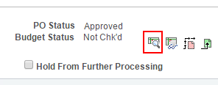
- When the PO is Approved and Valid, it can be Dispatched.
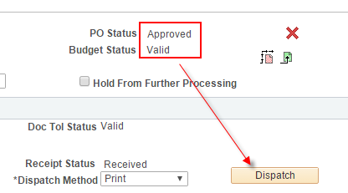
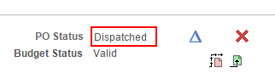
- The PDFs of your dispatched POs are stored in the Administration page of the Report Manager.
