PO – Copy a Purchase Order

  - Go to Main Menu > Purchasing > Purchase Orders > Add/Update POs. Click 'Add' to use autonumbering, or enter a PO ID manually and click 'Add'.
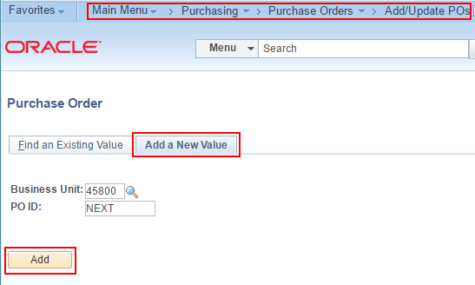
  - Choose 'Purchase Order' from the Copy From dropdown list.
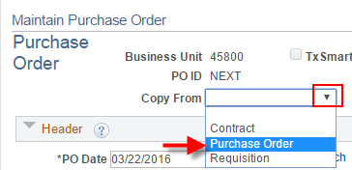
  - Enter the PO ID you want to copy. Select the line(s). Click OK.
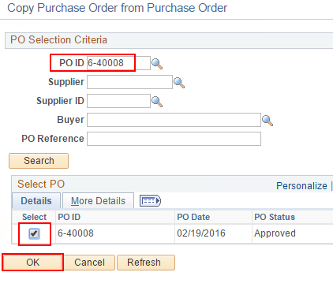
  - Click OK on the message.
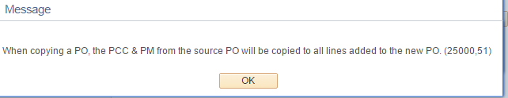
  - Go to HUB Bid Details
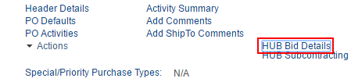
  - Set Competitive to 'No' unless you have Bid information to enter. Click OK.
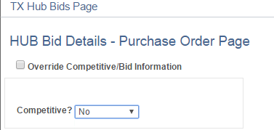
  - Save.

