Requisition– Saving Time with Defaults

- Requisition with multiple lines using the same chartfield for each line.
  - Start by going to Requisitions -> ‘Requisition Settings’.
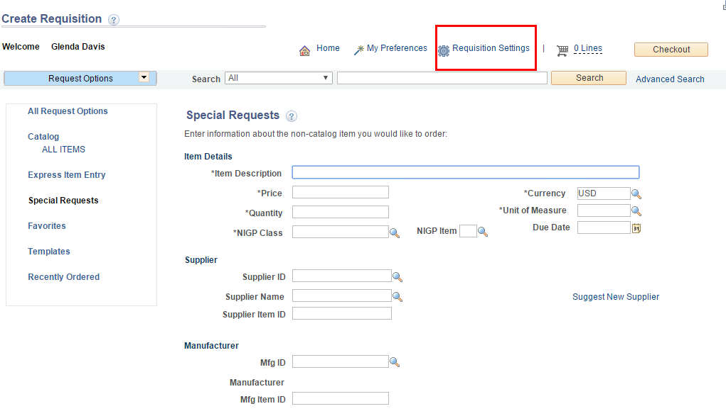
  - Enter ‘Requisition Name,’ set the Default Options to ‘Override’ and enter the chartfield information. (i.e. Ship To; Location; Account; Fund; Dept; Program; Appn/PCA; AY). Reference “CAPPS Chartfield Info” handout.
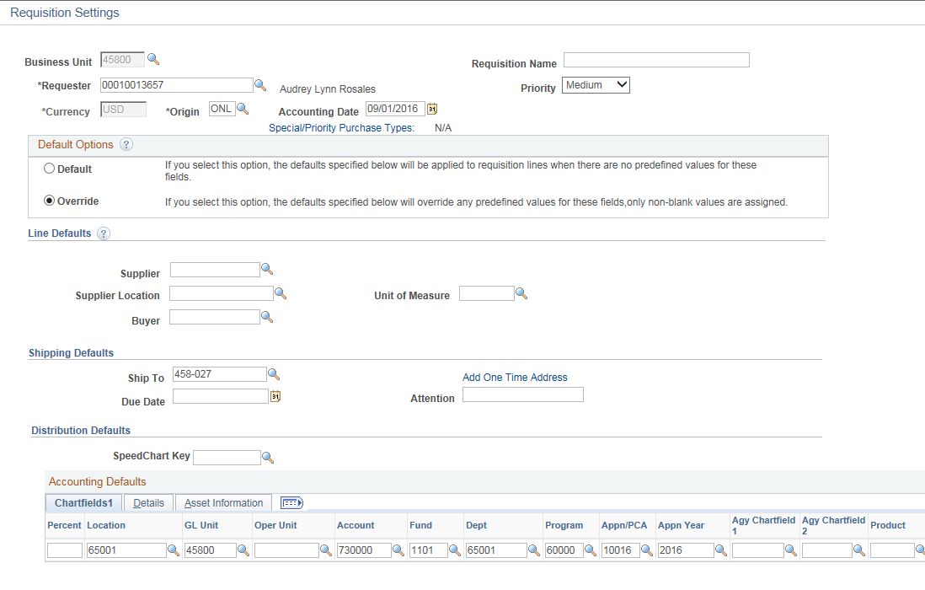
  - Once you have entered all your chartfield values, click OK.
  - Now you can enter multiple lines without the need to enter the chartfield values on each line. They will populate automatically with the values you entered in the ‘Requisition Settings’ page.
  - Once you click Checkout, spot check that your chartfield values populated.
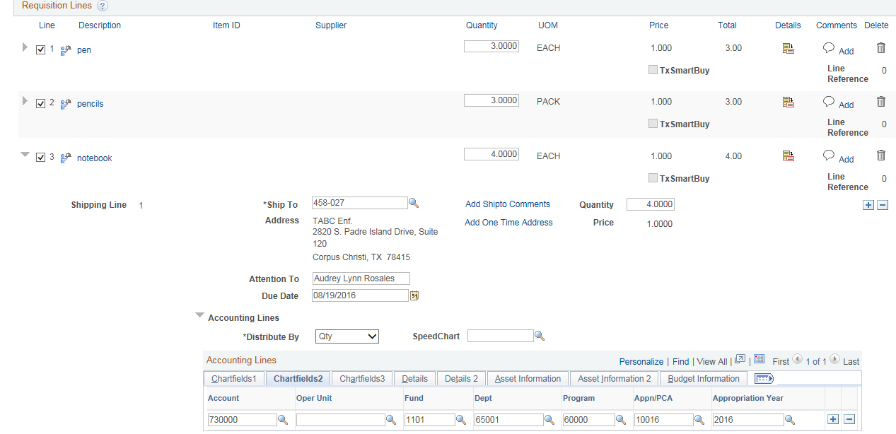

- Editing/changing chartfields on multiple lines.
  - Go to ‘Manage Requisitions’
  - Select the specific requisition to be edited/changed and in the dropdown menu choose ‘Edit’ requisition.
  - Once in the Requisition, select the Box(es) per line(s) to be changed.
(‘Select All’ option at bottom)
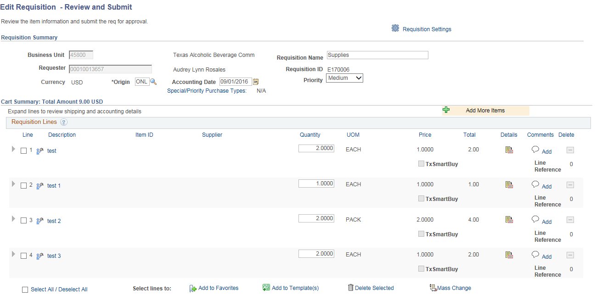
  - Once all line(s) have been chosen to change, select Mass Change

  - Enter the chartfield values you want to change (under both Chartfields1 & Chartfields2 tabs) and click OK.
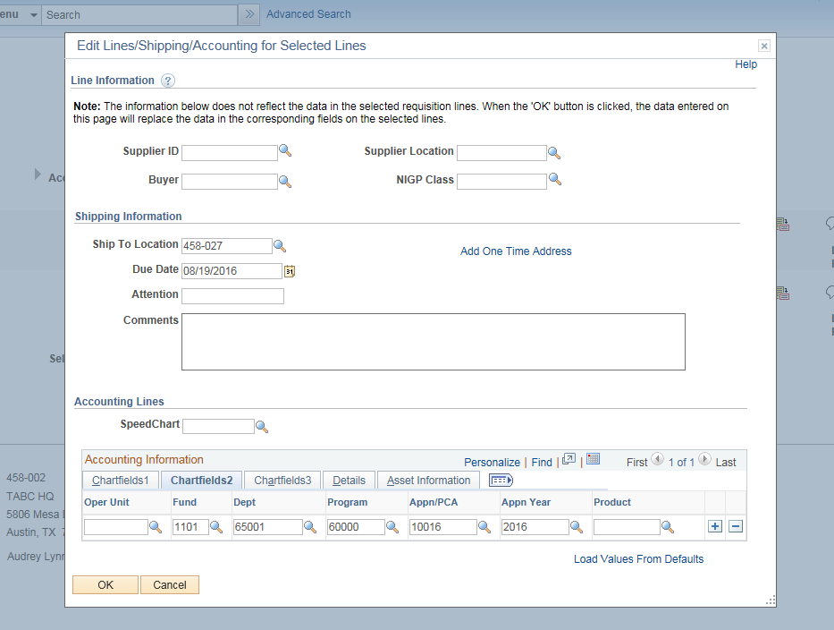
  - A window will appear, select ‘All Distribution Lines’ and click OK.
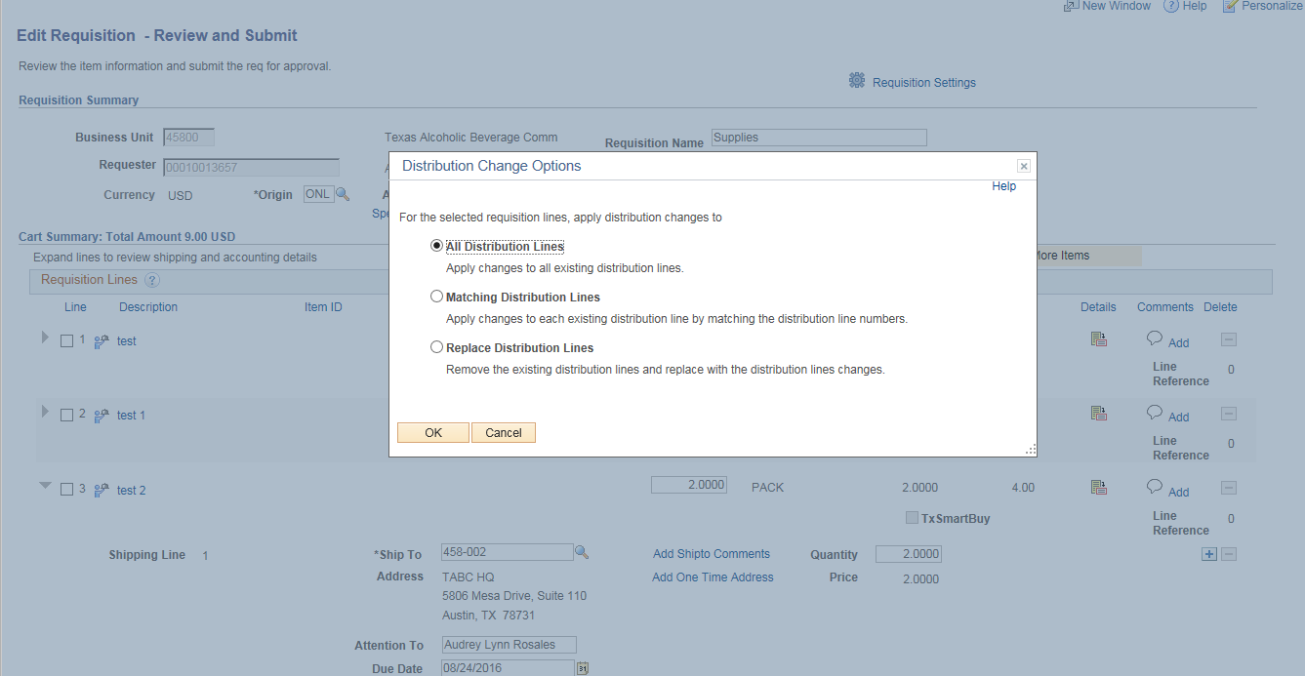
  - It will take you back to your Requisition, spot check that the changes were made.

