MANAGE REQUISITIONS – Search Requisitions
- Manage Requisitions – one page does it all – find, track, edit, cancel, copy.
- Navigation – Main Menu > eProcurement > Manage Requisitions.
- Most Common Search used by Requesters:
To see all of a particular requester's requisitions, search as shown below.
This will produce a list of all active (not Closed/Complete) requisitions for the Requester.
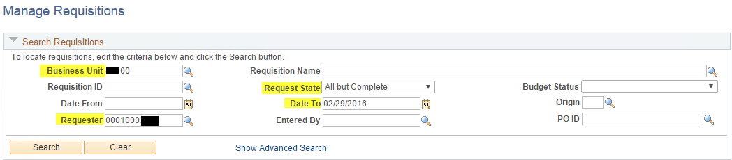
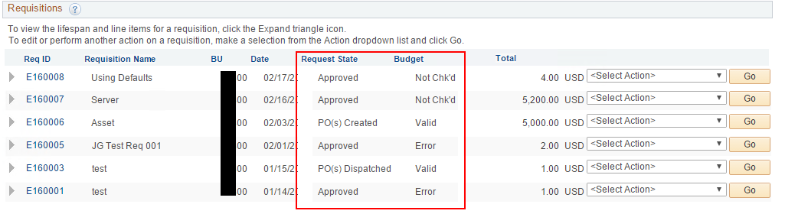

- To search for requisitions that are Pending approval, choose Pending in 'Request State'.
Note: blank out 'Requester' field to see Pending requisitions for all Requesters.
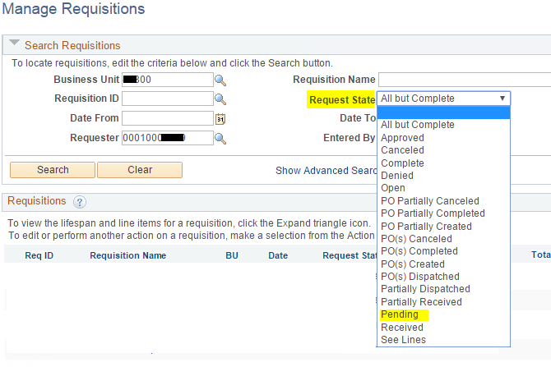
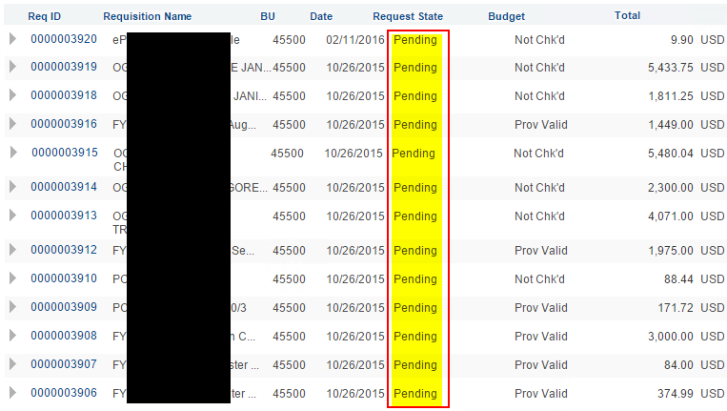

- To search for a specific requisition, helpful fields are Requisition ID or Requisition Name.
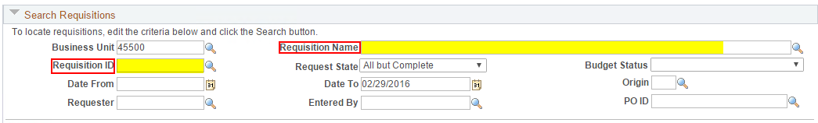
If you don't know the Req ID or Req Name, search wide open and just scroll through the list or narrow your search by date range.
- Most common search used by Buyers to find Requisitions ready to source to POs:
Search for all requisitions that are Approved and have a Valid budget check. All other search criteria left blank except for Business Unit.
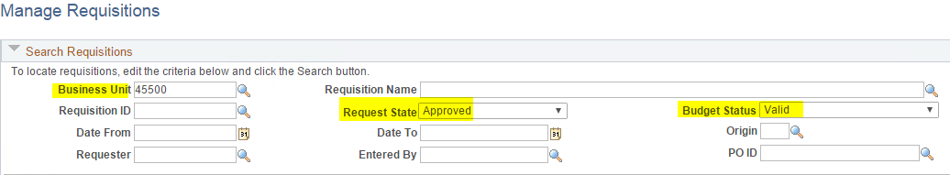
- Tip: Less is more. The less criteria you use to search, the more requisitions your search will find. Therefore, if you're not finding a requisition you expected to find, remove some criteria and try again.

