Requisition – Distribute By Qty –vs- Distrib by Amt
- A setting on Requisition Lines allows you to 'Distribute By' quantity or amount.
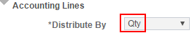 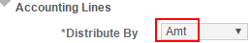
- 'Distribute by' controls how the Req Line is sourced to the PO.
- If a Req Line is Distributed by Qty, the Req Line is available to source to a PO until the entire Qty has been sourced.
Example:
Req Line with Qty = 10 is distributed by Qty.
Req Line is copied into a PO and the Qty is reduced to 1 on the PO.
Result: The Req Line has an "Open Qty" of 9 that is still available to copy into a PO.
- If a Req Line is Distributed by Amt, the Req Line is available to source to a PO until the entire amount has been sourced to a PO.
Example:
Req Line with Qty = 1 and Price = $100 is distributed by Amt.
Req Line is copied into a PO and the Price is reduced to $10 on the PO.
Result: The Req Line has an "Open Amt" of $90 that is still available to copy into a PO.
- The 'Distribute By' field should default to 'Qty' because that setting is appropriate for most types of orders.
- Distribute by Qty if you are ordering a certain number of goods such as 10 boxes of paper, 1 desk, 4 conference tickets, etc.
- Distribute by Qty if you are ordering a service in terms of a certain number of hours, such as 80 hours for a technical consultant at a certain rate per hour.
- Distribute by Amt on blanket orders, i.e. orders for a lump sum with a Qty of 1 that will need to be Received and/or Vouchered multiple times.

- Important checkbox when Distributing by Amount – Amount Only checkbox
The Req Line Details page (navigation below) contains a very important checkbox named Amount Only. The box must be checked in order to Receive against a PO Line multiple times for partial amounts. When you check the box on the Req Line, it carries forward as checked on the PO Line, thus allowing the PO Line to be received multiple times for partial amounts.
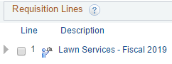 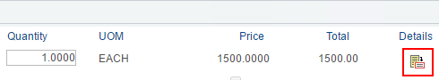 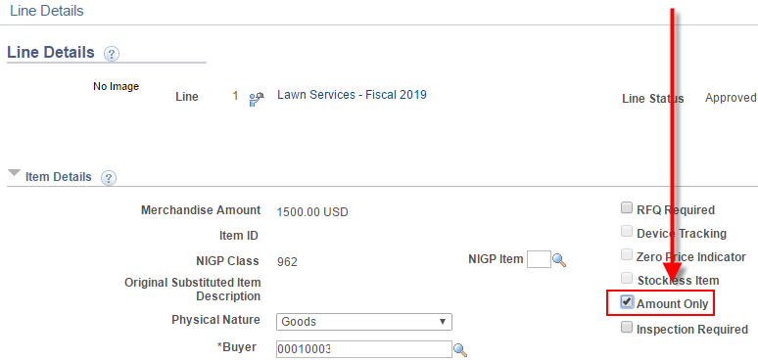
- If you need to receive against a line in partial dollar amounts multiple times, then check the Amount Only checkbox. This will automatically set the Distribute by field to Amt and will change the line quantity to 1 if it isn't 1 already.
Double-check the price and amount on the line after checking Amount Only to see if any change is needed.
- Example: if a line is for $1500 of lawn services for the entire year and you will need to receive $125 one month, $100 another month, $150 another month, etc. then the Amount Only checkbox should be checked. This will allow the $1500 line to be received in partial amounts multiple times throughout the year.

