CAPPS PHC/PHC Offset Overrides for OPTOUT

- Summary:

CAPPS is configured to take 1% of total base salary for the Payroll Health Contribution benefit. However, if an employee’s monthly compensation rate is greater than $6000.00 ($3000.00 part-time), then the OPTOUT benefit plans PHCSTO (PHC offset to STO) and PHC (Payroll Health Contribution) will need to be adjusted to ensure that the maximum of $60.00 ($30.00 part-time) is enforced. Below is an example of an adjustment that would need to be in place for EACH PAYROLL where the specified conditions exist.

- Navigation:

Main Menu>Payroll for North America>Payroll Processing USA>Update Paysheets>By Payline

- Screen Shot:

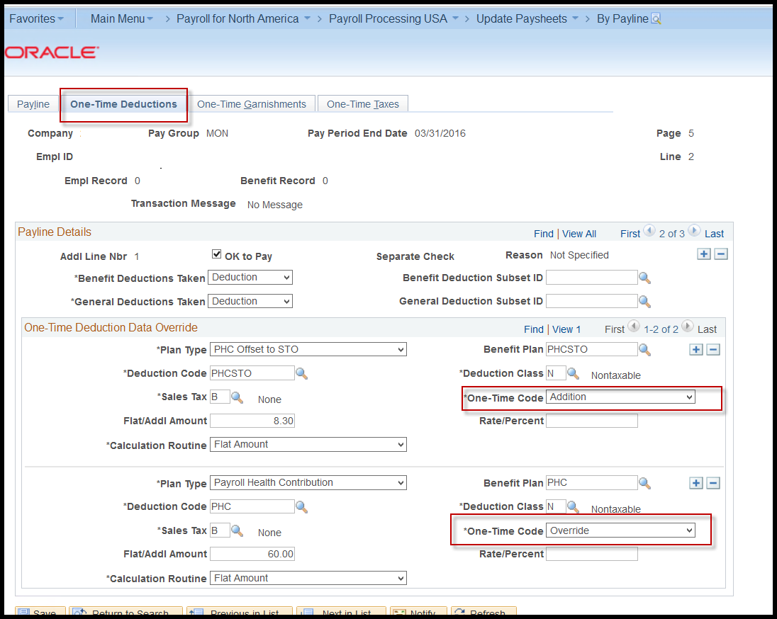

- Steps required:
- User will make One Time Deduction Adjustments directly on the Payline

- Benefit Plan = PHCSTO
  - Check is calculated to determine the negative amount needed to bring down the PHC Offset amount
  - Plan Type = PHC Offset to STO
  - Benefit Plan = PHCSTO
  - Deduction Code = PHCSTO
  - One-Time Code = Additional.
  - Flat/Addl Amount = Amount necessary to adjust the negative PHCSTO to $60.00 ($30.00 part-time); $8.30 in this example.
  - This adjusts the negative amount calculated ($68.30 in this example), down to $60.00 ($30.00 if part-time).

- Benefit Plan = PHC
  - The PHC amount will always be $60.00 for full-time employees ($30.00 part-time)
  - Plan Type = PHC
  - Benefit Plan = PHC
  - Deduction Code = PHC
  - One-Time Code = Override
  - Flat/Addl Amount = $60.00 (full-time), $30.00 (part-time)
  - This will override the employee’s 1% of base salary to $60.00/$30.00

NOTES

