CAPPS Record Grievances

Summary:

CAPPS provides a method to record “grievances”

Prerequisite: · Business Unit and Department; to allow only those users with security access to that department to be able to access the grievance record

Steps Required:

- Navigate to Workforce Administration / Labor Administration / Record Grievances
- Add a new value
- Note. the system will assign the grievance id
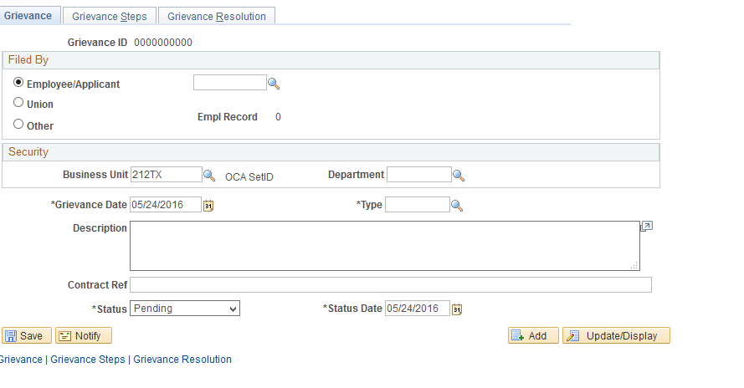
- Filed By Information to be entered:
  - Select “Employee” or “Other”
Employee | If you are adding a grievance filed by an employee, click this button and enter the ID in the adjacent field.
Other | Select if you are entering a grievance that isn’t filed by an employee. In the adjacent field, enter free-form text up to 40 characters to describe who filed the grievance.
  - Business Unit and Department
If you enter a business unit and department here, then only those users with security access to that department can access the grievance record when you save the information for this grievance. For example, if you select Department 10200 for Grievance ID 0000000001, then when you save the page only users with security access to Department 10200 can access this record.
Note. If you don’t enter a value in the Department field, then you won’t set department level security for this record and the system defaults to no department security for grievance records.
Note. This system does not default a worker's business unit and department into these fields.

- Grievance Details
  - Enter required fields: date, type, status, status date,
Type | (Required) Select a grievance type.
Status and Status Date | Select the status of the grievance — Settled, Pending, or Appealed — and the date that status was reached.
- Select the Grievance Steps tab
  - Enter the grievance step
  - Enter the action date
  - Enter comments as needed
- Save the record
- If this is a grievance with a final resolution, select the Grievance Resolution tab and enter a final resolution; otherwise, revisit the grievance record when a final resolution is set

