SPRS Payroll Outbound Interface

- Summary:
SPRS Payroll outbound interface contains paycheck/Advice information that needs to be accepted and paid by USAS.

After confirmation of Payroll and distribution, payroll admin needs to:
- create document
- run SPRS Payroll Outbound Interface
- run SPRS Audit Report
- contact Payroll Approver to release payroll file in SPRS.
Nightly control-M job will pick up SPRS payroll file from agency I/O area and sends it to SPRS. If there are any errors with file, SPRS will send it back to CAPPS with status “USAS Rejected” along with SPRS Print/Error files (ERROR.LCV.CSV, INPUT.PAY.LCV, PAY.PRINT.LCV). Payroll Admin needs to review these files, fix the issue, regenerate payroll file and resubmit the document.

- Create Document
Document must be created for every payroll, On-Cycle or Off-Cycle, so it can be send to SPRS and processed by USAS.
- Navigation:
Main Menu -> Payroll for North America -> Payroll Distribution -> TX Create Document
- Screen Shot:

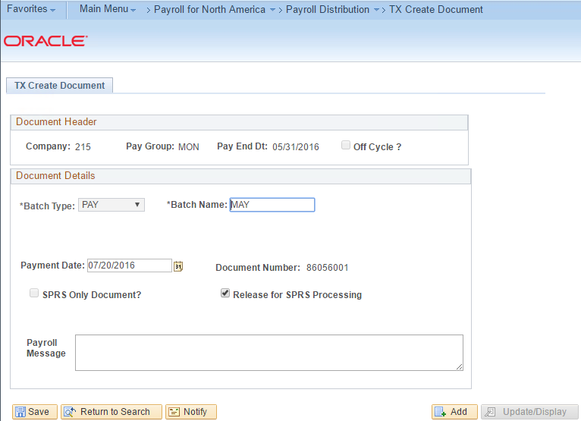

- Steps required:

- For On-cycle payroll, batch type will be defaulted to PAY and grayed out. Also Off Cycle check box will be grayed out.
- Enter batch name (Ex: May On Cycle)
- Payment Date will be defaulted to Tomorrow. It has to be >= Tomorrow
- Select “Release for SPRS Processing” check box to send payroll file to SPRS.
- Click Save, then document number will be generated.

- Run SPRS Payroll Outbound Interface
SPRS payroll file will be created and placed in agency’s I/O area. This interface picks up all documents that are in the status of “Reprocess SPRS” or “SPRS Requested”.

- Navigation:
Main Menu -> CAPPS Interfaces -> Payroll -> TX SPRS Pay Outbound

- Screen Shot:

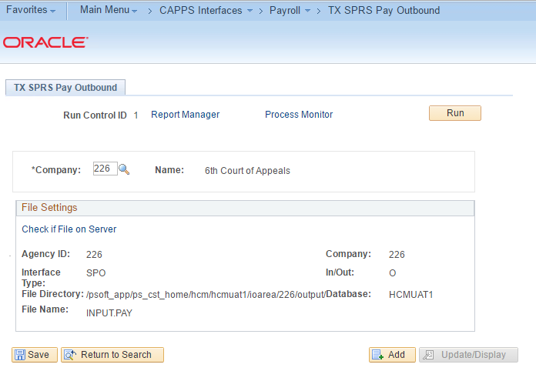

- Steps required:

- Enter Company code (Ex: 226) of the agency for which SPRS payroll file needs to be created.
- Click Run (select Process “TX_SPRS_PR”)

- Run SPRS Audit Report
This report contains Payroll and Distribution summary information. If payroll and distribution summaries do not balance, then payroll file will not processed by SPRS.
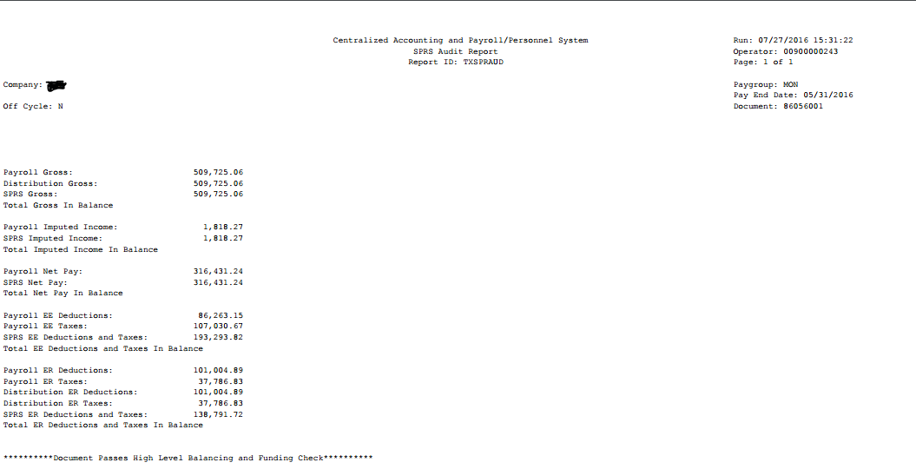
- Navigation:
Main Menu -> Payroll for North America -> Payroll Distribution -> TX SPRS Audit Rpt

- Screen Shot:
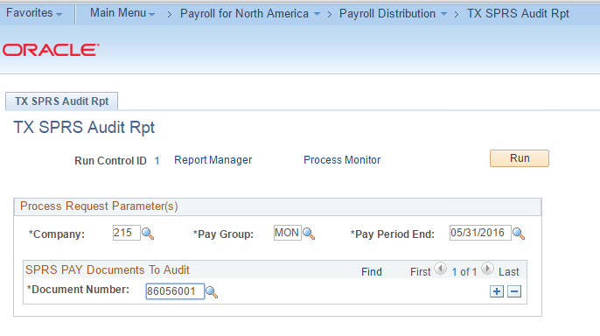
- Steps required:

- Enter Company code, Paygroup and Pay End Date.
- Add documents that need to be audited including On and Off cycles.

NOTES
- Use standard naming convention
- Place all desk aids on the shared drive under CAPPS Processes - N:\HCM\CAPPS FM- Processes,Req,Config,Scripts\CAPPS Business Processes,Documentation\Process Documentation,Aids,Helpful Hints\HR,Benefits & Position Management
- Open the footer and click in the template file name then right click and select Update Field to auto change to your file name
- Follow the outline of this template
- Add additional data and/or notes at the end of the document

