Running CAPPS Reports

CAPPS reports come in several formats. The complexity of the report determines its format. Format examples include “SQR” and “Application Engine”.
Users are most familiar with SQR. These reports produce .pdf output.
When running an SQR report in the Process Scheduler the following displays:

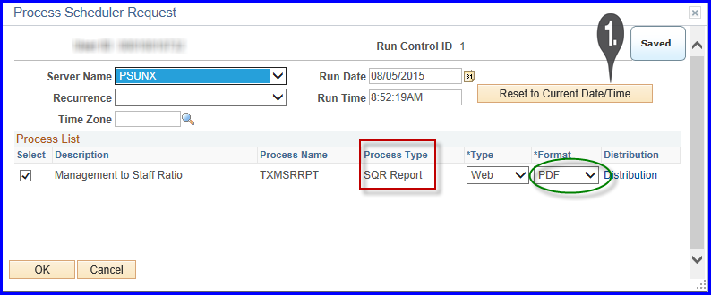
Notice the Process Type of “SQR Report” and the output Format of “PDF”.
Here is an example of PDF output:

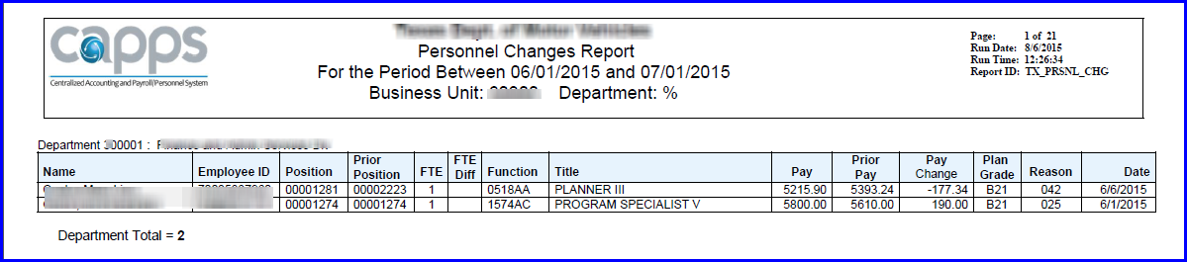

CAPPS reports developed using non-SQR formats like “Application Engine” may pull data using multiple methods. These methods include Excel and PDF output.
When running an Application Engine Report the Process Scheduler the following displays:
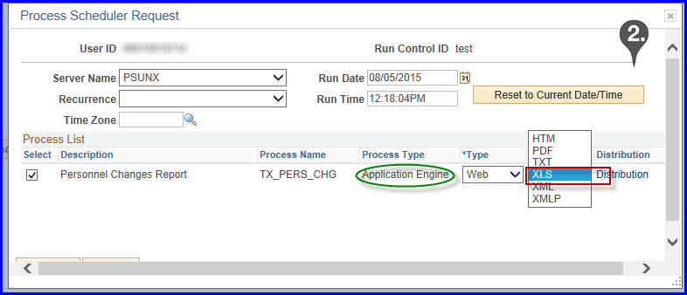
Notice the Process Type of “Application Engine” and the multiple outputs. The most commonly used output is XLS, or the Excel format. Typically, the Excel output displays the same way the .pdf output displays.
Here is an example of Excel output:
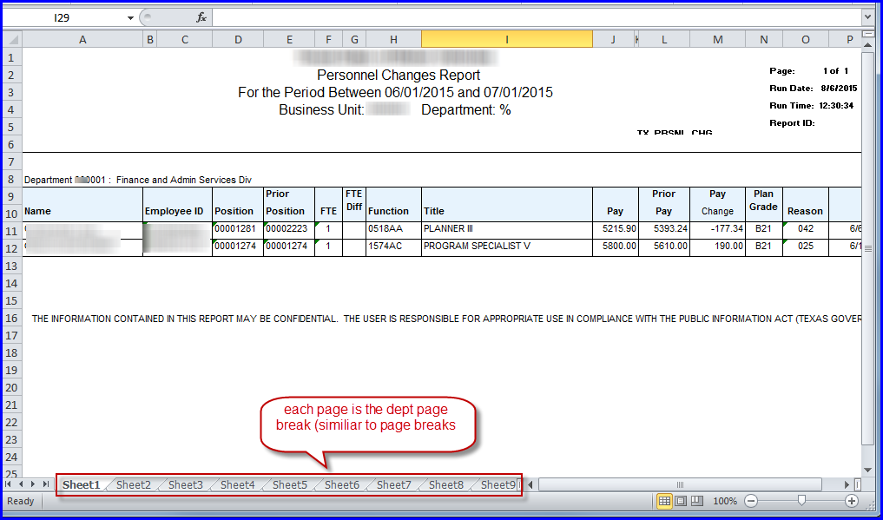
Some reports are “Query Based”. Query based reports usually have a corresponding query available in CAPPS Query Viewer.
Use a simple search to find a corresponding query:
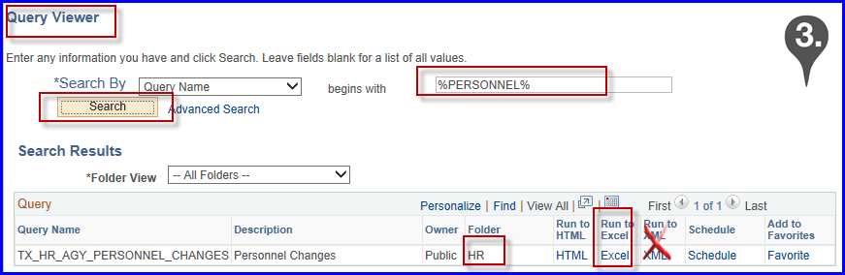

The most commonly used query output is XLS. The Excel output displays the “raw data” and column headers.
Here is an example of Excel output from Query Viewer:
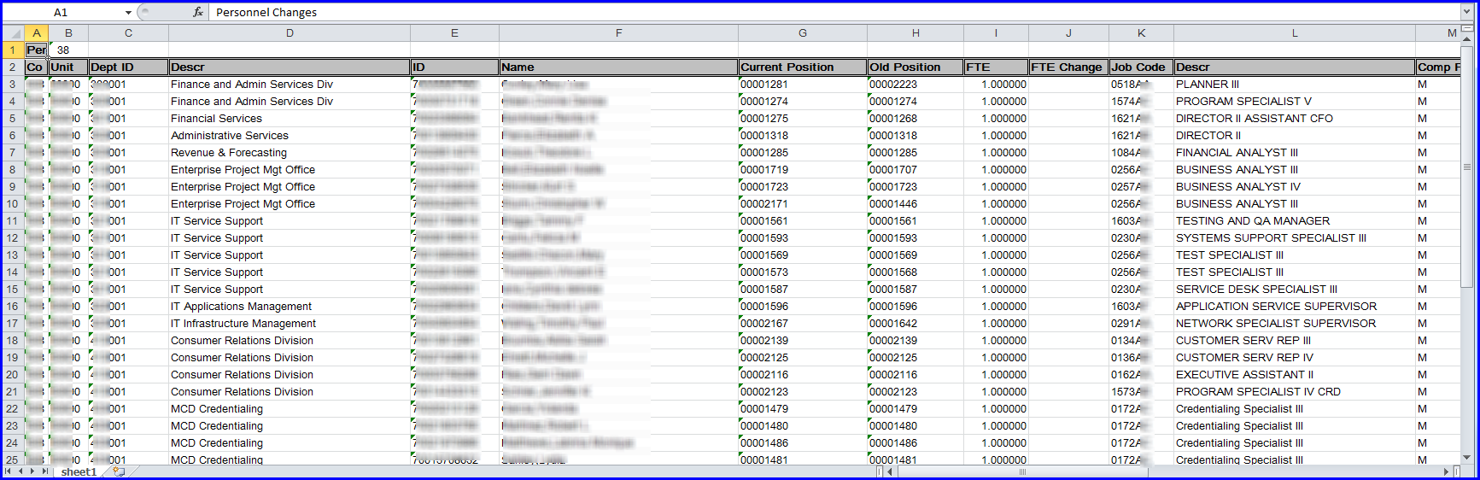
NOTE: Prompts in Query Viewer may differ from the report prompts on their respective run control pages.
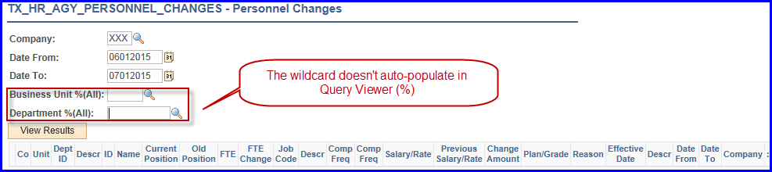
You will need to add the % to the prompts in your query.

