FMLA Business Process

This is the recommended process for agencies to use to track FMLA.

* Manager or FMLA Administrator is notified employee is going out on FMLA
* Manager notifies agency FMLA administrator
* FMLA administrator enters FMLA event in CAPPS (see steps below)

Navigate: Main Menu > Benefits > Track FMLA (Family Medical Lv) > Tx FMLA Administration

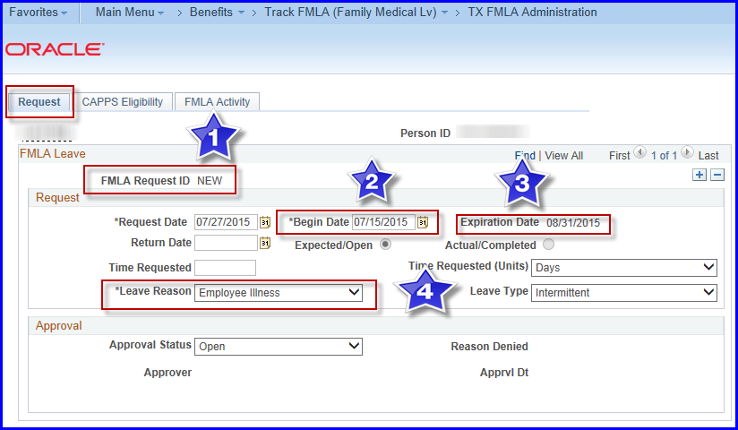

1. FMLA Request ID is “New” until saved (this is the ID used in T&L)
2. Enter the first day the employee will use FMLA
3. Expiration date Is calculated depending on the type of “calendar” year the agency is using (The agency has a designated “calendar” year based on the setup in the TX Agency table): Fiscal year - FFY, Rolling year forward - FMF, Rolling backward – FML. The type of FMLA year an agency is established with in CAPPS converts from USPS.

Note: CAPPS also allows setup for events related to Parental Leave (PAR) and Military Caregiver Leave (MCL).

1. Enter a leave reason

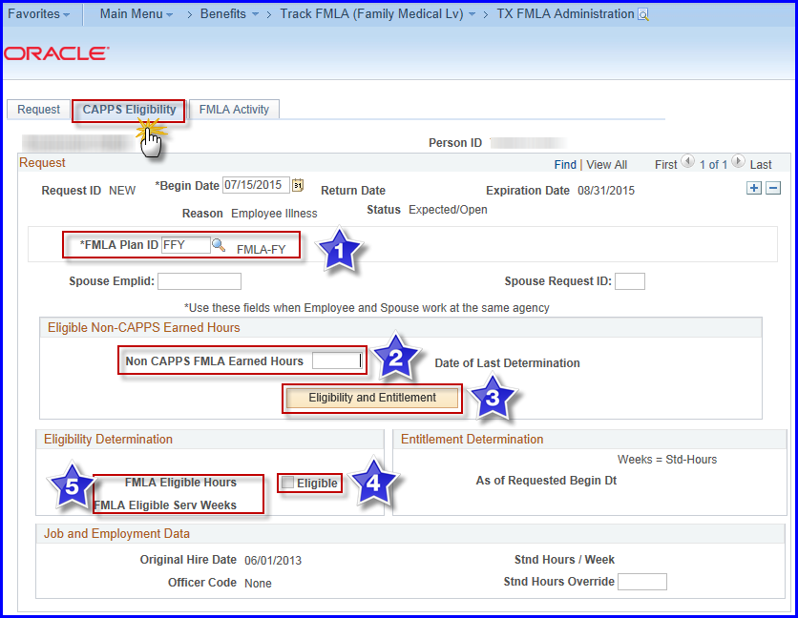

Click “CAPPS Eligibility” tab

1. Select the correct FMLA Plan ID (what type of covered leave is employee using) (The default value for the FMLA comes from the agency table setup for the FMLA year type your agency uses):

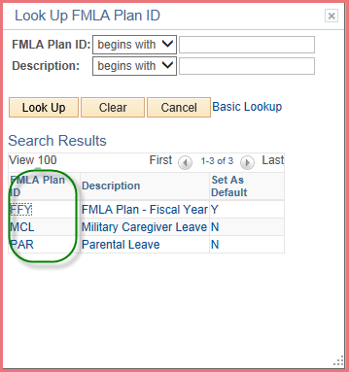

1. Use the **TX_HR_AGY_FMLA_ELIG_HRS** query to determine any non-CAPPS hours needed for eligibility (used for 1 year after conversion into CAPPS or if the employee worked for another agency or institution of higher education). Only enter the hours for the number of months needed – for example, when your agency has been on CAPPS for 2 months, you will have 2 months of data from CAPPS, you will only need the prior 10 months from the query).
2. Click the “Eligibility and Entitlement” button to determine if the employee is eligible to be covered under FMLA and the Eligible hours and weeks will populate (which include Non-CAPPS FMLA Earned Hours) and if eligible the box is checked (see screen shot below)
3. If checked, go to “Request” tab to **approve** event. (If this step is not performed the FMLA Activity page will not open for entry.)
   1. If not checked, go to “Request” tab to **deny** the event (unless agency decides to approve the event anyway) CAPPS will allow the administrator to add/approve the event.

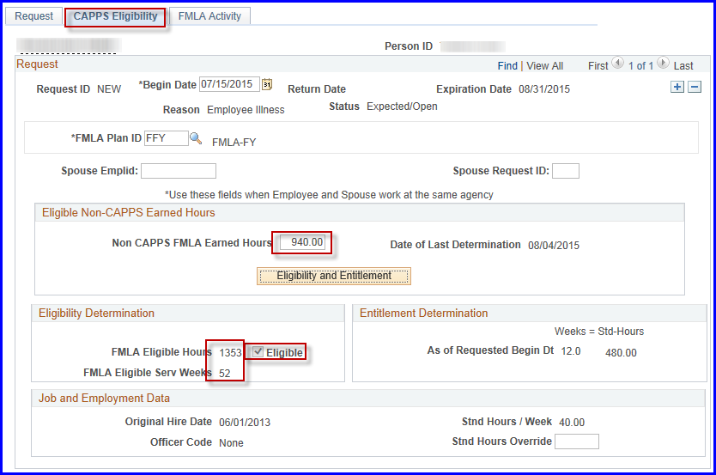

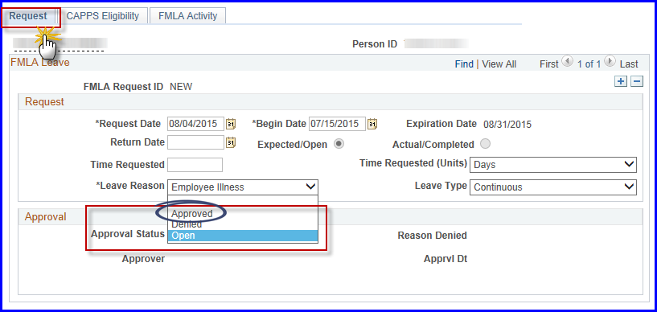

If denied administrator can add a reason for denial (see below):

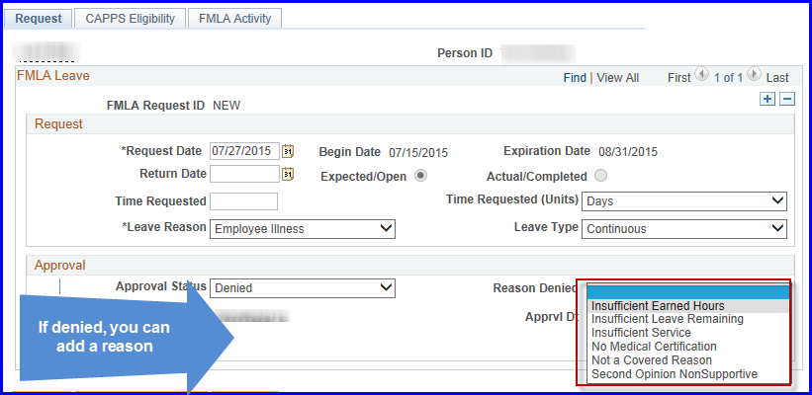

If the employee is on continuous FMLA and will be out for longer than 1 month, a Leave of Absence job action should be entered on job data.

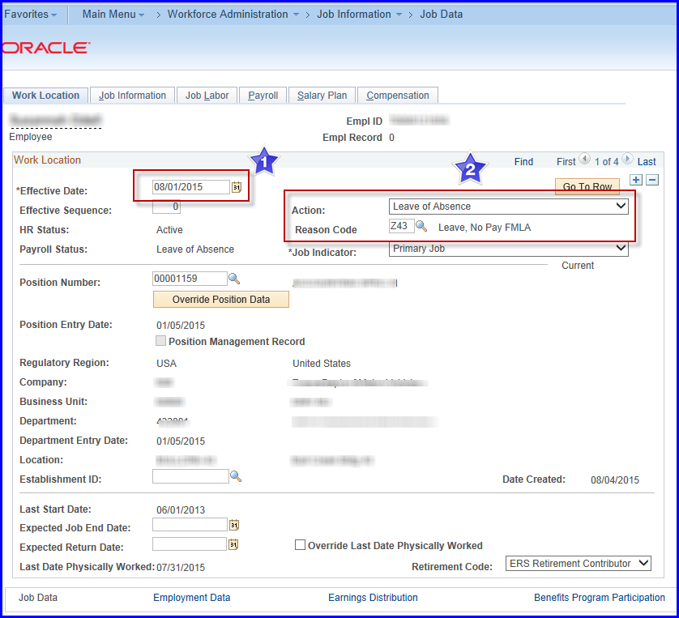

1. Effective date is first of the month of full month of leave of absence
2. Action = Leave of Absence and select the correct Reason Code

FMLA Activity Tab

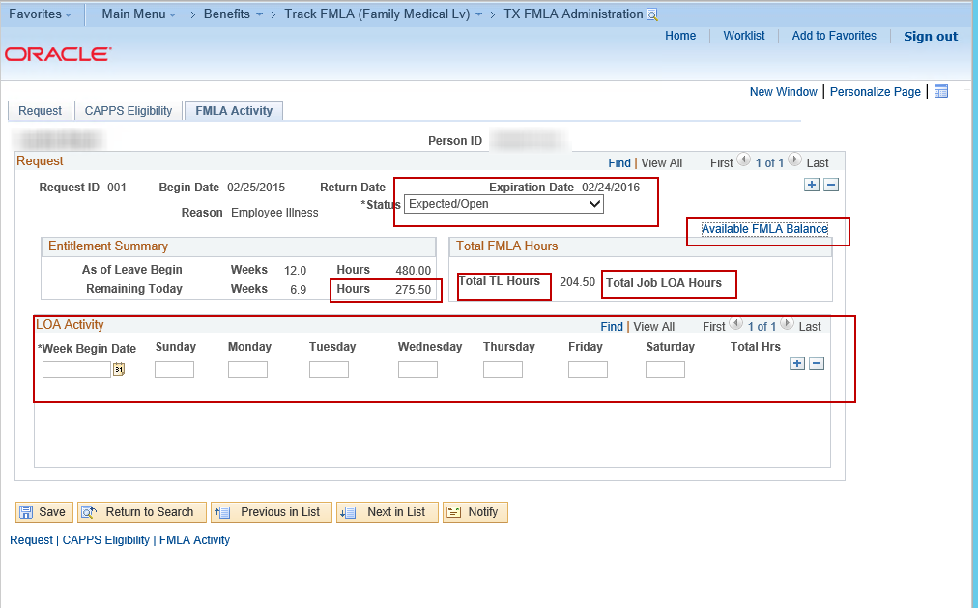

**3**

**4**

**1**

**2**

**5**

1. Total TL Hours: Displays FML related hours taken from Time and Labor with the Request ID from the event
2. Total Job LOA Hours: Displays the hours entered in Step 3.
3. LOA Activity: When employee is out for full calendar month, a job data action is entered and all hours from that period are manually entered in this section. (this opens for entry after event is approved)
4. Remaining Today Hours: Eligible hours minus Total TL hours (1) minus Total Job LOA Hours (2).
5. Available FMLA Balance link displays when Status is Expected/Open. The balance allows the agency to monitor concurrent or overlapping FMLA or Military Caregiver events.

The FMLA administrator will need to let the manager and employee know the request number (e.g. 001, 002….) to use when entering FMLA on the timesheet.

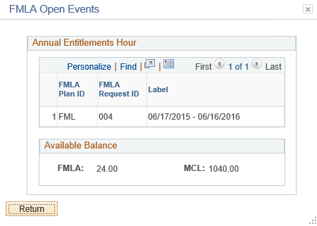

**2**

**2**

**1**

**2**

**1**

**2**

Single Event

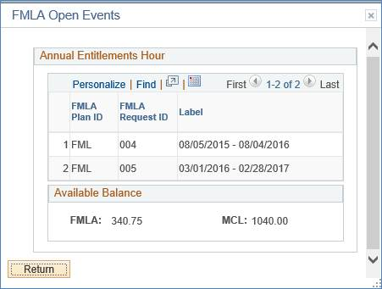

Multiple Events

The FMLA Open Events box will display when you select the Available FMLA Balance link on the FMLA Activity tab or on the timesheet.

1. Shows the active request ID(s) and the time frames.
2. Shows the available balance by event.

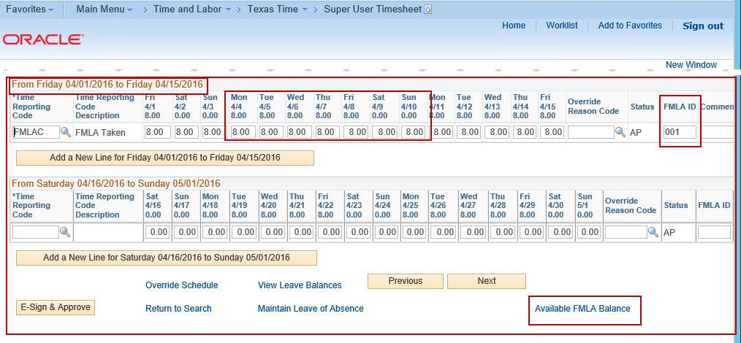

**2**

**33**

**1**

**2**

**4**

1. Manager or employee will enter the correct TRC (time reporting code) with the hours taken.
2. Manager or employee will enter the FMLA ID.
3. The dates under report using the FMLA ID need to be within the dates entered on the FMLA event.
4. The Available FMLA Balance link will display ONLY when the employee has an open event.

**Running FMLA reports to assist in FMLA administration**

[TX FMLA/PRNTL History Report](https://hcmtest.cpa.state.tx.us/psp/HCMTST/EMPLOYEE/HRMS/c/TX_CUSTOM_OBJECTS.TX_RUNCTL_TXFMLRPT.GBL?FolderPath=PORTAL_ROOT_OBJECT.HC_BENEFITS.HC_TRACK_FMLA.TX_RUNCTL_TXFMLRPT_GBL&IsFolder=false&IgnoreParamTempl=FolderPath%2cIsFolder)/TXFMLRPT

This report allows users to see the FMLA and Parental Leave activity by agency, business unit, department or individual employee. This can be used to reconcile and/or answer inquiries by employee.

Run Control Page

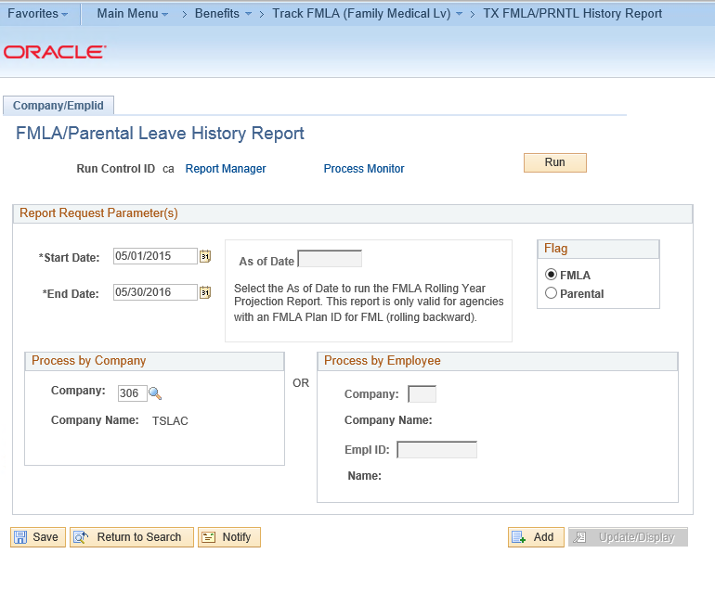

Select the report that you requested on the Run Control page.

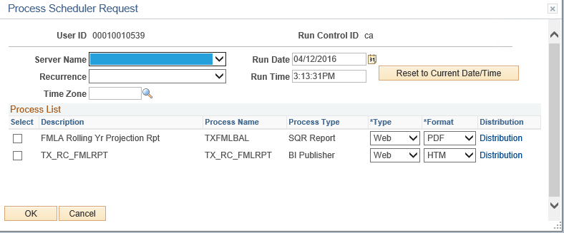

Report Output

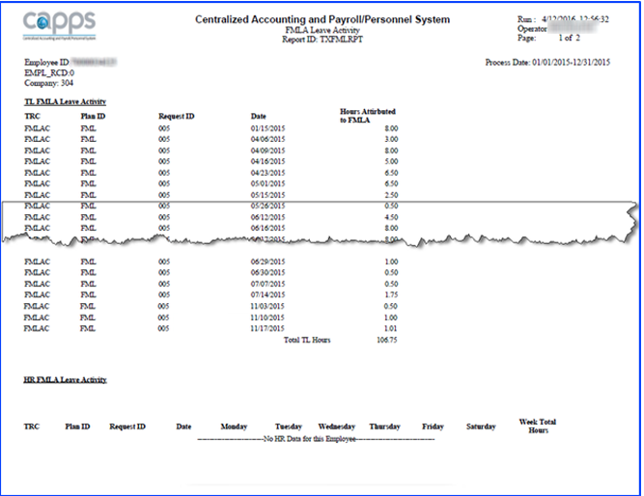

**1**

**2**

**2**

**2**

1. These hours are pulled from T&L for time reported using the related FMLA ID
2. These hours are manually entered by administrator when employee is out a full calendar month on job data

FMLA Rolling Year Projection Report/TXFMLBAL

This report shows an estimated projection of available hours that will roll back to an employee in a future month. The report is only available to be run for future months. In this example, the employee’s FMLA period was May 2015 to April 2016, therefore the projection report is run for a 1 year period after the conclusion of the original FMLA to show the hours rolling forward.

The hours are summed by month. Use the history report to analyze the detail on a daily basis.

Run Control Page

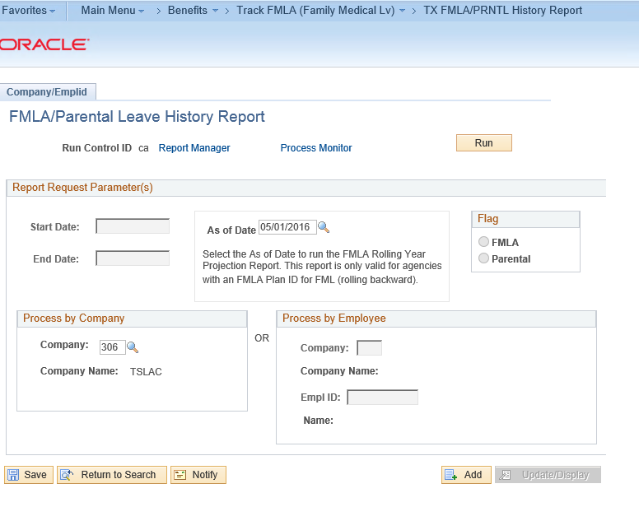

Report Output

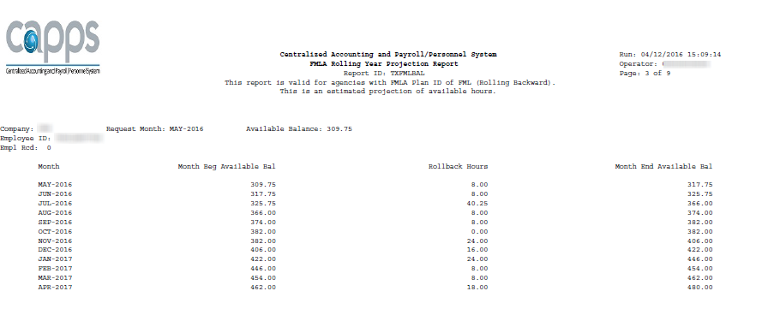

[TX FMLA ER Insurance Rpt](https://hcmtest.cpa.state.tx.us/psp/HCMTST/EMPLOYEE/HRMS/c/TX_PAYROLL.TX_TXPYFMLA_RC.GBL?FolderPath=PORTAL_ROOT_OBJECT.HC_BENEFITS.HC_TRACK_FMLA.TX_TXPYFMLA_RC_GBL&IsFolder=false&IgnoreParamTempl=FolderPath%2cIsFolder)

* Report identifies Active, On-Leave, and Terminated Employees who MAY need employer paid insurance contributions processed in the current month based on FMLA status.
* Report is run towards the end of the month and analyzes the prior month payroll activity.
* It identifies employees who have not received any Base Pay and determines if any FMLA Leave (HR FMLA LOA action reason) or FMLA LWOP (TL LWOP with FMLA override reason code) applies.
  + If it does, the report calculates the employer contributions for Medical, Basic Life, Dental as a result of Opt Out Credit, AD&D as a result of Opt Out Credit, and Opt Out Credit.
* Each employer contribution is reported.
  + The report determines for each contribution if these contributions are currently in CPE and yet to be processed, currently in core payroll and yet to be processed, or currently in core payroll and confirmed.
  + At that point it is up to the user to research and evaluate whether or not State Paid contributions need to be manually entered into payroll.

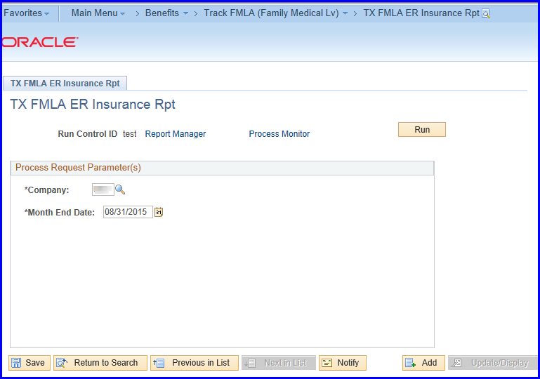

NOTE: This is a tool to assist the administrator in analysis for FMLA contributions

Report Output Page 1 – Active/On Leave employees

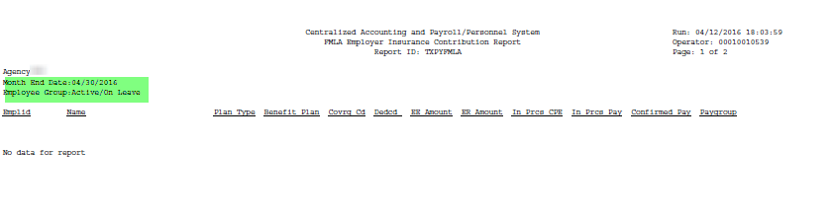

Report Output Page 2 – Terminated Employees

