Copy an Asset
- Navigation: Main Menu > Asset Management > Asset Transactions > Owned Assets > Copy Existing Asset
- Enter: Business Unit, asset ID to be copied from, then Search. The Copy Asset page is displayed.

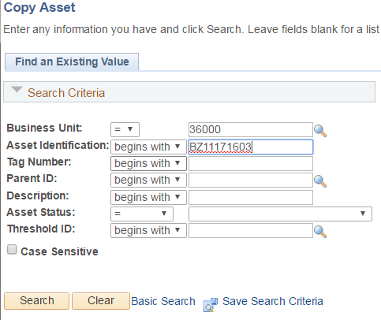
- Enter the number of copies you want to make in the 'Num of Asset Copies to create’ field. Click ‘Create Assets’.
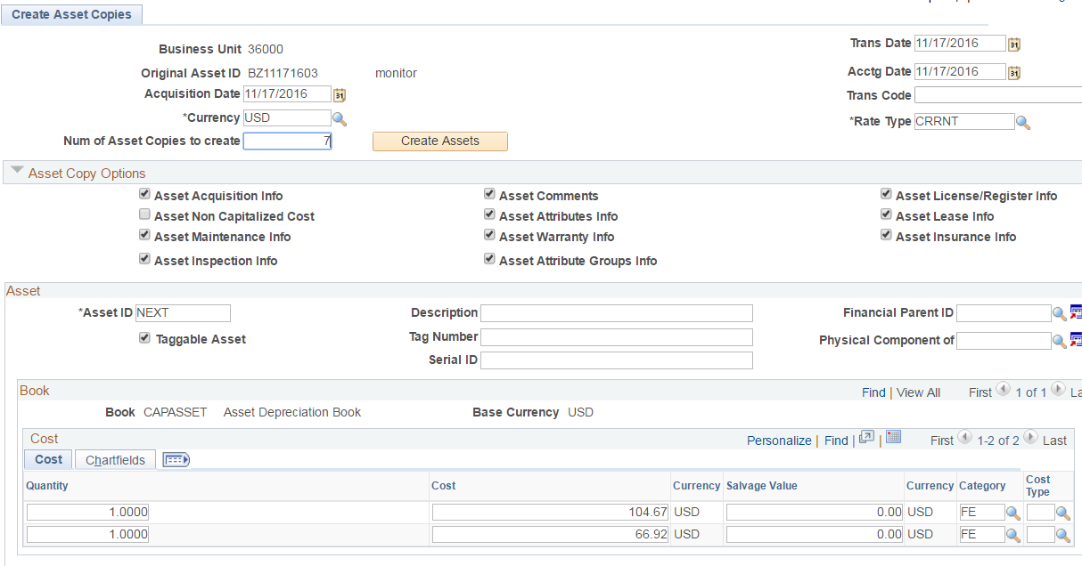

- For each new copied asset, enter an asset ID, Description and Serial ID.
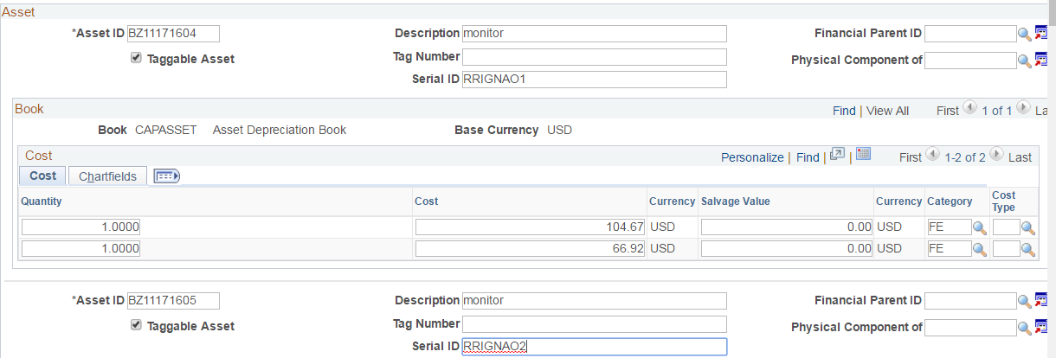
- Click the Save button to save the page.

