Vouchers that are created in CAPPS will be processed in USAS in order to pay.

In CAPPS, Vouchers are created and then run through all of the Accounts Payable Processes:
- Matching
- Doc Tolerance
- Budget Checking
- Voucher Post
The Vouchers are posted to the General Ledger with the Journal Generate process. At this point, Vouchers are complete and are ready to go to USAS.
The USAS Outbound Interface is a batch process that runs every day at 4:00 PM to send vouchers to USAS for processing. This interface creates the batches that are sent to USAS.

There are 2 reports that can be run to identify the batches that are being sent to USAS:
- USAS Pre-Release Report – This report displays Accounts Payable Batches and the transaction detail. This report is scheduled to run daily following the USAS Outbound Interface.
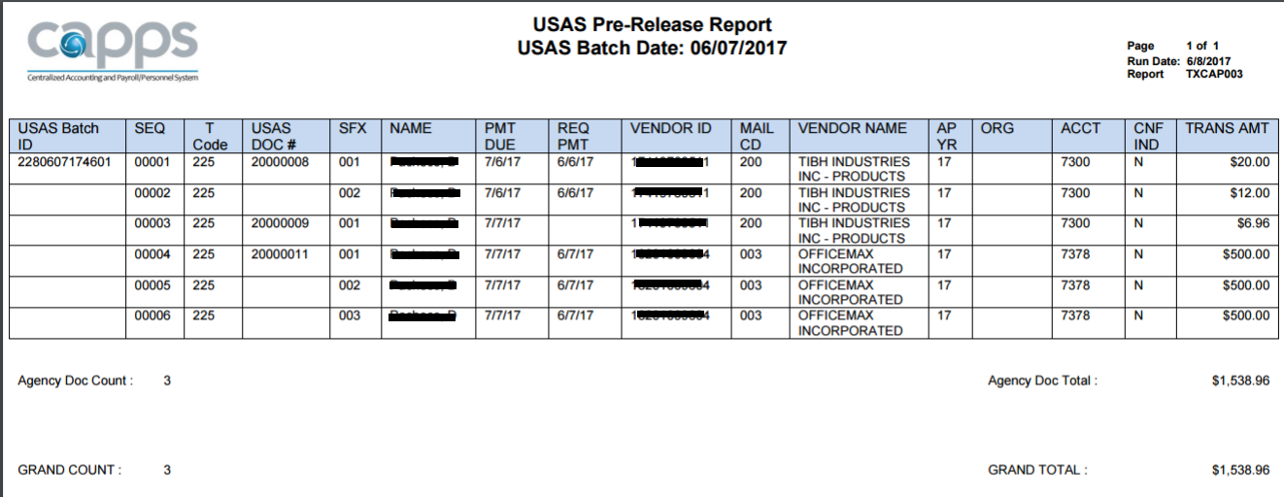

- Pre-Release Daily Report – This report displays ALL batches and transactions that are being sent to USAS.

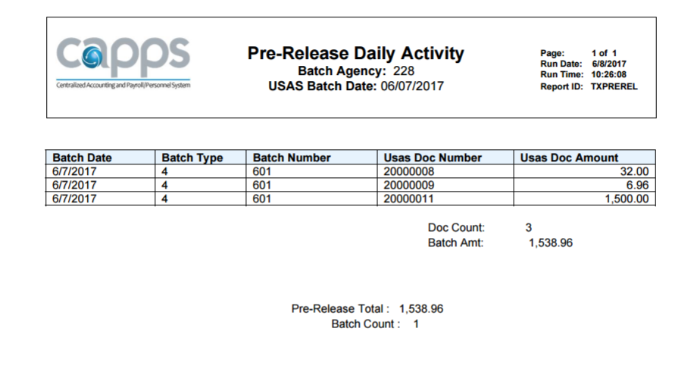

Once the batch numbers have been identified, they will need to be released in USAS. There are 2 ways to release batches in USAS:

- Pre-Release
- Release

The Pre-Release is used when you want the batch to process on the same day that it is sent to USAS. The Pre-Release prevents the batch from sitting in USAS on the IT File to wait for approval. The Pre-Release is performed on the 35 screen in USAS.

If the batch was not Pre-Released, the USAS nightly processes will place that batch on the IT file that night and that batch will be available for Release on the 53 screen the next day.

USAS Pre-Release Report

SCENARIO NAME AP-USAS_PRE-RELEASE_REPORT
DESCRIPTION: Run the USAS Pre-Release Report for Vouchers
SCENARIO STEPS:
STEP 1
Navigate to CAPPS Reports > Statewide Reports > Accounts Payable > USAS Pre-Release Report.

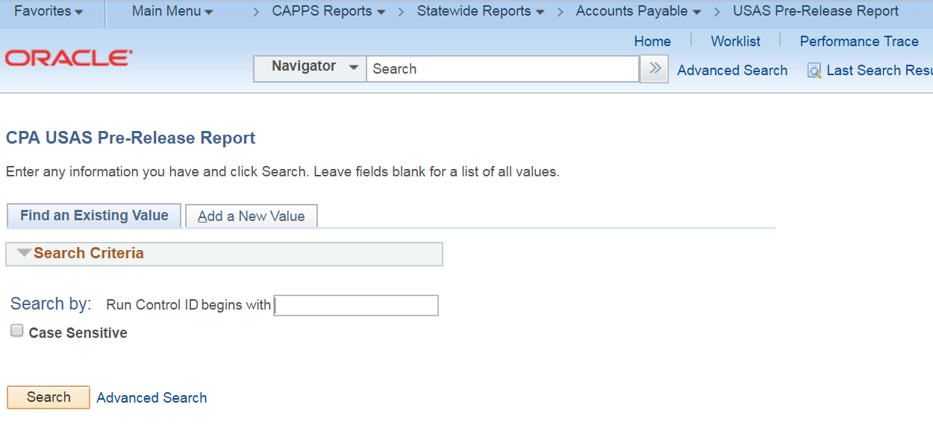

STEP 2
Select the Add a New Value tab and enter:
Run Control Id
Click the 'Add' button.
* Note -- The Run Control Id is used to run a report and to save the report parameters that are
selected. Once it has been created, it can be re-used to run the report.

STEP 3
Enter:
USAS Batch Date (Enter '01/01/1900' to see what needs to be released for the current date)
SetID

Click the 'Save' button.

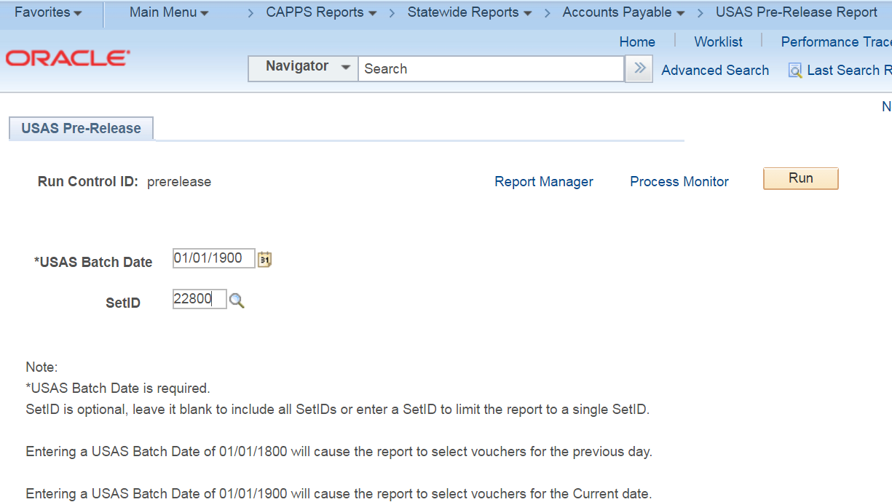

STEP 4
Click the 'Run' button.
STEP 5
Verify:
'USAS Pre-Release Report - XML' is selected
*Type 'Web' is selected
*Format 'PDF' is selected

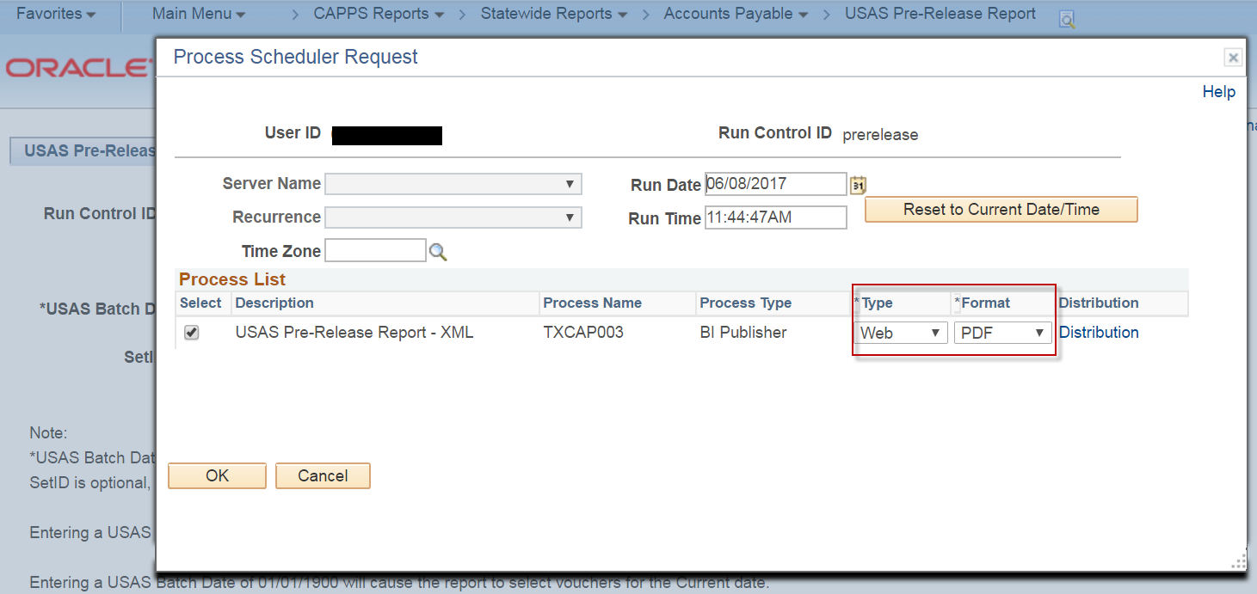

STEP 6
Click the 'OK' button.

STEP 7
Notice the Process Instance Number under the 'Run' button.

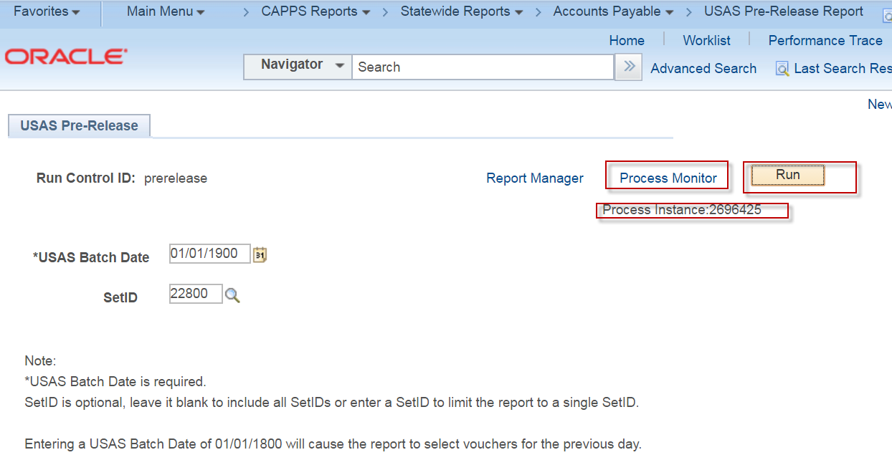

STEP 8
Click the 'Process Monitor' link.

STEP 9
Notice the Process Instance Number under the Process List. This is the batch job that is running the
selected report. Click the Refresh button until the Run Status is ‘Success’ and the Distribution status
is ‘Posted’.

STEP 10
Click the 'Go back to CPA USAS Pre-Release Report link.

STEP 11
Click the 'Report Manager' link.
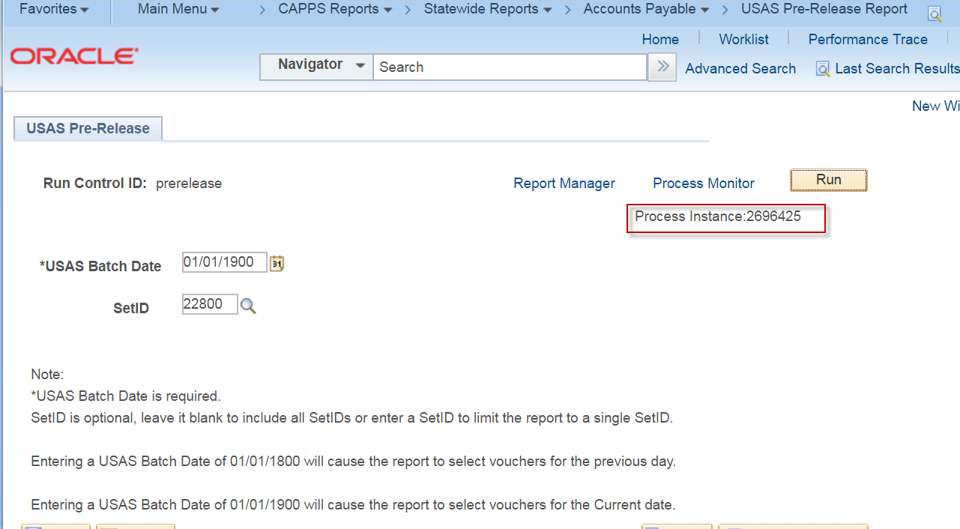

STEP 12
Click the 'Administration' tab.

STEP 13
In the Report List, click on the TXCAP003-TXCAP003.pdf file for the Process Instance that you ran.

STEP 14
The Pre-Release Report should be displayed.

Pre-Release Daily Report

SCENARIO NAME
DESCRIPTION: Run the Pre-Release Daily Activity Report that provides ALL batches and transactions that are being sent to USAS.
SCENARIO STEPS:
STEP 1
Navigate to CAPPS Reports > Statewide Reports > Interface > Pre-Release Daily Reports

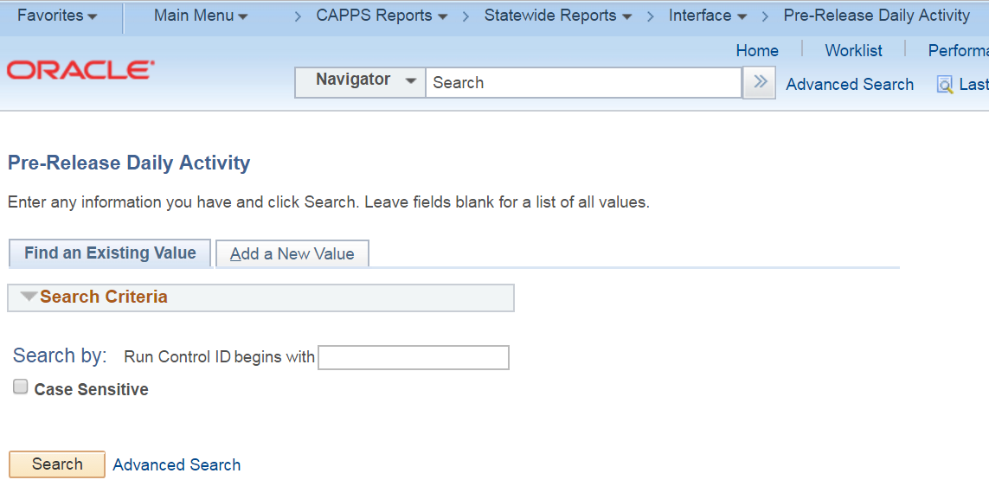

STEP 2
If you have a run control already setup for the report, click 'Find an Existing Value' tab.
Click "Search" and select your run control ID. Skip to step 5

STEP 3
If you do not have a run control ID for the Pre-Release Daily Report, click on the 'Add a New Value' tab and type
in a run control name that you can remember. No spaces are allowed in the name, however, you
can use an underscore.('_')

STEP 4
Click 'Add'. This should take you to the 'Voucher Posting' run control page.

STEP 5
On the Pre-Release Daily Report run control page, enter:
Setid
USAS Batch Date

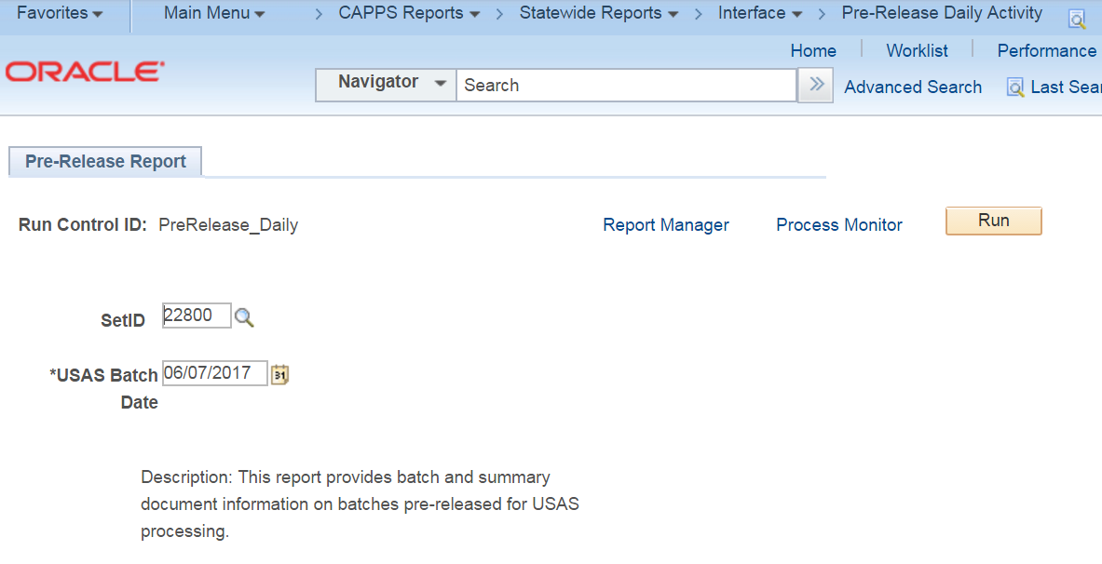

STEP 6
Click "Save"
Click "Run"

STEP 7
The "Process Scheduler Request" window should appear
Verify that the box is checked next to the "PS/AP Voucher Posting" checkbox.
Verify that the value under the "Type" column is "Web".
Verify that the value under the "Format" column is "TXT"
Click ‘OK’

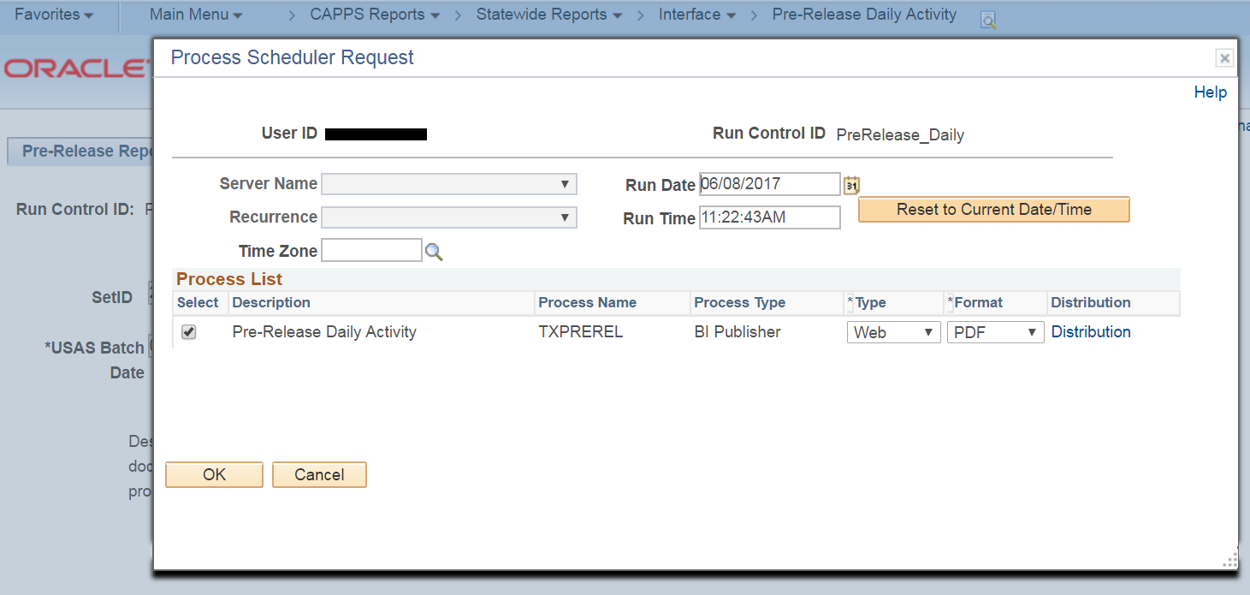

STEP 8
You will be taken back to the "Voucher Posting Request" page.
A "Process Instance" number will be displayed at the top of the "Voucher Posting Page"
Make note of the Process Instance Number

Click on the "Process Monitor" hyperlink.

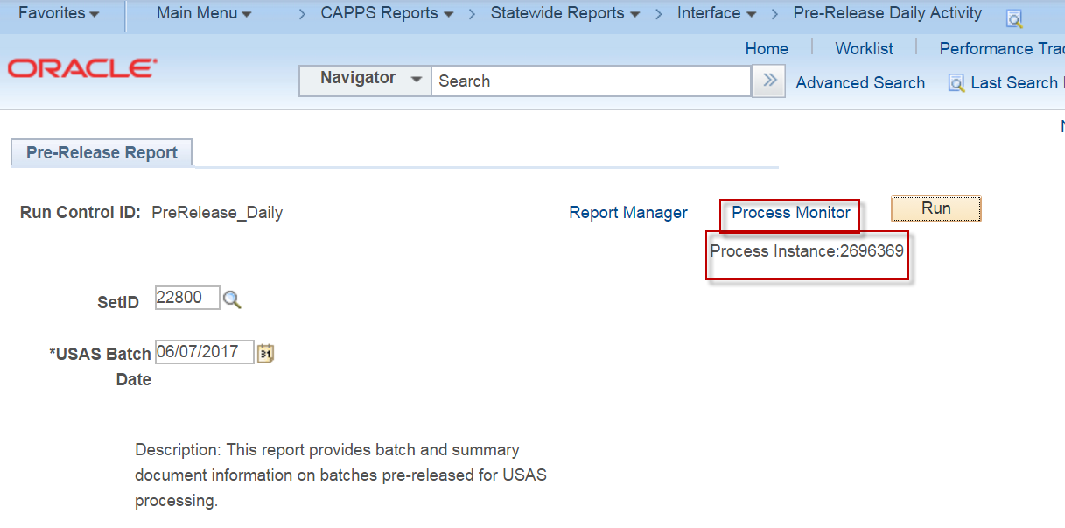
STEP 9
Click the ‘Reset’ button until the Run Status displays ‘Success’ and the Distribution displays ‘Posted’.

Click the ‘Go back to Voucher Posting Request’ link

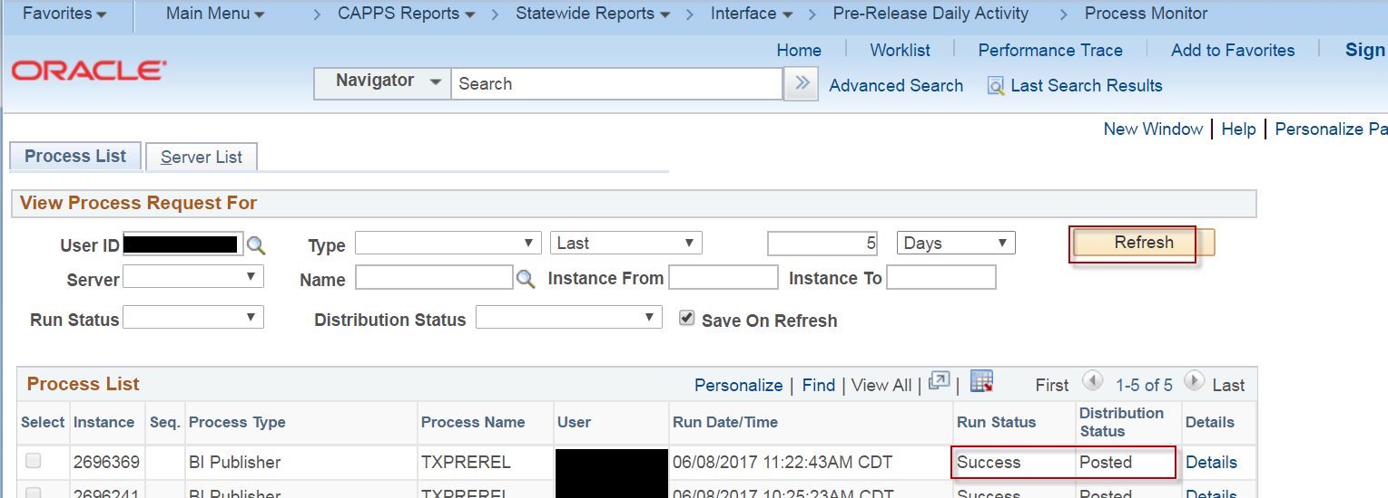

Pre-Release Batches in USAS

SCENARIO NAME
DESCRIPTION: Pre-Release CAPPS batches so that they will process in USAS the same night.
SCENARIO STEPS:
STEP 1
Log into USAS.

STEP 2
Navigate to the USAS 35 screen.

STEP 3
Add the Batch ID for each batch on the CAPPS Pre-Release Daily Activity Report or the USAS Pre-Release report.

