Voucher Entry - Travel Reimbursement for one Employee with Multiple Expenses using the “Regular Voucher” Style
- Main Menu > Accounts Payable > Vouchers > Add/Update > Regular Entry.
'Add a New Value'
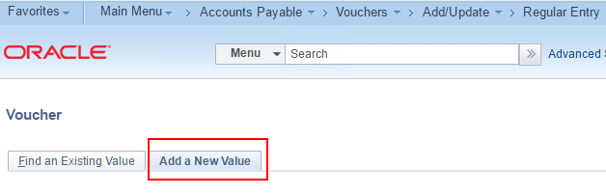
- Enter Voucher Style of “Regular Voucher”, Supplier ID (Employee “7” number), Invoice Number, Invoice Date, and Gross Amount
and click Add.
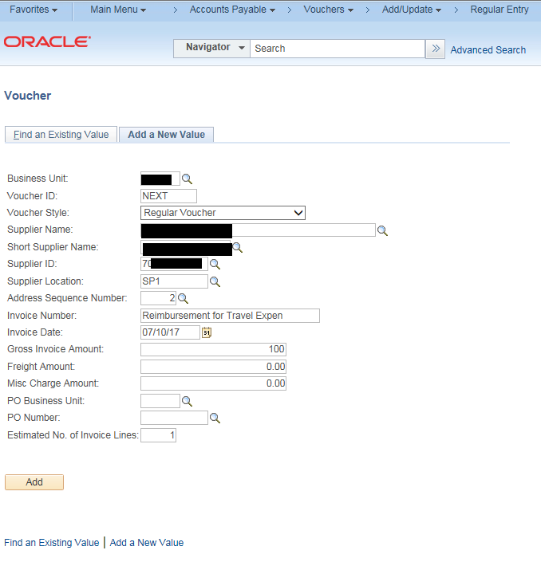
- Verify header information is correct
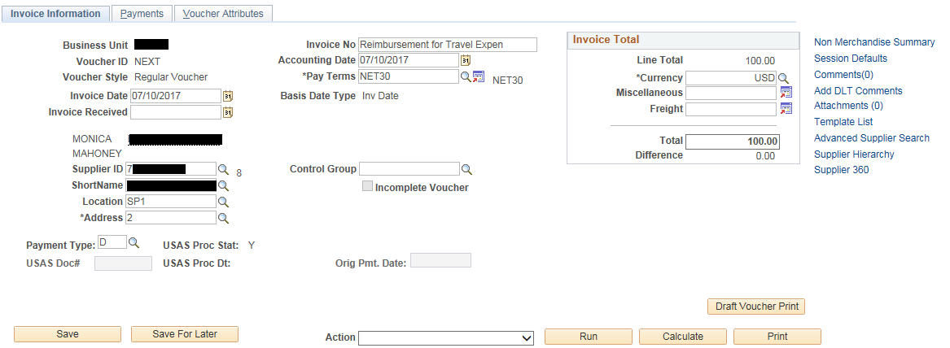

- Enter Invoice Receipt Date, Service Date, Requested Payment Date where applicable, and Invoice Description.
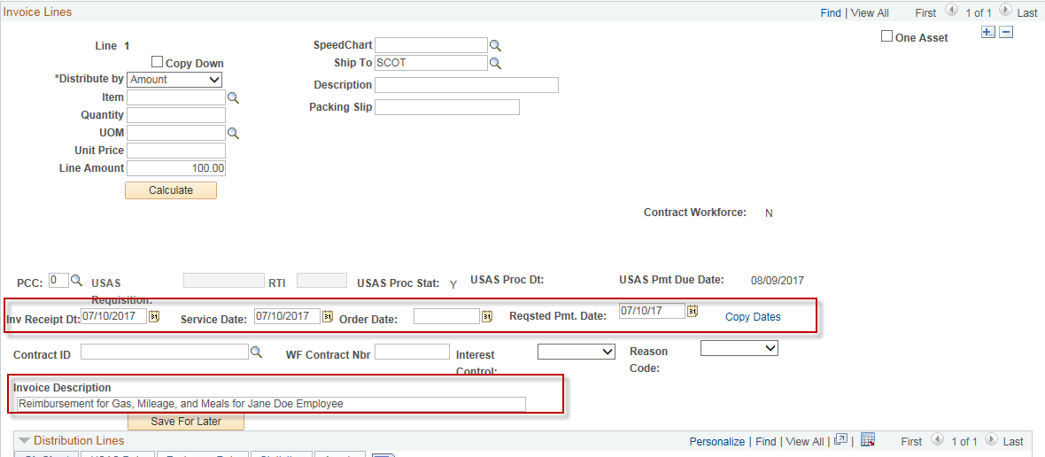.

- Enter the GL Chartfield (Coding Block) information on the voucher Distribution Line.
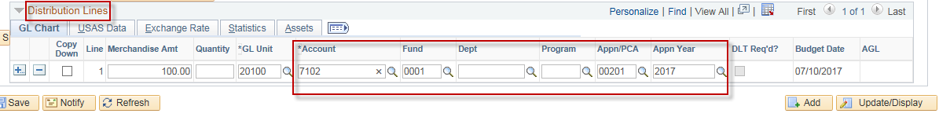
- Click the box in the “Copy Down” column next to the GL Coding line that you just entered.
Click the “+” sign next to the GL Coding line.
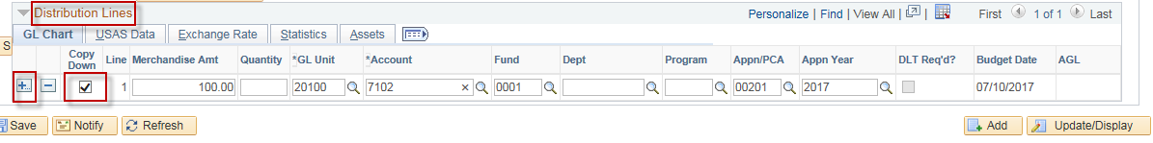

- Enter the number of GL Coding lines that you wish to enter.
Click “Ok”
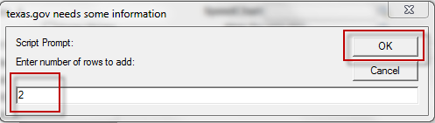

- Enter the GL Coding information for the new GL Coding lines that you just added.
Update the “Merchandise Amt” column to reflect the correct amount for each GL Coding line.
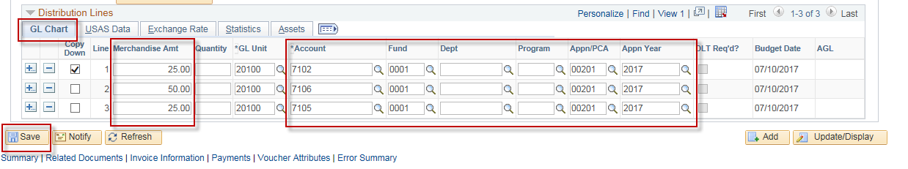

- On the “Voucher Attributes” tab, select the “TRV 225” Accounting Entry Template:
- It is important to select this value as it not only assigns the TCode of 225 but it will also assign a document type of “1” to this voucher when it is sent to USAS.
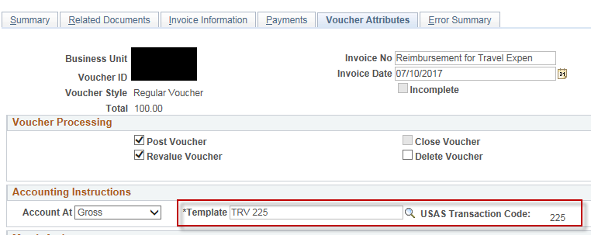

Click “Save”

Note: If you would like to know more about how document types are assigned to your vouchers when they are sent to usas, refer to the job aid “CAPPS Configuration - How USAS Document Types are Assigned to Vouchers”.

