Voucher Entry – “Purchase Order” Box Buttons on Voucher Line

Menu Navigation: Accounts Payable > Vouchers > Add/Update > Regular Entry
Tab: Invoice Information
Section: Invoice Lines
Box: Purchase Order - This box is only available if you are entering a PO Voucher, i.e., if you have copied a Purchase Order or PO Receipt into the voucher.

- “Force Price” checkbox - If you check on this box, then you will not be able to change the Unit Price that came over from the PO. It grays out the “Unit Price” field on the voucher line.
Here is an example screen print of when I clicked on the “Force Price” box:
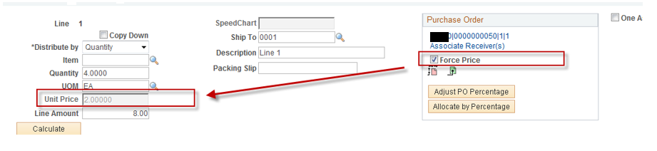

- “Adjust PO Percentage” – When a voucher line has more than one GL Distrib Line associated to it, this button can be used to override the percentages that are distributed across those GL Distrib lines.
If you click on it, then you will notice on the GL Distrib lines that the “Percent” column becomes enabled and you can adjust the percentage allocation across the GL Distrib Lines for that Voucher Line.

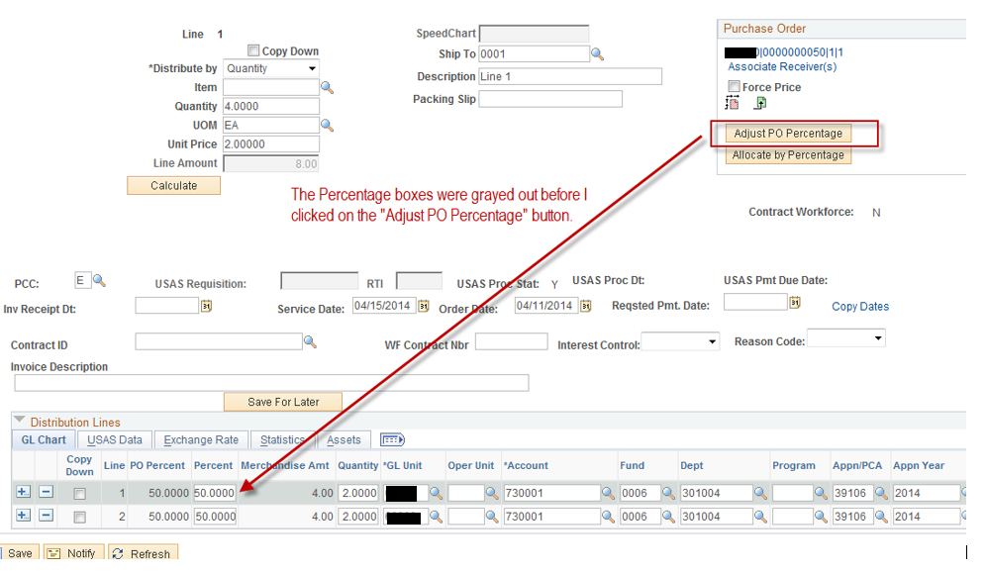

- “Allocate by Percentage” button – after you have adjusted the Percentages (see Item #2 above), then click on this to have it re-calculate the amounts and quantities on the GL Distrib Line:

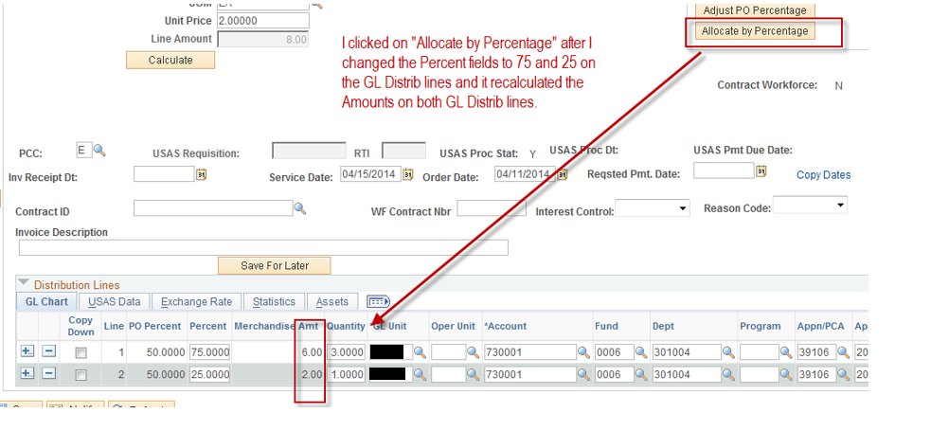

- The “Finalize” and “Undo Finalize” buttons have to do with Commitment Control. The “Finalize” button liquidates the rest of the unused PO Line and also puts that unused amount back into the budget. The “Undo Finalize” button, reverses the Finalize action, i.e., it puts that amount (encumbrance) back onto the PO and also adjusts the budget for that encumbrance.
*** IMPORTANT: It is recommended that you finalize or undo-finalize at or around the time you are entering your voucher. If you finalize/undo-finalize at a later date and your agency has closed the budgets that are applicable to these voucher/po lines, it could cause budget errors when running the budget checking for these vouchers.

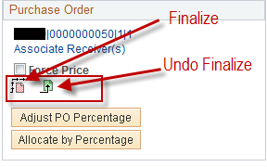

Steps to “Finalize” a PO Line from the voucher:
Navigate to: Accounts Payable > Vouchers > Add/Update > Regular Entry
Click: “Find an Existing Value”
- Search for your applicable voucher
- Select your applicable voucher from the Search results
Tab: Go to the “Invoice Information” tab
Section: Scroll down to the “Invoice Lines” section.
- For each line that you wish to Finalize, click on the “Finalize” icon on EACH of those lines.
Click: “Yes” to Continue
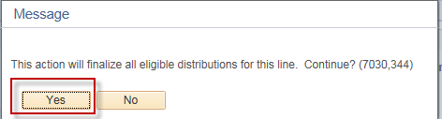
Click: “Save”
Select: From the “Action” drop down box, select “Budget Checking”
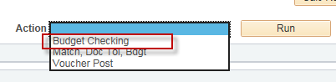
Run: Click “Run”
Completed: Finalize is Complete, i.e., the rest of the respective PO Line(s) is liquidated and the liquidated encumbrance is restored to the budget.

Steps to “Undo-Finalize” for a PO Line from the voucher:
Navigate to: Accounts Payable > Vouchers > Add/Update > Regular Entry
Click: “Find an Existing Value”
- Search for your applicable voucher
- Select your applicable voucher from the Search results
Tab: Go to the “Invoice Information” tab
Section: Scroll down to the “Invoice Lines” section.
- For each line that you wish to Undo the Finalize, click on the “Undo Finalize” icon on EACH of those lines.
Click: “Yes” to Continue
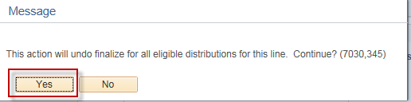
Click: “Save”
Select: From the “Action” drop down box, select “Budget Checking”
Run: Click “Run”
Completed: Undo Finalize is Complete, i.e., the encumbrance is restored to the respective PO line(s) and the budget is updated for that encumbrance.

