Voucher Entry - Travel Reimbursement for one Employee using 247/904 TCode
- Main Menu > Accounts Payable > Vouchers > Add/Update > Regular Entry.
'Add a New Value'
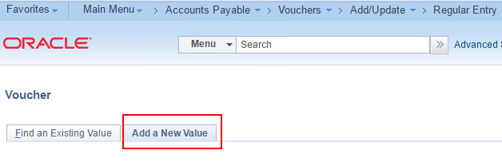
- Enter Voucher Style of “Regular Voucher”, Supplier ID (Employee “7” number), Invoice Number, Invoice Date, and Gross Amount
and click Add.
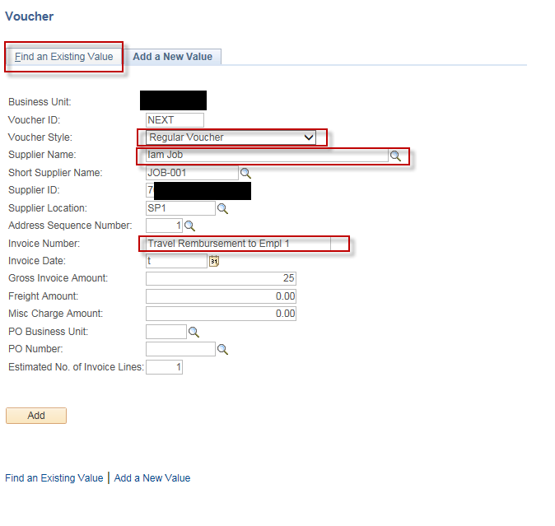
- Verify header information is correct
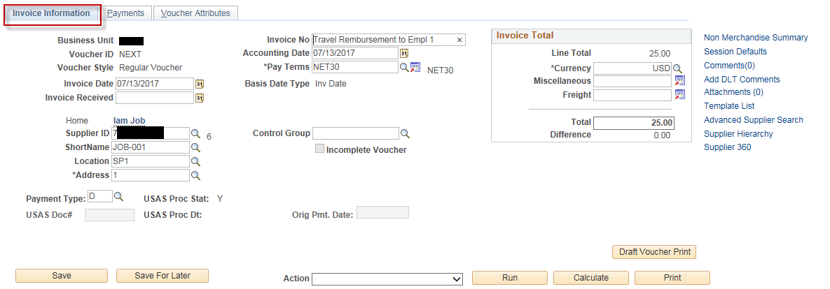

- Enter Invoice Receipt Date, Service Date, Requested Payment Date where applicable, and Invoice Description.
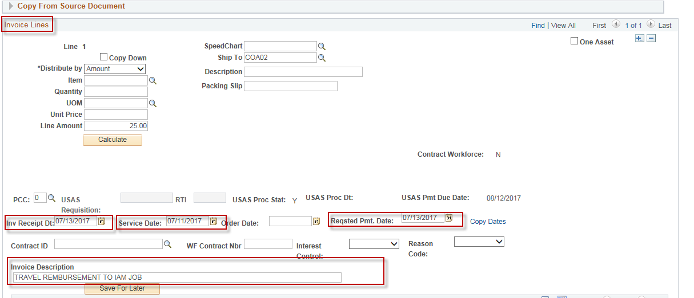.

- Enter the GL Chartfield (Coding Block) information on the voucher Distribution Line.
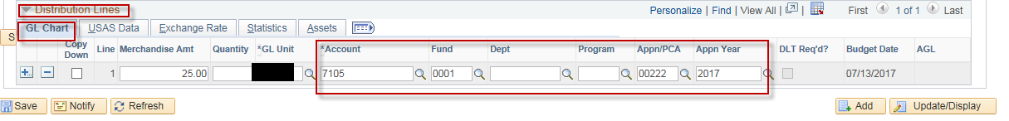

- On the “Voucher Attributes” tab, select the correct Accounting Entry Template:
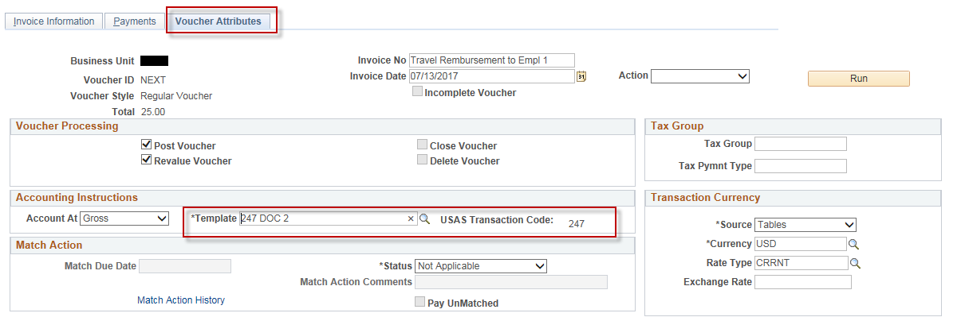

Click “Save”
