Supplier - Inactivate a Supplier in CAPPS
NOTE: The individual that is performing this action must have “Authority to Inactivate” suppliers checked in their User Preferences security.
- Suppliers > Supplier Information > Add/Update > Supplier
- Tab: Find an Existing Value
Enter: SetID, and one or more Search Parameters such as all or part of Supplier Name or Supplier Id
Click: Search
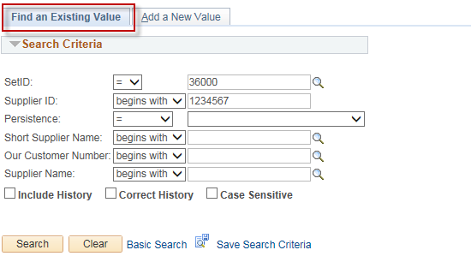
- Select your supplier from the Search Results list by clicking on it:
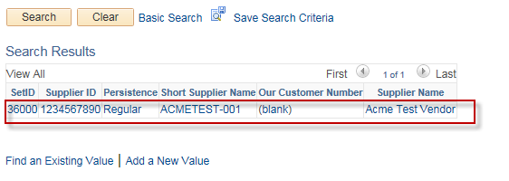
- Tab: Identifying Information
Action: Select “Inactive” in the “Supplier Status” dropdown

Click: Save
