Supplier- Add A Location to an Existing Supplier in CAPPS
- Suppliers > Supplier Information > Add/Update > Supplier
- Tab: Find an Existing Value
Enter: SetID, and one or more Search Parameters such as all or part of Supplier Name or Supplier Id
Click: Search
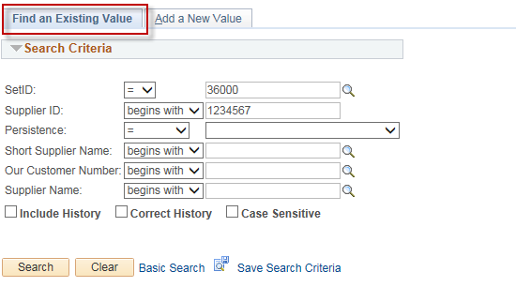
- Select your supplier from the Search Results list by clicking on it:
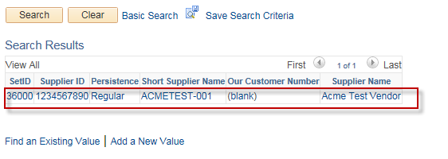
- Tab: Address
Action: Click on the “+” in the “Supplier Address” section
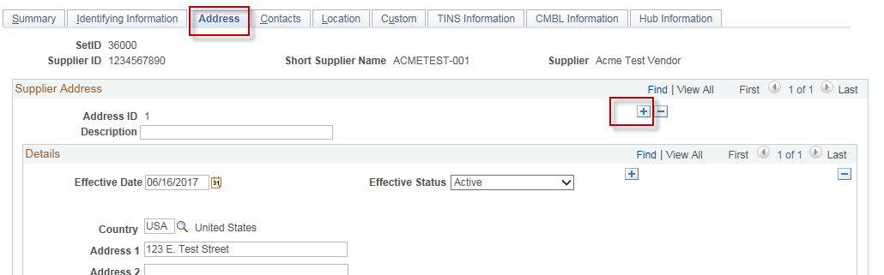

- Enter: Description (optional), Address 1, City, Postal (Zip), State
Click: Save
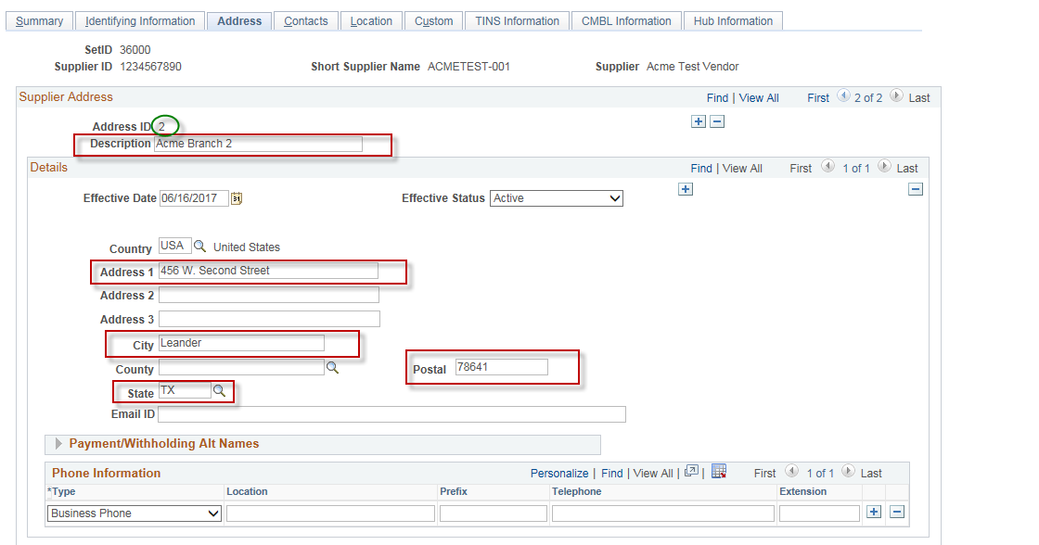
- Tab: Location
Action: Click the “+” in the “Location” section
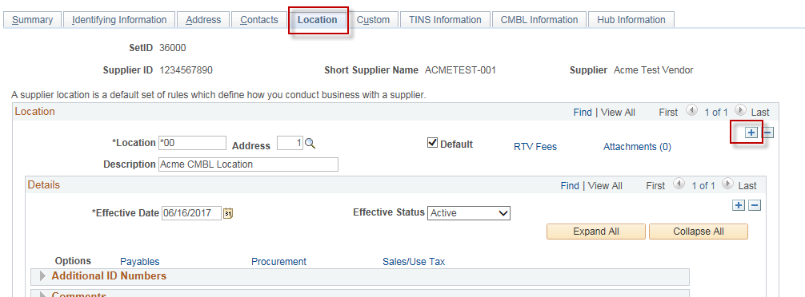

Enter: Location (Mailcode), Description (you see this when entering vouchers in CAPPS)
Select: The new Address in the “Address” drop down
Optional: Click on “Default” if this is the new default location for this vendor, otherwise, leave it unchecked.
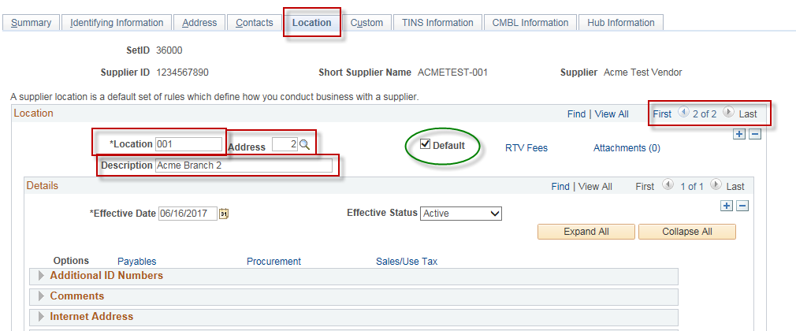

- Tab: TINS Information
Enter: In the “Vendor Location Information” section, enter Location Name (name that will be printed on the Voucher) and Payment Type. If required, entered Bank Type and DD Bank Account Information. The DD Bank Account Information is not used in CAPPS and not sent to USAS, so you can enter dummy values in the DD Bank # and DD Routing # fields if needed.
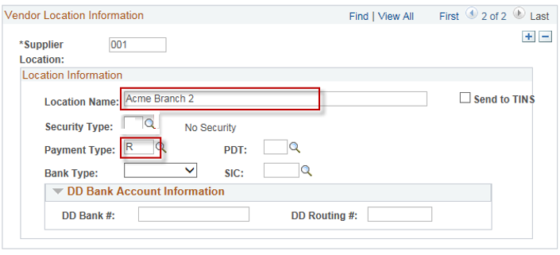
- Click: Save.

