Workflow – How To Set Up A Proxy Approver
- If you plan to be out of the office you can set up a proxy approver to approve requisitions or purchase orders for you.
- The proxy approver must already have the security necessary to approve.
For example, if you approve requisitions for Dept. A and John approves reqs for Dept. B, you can assign John as your proxy approver. Your requisitions for Dept. A will then route to John's worklist/email until the proxy assignment expires.
- Navigate to My System Profile.
- In the 'Alternate User' section, choose your proxy approver.
You can click the Search button (magnifying glass) to search by name or userid.
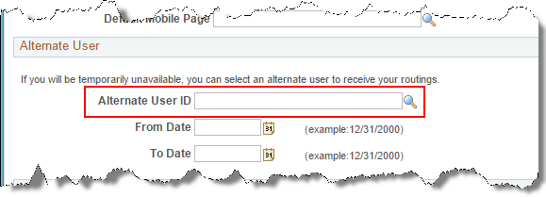
- You must enter a date range that the proxy will be active.
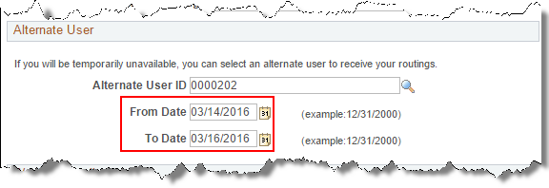
- Click 'Save' at the bottom of the page.
- During the date range specified, requisitions or POs that you would normally approve will flow to your proxy and not to you.
- When you return to the office, you can get a quick look at which new requisitions were entered and/or approved by going to the Manage Requisitions page.
For step by step instructions on using Manage Requisitions, see the document "MANAGE REQUISITIONS – Search Requisitions".

