PO– Dispatching and Filing
Tips on How To:
- Email the PDF version of the Dispatched PO to the Supplier
- File the PDF and Email for easy retrieval
- Run the PO Dispatch process ( see 'PO Entry – Basic PO Entry', page 7, step 15).
- The PDF version of the PO that was generated by the Dispatch process will be located on the Administration tab of the Report Manager.
> Save this page to your Favorites menu since you will be using it often.
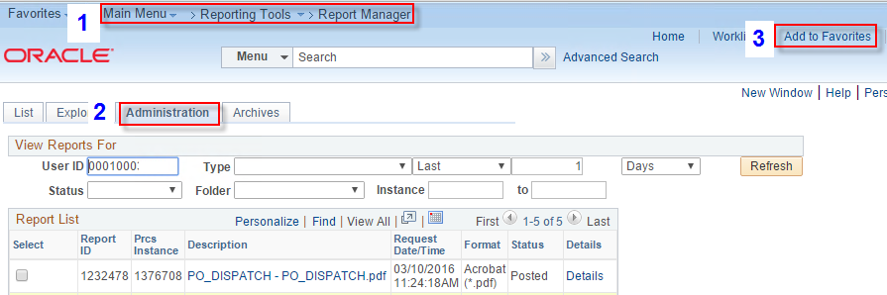
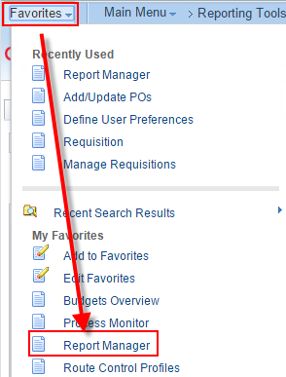
- Open the PDF version of the Dispatched PO by clicking the hyperlink in Report Manager.
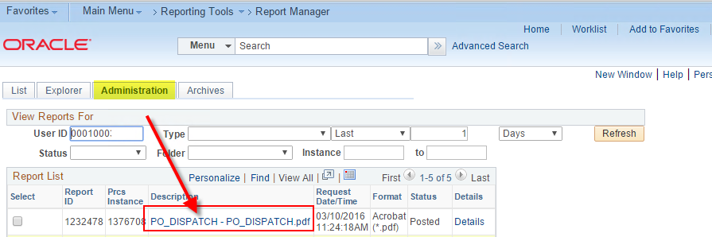
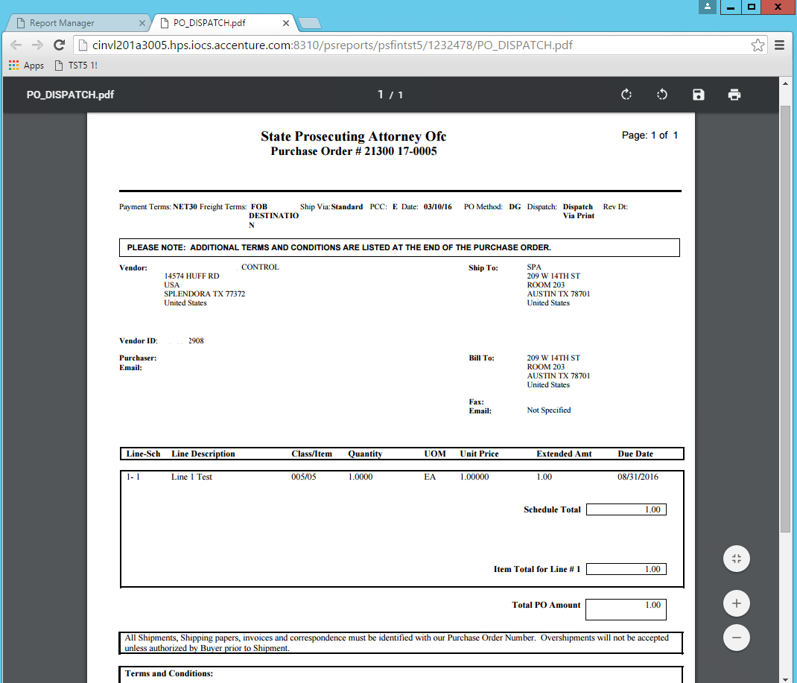
- Save the PDF to a folder you create on a network drive (not your C drive).
Name the folder something like 'Dispatched POs'.
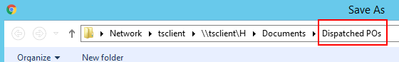
- Suggested naming convention for your PDFs:
Name the PDF beginning with the PO ID and ending with the Supplier name. 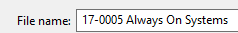
- Save the PDF again, this time naming it with the Supplier name first and PO ID last.
- This allows you to come back and find a PO
numerically by PO ID or
alphabetically by Supplier name.
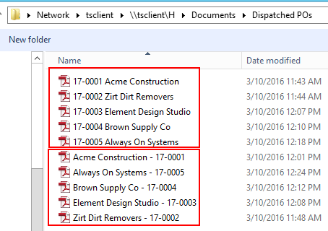
- Attach the PDF to an email addresed to the Supplier's contact person.
- Consistency in the way you use the Subject field pays dividends when you need to find the email later.
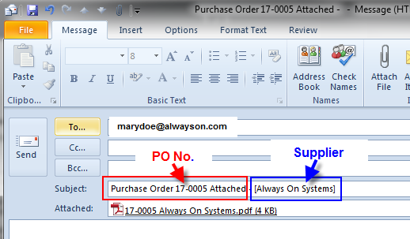
- Drag the email from your Outlook Sent Items folder to an Outlook folder not on your C drive named something like 'Dispatched POs'.
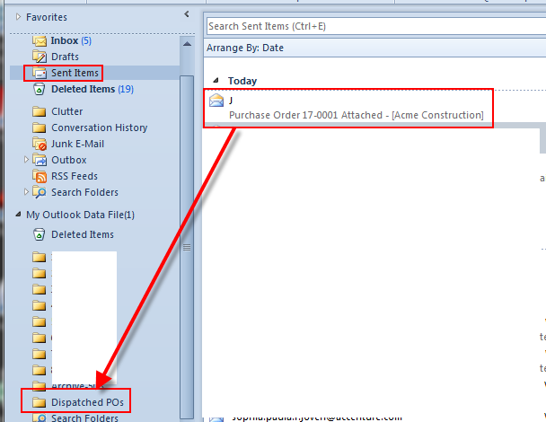

- Finding emails in your Dispatched POs folder months later is easy when you
- use the Subject field consistently, e.g. "Purchase Order 17-0001…." and
- include the Supplier name in the subject.
