PO – Reserve PO Numbers
- PO numbers can be reserved for later use if you need to protect a batch of consecutive numbers. A common example would be reserving a set of consecutive PO numbers for the beginning of the next fiscal year.
Note: Your agency must use PO Autonumbering in order to reserve PO numbers.
When you create a new purchase order, if you let the system generate the number for you, that means you do use autonumbering and you can reserve PO numbers.
Note: This process of reserving PO numbers has a couple of critical steps to make sure you create the exact PO numbers you intend to create. It's a good idea to try it in the Maintenance environment (MNT) first. The whole process takes only a minute or two. Better to do a practice batch in MNT rather than being stuck with the wrong PO numbers in Production.
- Navigate to the Reserve PO IDs page as shown below.
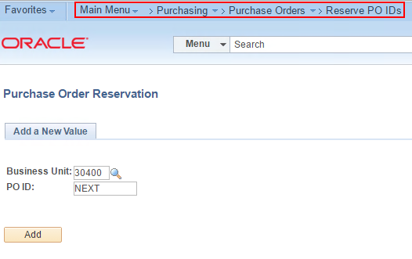
- If you want the first PO number to be 18-0000001, then enter 18-00000 in the PO ID field. Click Add.
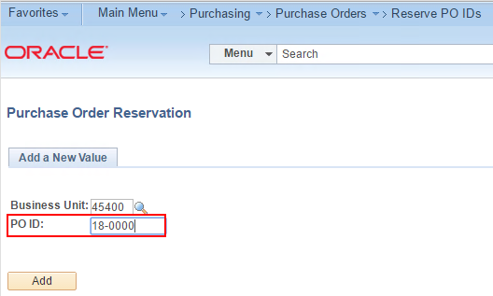
- Click OK on the message.
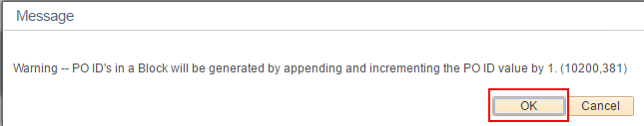
- PO numbers must be reserved to a specific Supplier, but no worries, the Supplier can be changed on the PO later.
If you want to reserve 10 POs, enter 11 in the 'Number of PO's' field as shown below.
Click 'Save'.
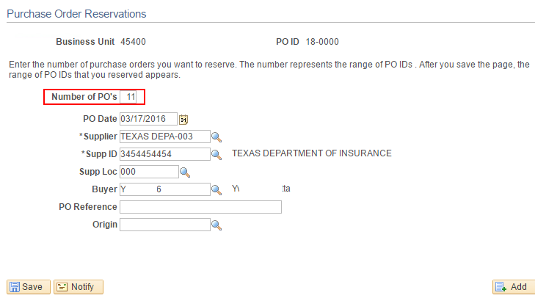

- Navigate to the Add/Update POs search page, enter the beginning digits of the reserved PO IDs and click Search.
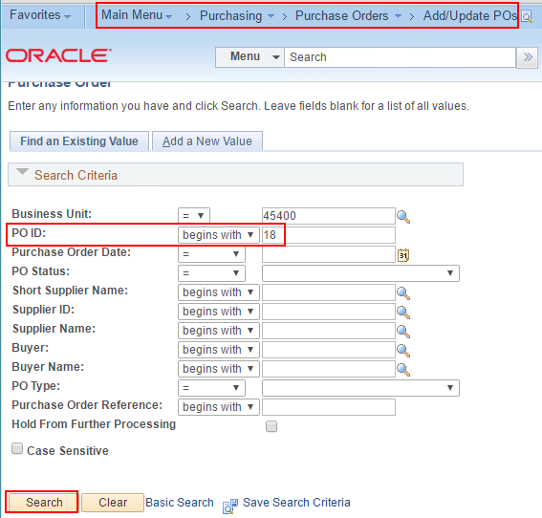
- You should see the PO IDs you wanted and one straggler.
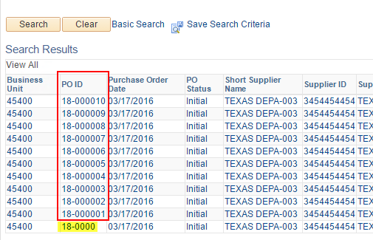
- Click on the straggler, '18-0000' in this example.
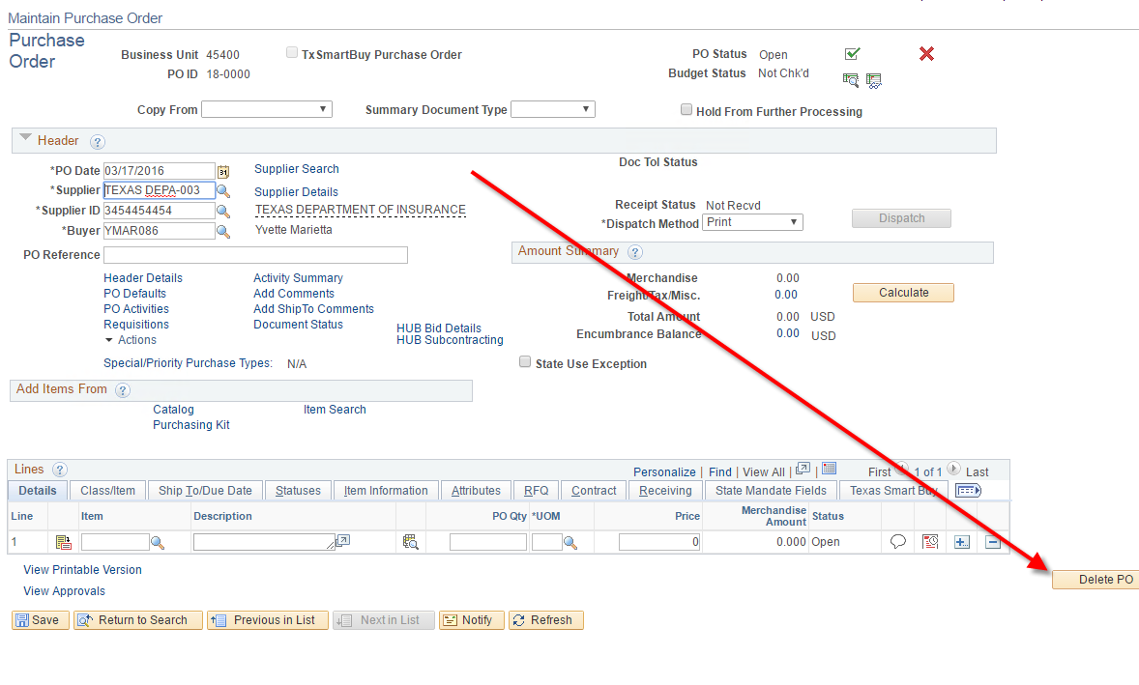
- Click the 'Delete PO' button.
- Now your list contains only the PO numbers you want.
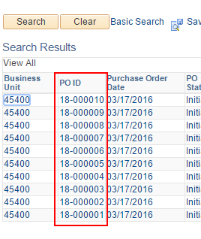
- When you open one of the Reserved purchase orders you will see that it is an empty shell containing Supplier and Buyer. You can change the Supplier before or after sourcing requisitions to the PO.
