MANAGE REQUISITIONS – Tracking Your Order
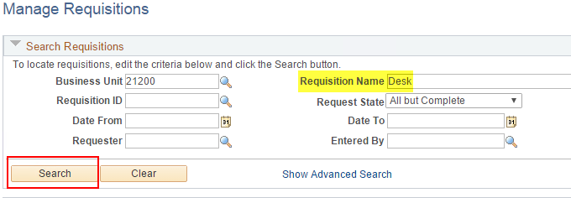
- Req is waiting to be approved.
- Req is approved and waiting to be budget checked.
- Req is available to be sourced to a Purchase Order.
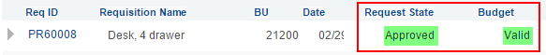

- Req has been sourced to a Purchase Order. PO is not dispatched yet.
Open Request Lifespan view. Colored icons show which stage the order is in.
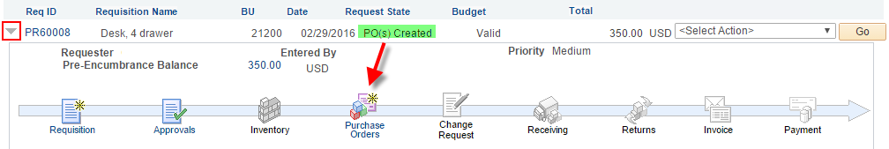
Click the colored icon to view document details such as the PO Number.
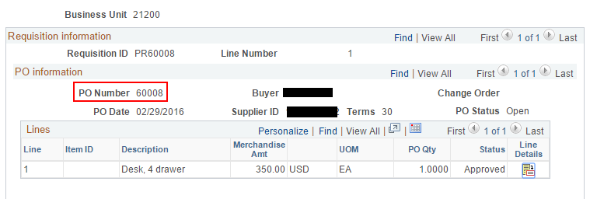
- The PO has been Dispatched, but not received or vouchered.
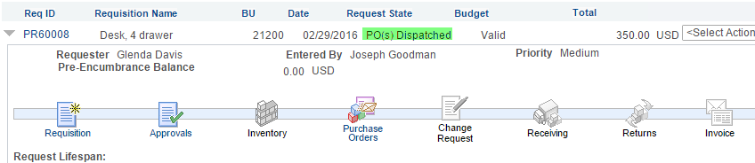

- The PO has been Received, but not vouchered.
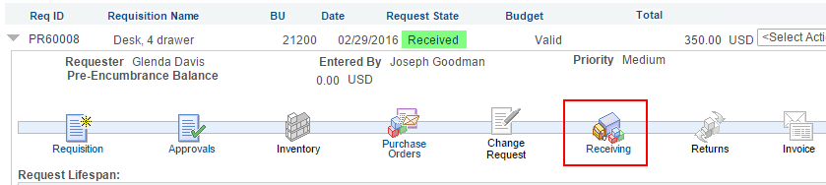
Click the colored icon to view document details such as the Receiver ID.
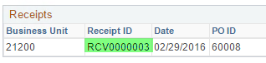
- A voucher has been entered, indicated by the colored Invoice icon.
We don't use the Payment icon because payments are issued from USAS.
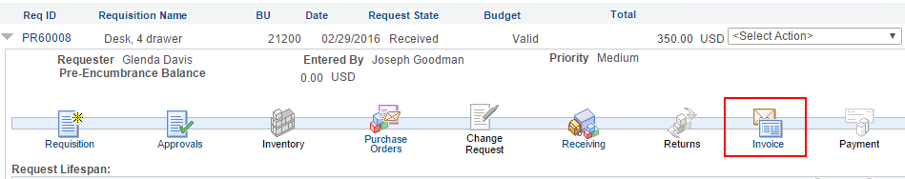
Click the colored icon to view document details such as the Voucher ID.
