Requisition – ProCard
- Begin the 'Requisition Name' field with 'PROCARD' in ALL CAPS. This allows ProCard requisitions to be identified as such when the Buyer searches for ProCard reqs from inside the PO. Feel free to include any additional text after 'PROCARD'.
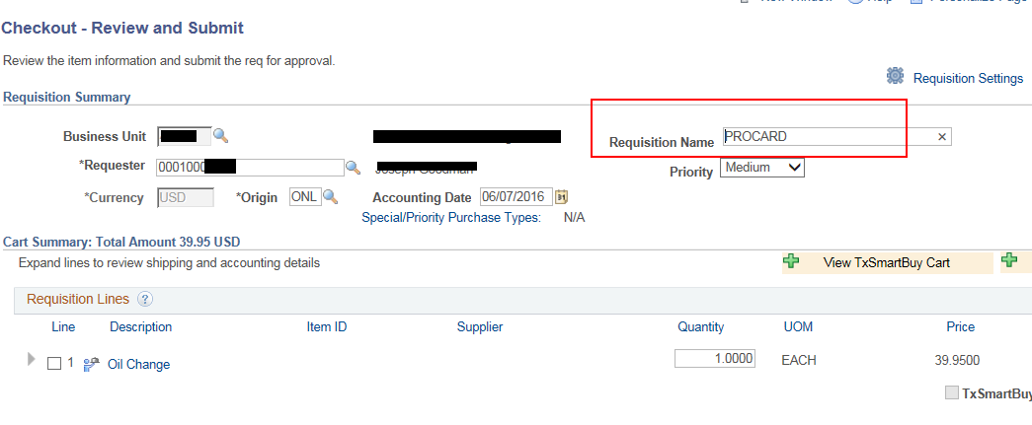
- Include a Supplier on each line of a ProCard requisition. This supplier will display on the voucher line when Voucher Style 'Procard Voucher' is used. The voucher will pay the header Supplier, e.g. Citibank. The supplier on the lines of a Procard Voucher are for reference purposes. The voucher must pull this information from the requisition, not the PO, which makes it important to include the Supplier on each line of a Procard requisition. If the Supplier doesn't exist in CAPPS, the requester can enter the supplier in the line comments of the requisition.
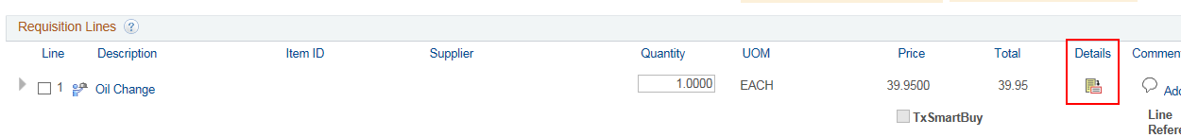
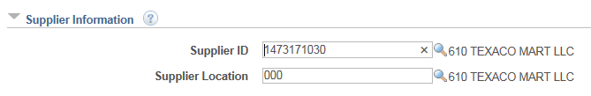

The above two items are the only additional considerations for ProCard requisitions. Aside from these two items, a ProCard requisition is just a requisition.

