Receiving – Basics
- Navigation to enter a new Receipt.
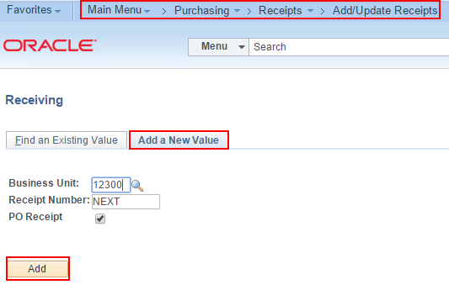
Your first time, Add to Favorites.
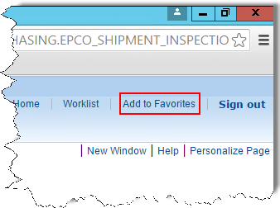
You can customize how it appears in your Favorites menu.
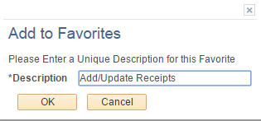 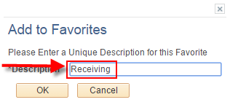
- Fetch the PO you want to receive.
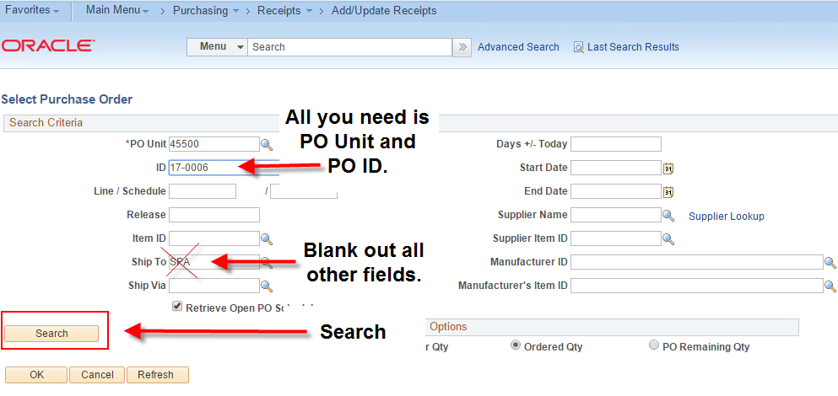
- Find the PO Lines you want to receive.
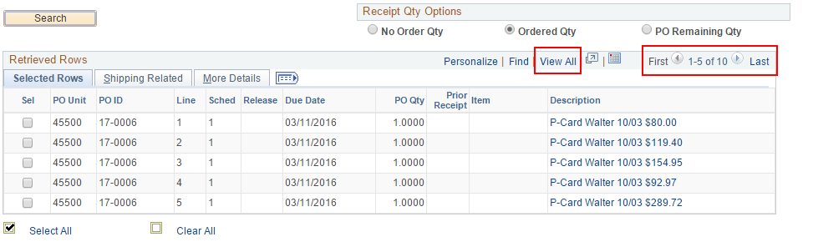
- Selelct individual lines or Select All.
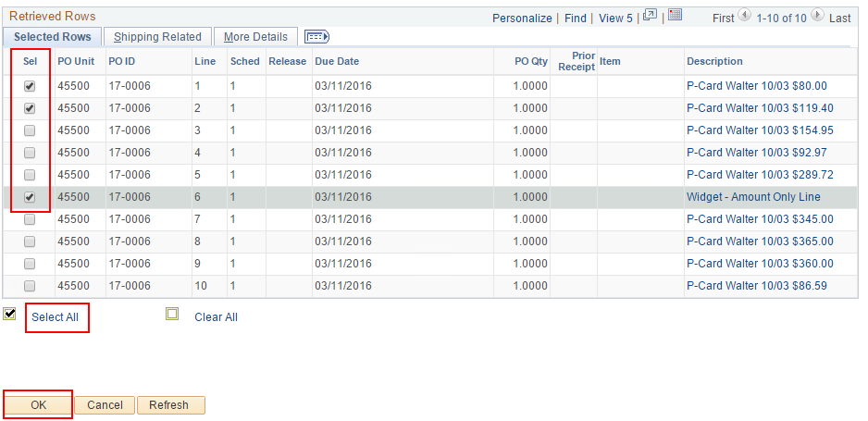
- Important. Do not over-receive. Change the Qty or Price to match the actual Qty or Amount received or invoiced before clicking the Save button.
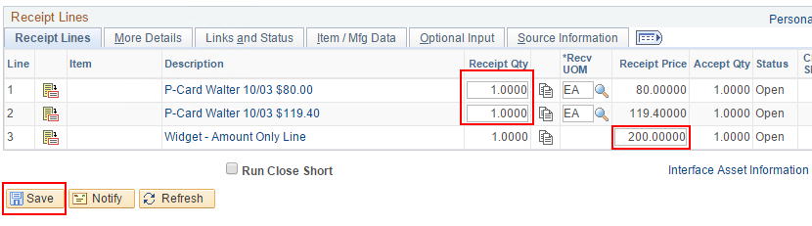
- A confirmation message will appear. Click OK.
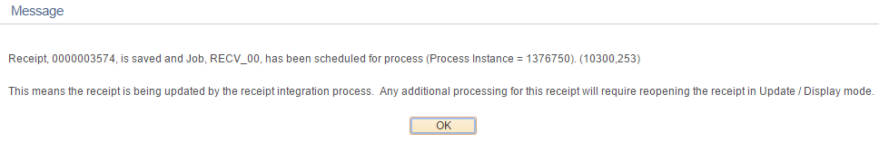
- Receipt ID is created. The Receipt Status will show 'Fully Received' even if you only partially received the full quantity or amount on the PO. It simply means you fully received the quantity or amount you wanted to receive in this one Receipt.