Desk Aid – Balance Adjustments

Summary:
This Desk Aid will explain how to adjust balances for
- Earnings
- Taxes
- Deductions

Earnings:

Steps:
- Navigate to the page to adjust balances for earnings.
- Enter required values, save Adjustment.
- Review Adjustment.

- Navigate to the page to adjust balances for earnings.
Navigation:
Main Menu > Payroll for North America > Periodic Payroll Events USA > Balance Adjustments > Earnings
Screen Shot:
Search Page:
Use the search page to look up the Employee for whom the Adjustment needs to be made, click Search.
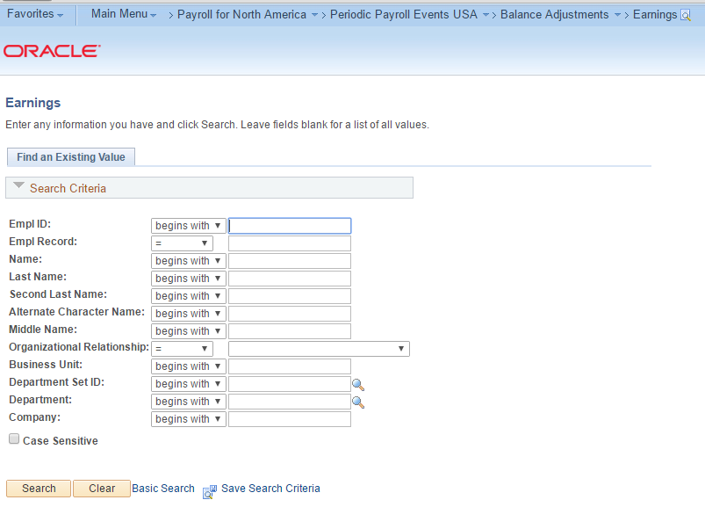

- Enter required values: Company, Balance ID, Year, Period, Earnings Code. Click Save.
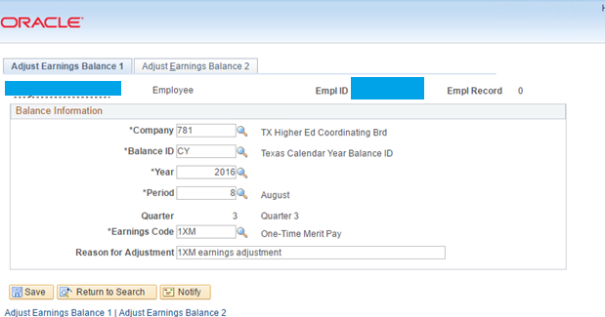

Enter the values that need to be adjusted, click Save:

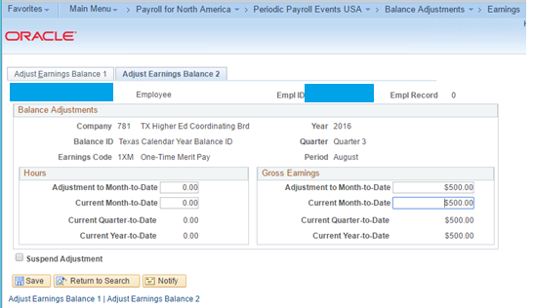

- Review Adjustment: Navigate to the page to review balances for earnings.

Navigation:
Navigate to: Main Menu > Payroll for North America > Periodic Payroll Events USA > Balance Reviews > Earnings

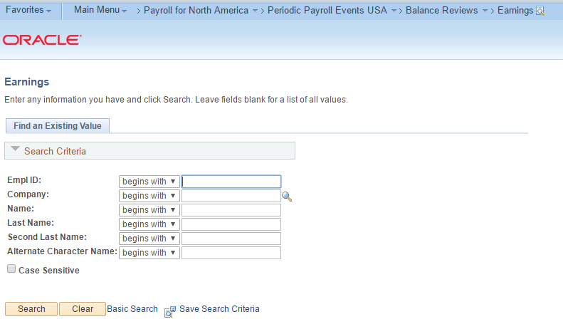
Look up the Employee, navigate to the adjustment done for Verification.

Screen Shot:

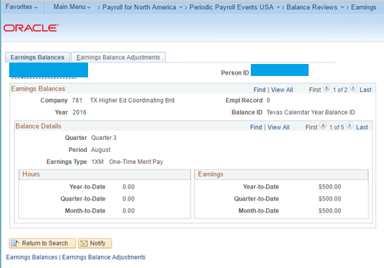

Deductions:

Steps:
- Navigate to the page to adjust balances for deductions.
- Enter required values, save Adjustment.
- Review Adjustment.

- Navigate to the page to adjust balances for earnings.
Navigation:
Main Menu > Payroll for North America > Periodic Payroll Events USA > Balance Adjustments > Deductions

Screen Shot:
Search Page:
Use the search page to look up the Employee for whom the Adjustment needs to be made, click Search.
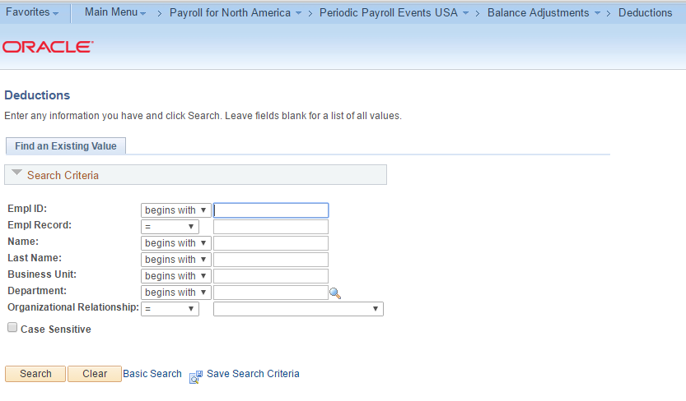

- Enter required values: Company, Balance ID, Year, Period, Plan Type, Deduction Code, Deduction Class. Enter appropriate non-required fields. Click Save.
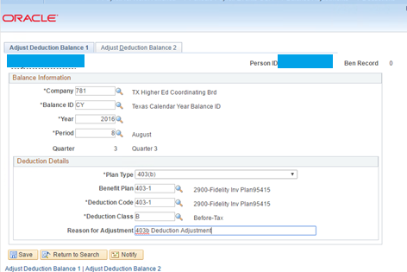
Enter the values that need to be adjusted, click Save:
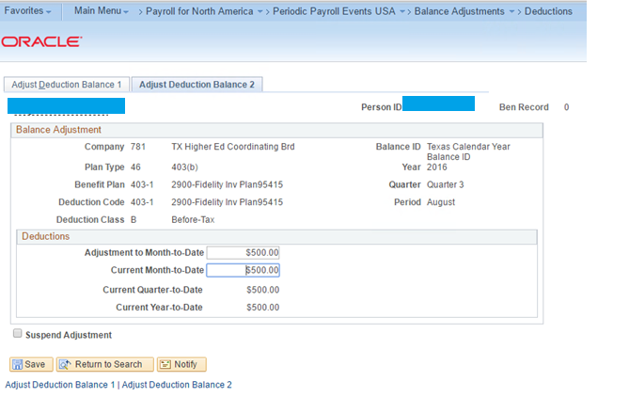

- Review Adjustment: Navigate to the page to review balances for deductions.

Navigation:
Navigate to: Main Menu > Payroll for North America > Periodic Payroll Events USA > Balance Reviews > Deductions
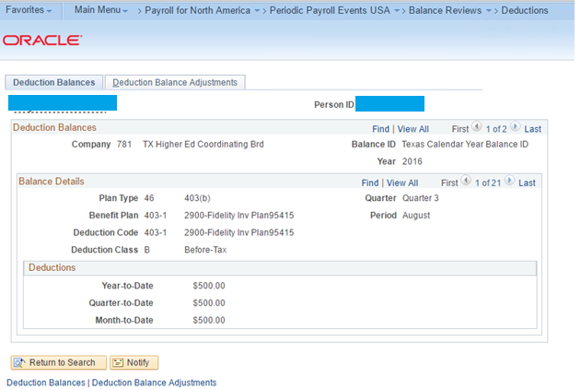

Taxes:

Steps:
- Navigate to the page to adjust balances for Taxes.
- Enter required values, save Adjustment.
- Review Adjustment.
- Navigate to the page to adjust balances for earnings.
Navigation:
Main Menu > Payroll for North America > Periodic Payroll Events USA > Balance Adjustments > Taxes

Screen Shot:
Search Page:
Use the search page to look up the Employee for whom the Adjustment needs to be made, click Search.
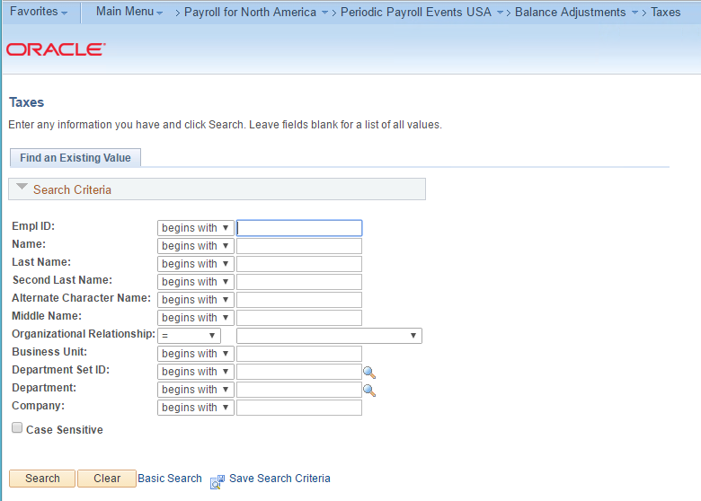

- Enter required values: Company, Balance ID, Year, Period, State, Tax Class. Enter appropriate non-required fields. Click Save.

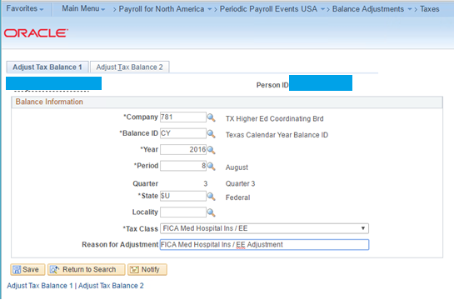

Enter the values that need to be adjusted, click Save:
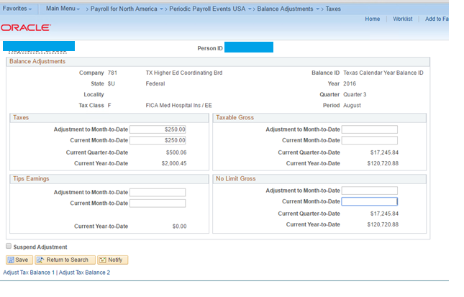

- Review Adjustment: Navigate to the page to review balances for deductions.

Navigation:
Navigate to: Main Menu > Payroll for North America > Periodic Payroll Events USA > Balance Reviews > Taxes

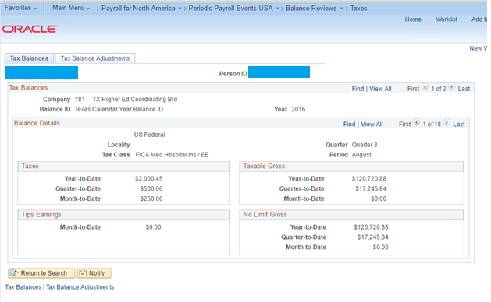

NOTES
- Use standard naming convention
- Place all desk aids on the shared drive under CAPPS Processes - N:\HCM\CAPPS FM- Processes,Req,Config,Scripts\CAPPS Business Processes,Documentation\Process Documentation,Aids,Helpful Hints\HR,Benefits & Position Management
- Open the footer and click in the template file name then right click and select Update Field to auto change to your file name
- Follow the outline of this template
- Add additional data and/or notes at the end of the document

