Reviewing Paychecks
There are two “Review Paychecks” processes.
- Main Menu > North American Payroll > Produce Payroll > Review Paychecks
- Under this menu item the Super Users can review an employee’s Paycheck regarding their Earnings, Deductions and Taxes. In addition, it will show taxable grosses used for calculating Taxes, Retirement and Savings plans.
- Using this “Review Paycheck is for the Payroll user and should be used to review employee’s paychecks after Preliminary Calc, Final Calc, Confirm, and TX SPRS Doc Info to:
  - Review calculations Gross to Net
  - If an employee received a special pay - ensure it calculates correctly
  - Overall review of your payroll calc- spot checking a few employees.
  - In the event that an employee has questions about their paycheck
  - Review SPRS Payment Information (after SPRS processing is complete)

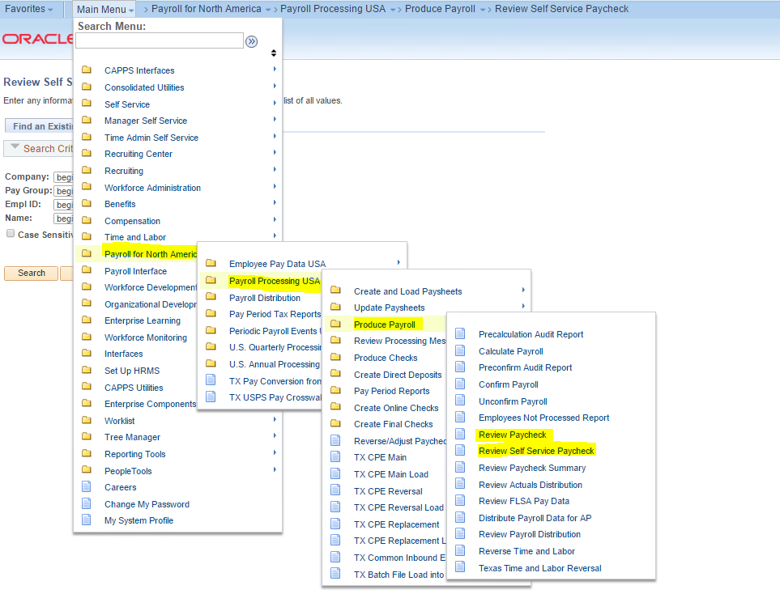

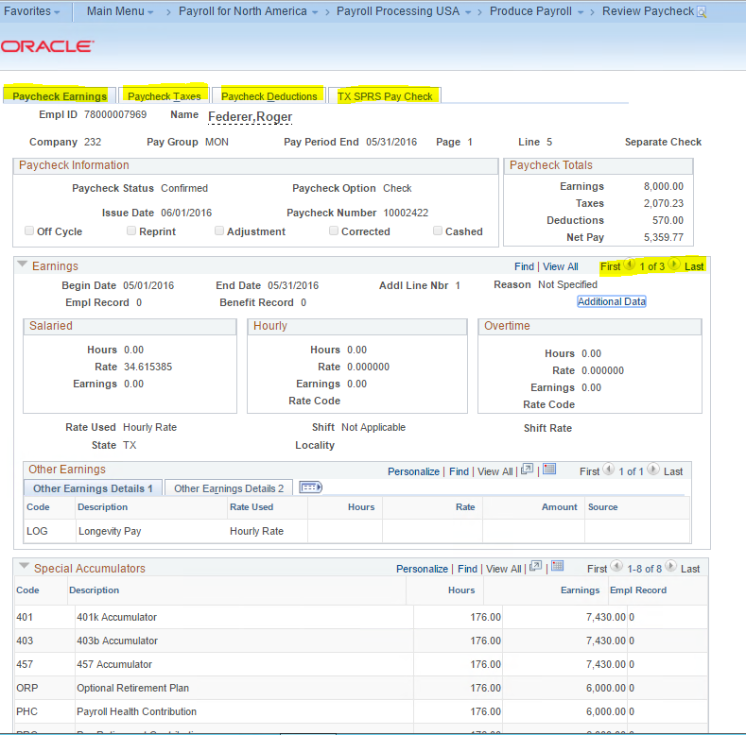

- Main Menu > North American Payroll > Produce Payroll > Review Self Service Paycheck
- Under this menu item the Payroll Super User can review the employee’s paycheck as the employee would review it in their Self Service Paycheck. This is essentially their Earnings Statement/Paystub.
- This allows the Payroll Super User to see what the employee sees, if the employee has questions about their paycheck.
Important:
- Employees will be able to see their paycheck AFTER payroll documents have been created, accepted by USAS and the document status has been update to “USAS Accepted”
  - THIS ONLY ALLOWS THE EMPLOYEE TO VIEW THEIR PAYCHECK AND THEY ARE NOT ACTUALLY PAID.
- Employees will not see their deposit or “Get Paid” until the actual Paycheck Due Date (generally the 1st of the following month)

