CAPPS Employee Training

Log into CAPPS
- Enter the URL https://entprtlprd.cpa.texas.gov/ in a browser window.
HINT: You can add this web address to your Favorites for easy access later.
- Click on the Authorized Use Disclaimer page.
HINT: You should have received an email with a temporary password and instructions to reset. If you did not change your password, contact your Security Administrator at _______________.
- Enter your User ID and Password.
- Click

CAPPS Login Screen
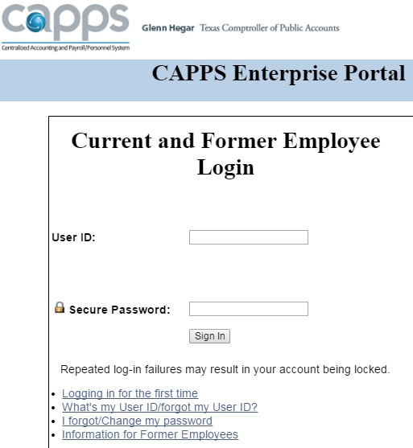

HINT: CAPPS will lock your account after 3 failed login attempts.
HINT: If you set up a Password Hint previously, you can click on I Forgot/Change my password to reset it.

For Help
Contact the following resource if you need additional assistance with logging into CAPPS:
Insert your agency specific instructions here, including your security administrator’s contact information.

Enter Leave Time Taken or Time Earned Online
- Click the My Time & Leave button from the CAPPS main menu.
CAPPS Main Page: Access Time & Leave
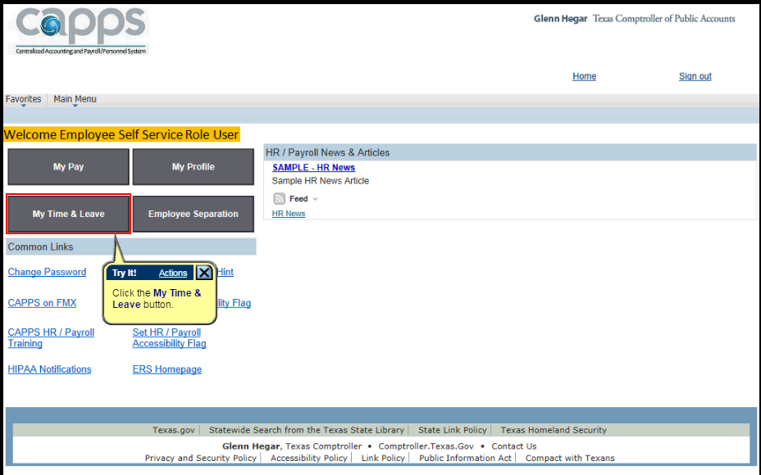
- Click on in the middle of the page.
- The date defaults to the 1st of the current month, but it can be changed if needed.
- Click to view the timesheet.
- In a blank row, enter the appropriate Time Reporting Code (TRC) for the day you earn time or use leave.
HINT: If you don’t see a blank row, click the Add a New Line button.
Example Timesheet: Enter Time Reporting Code

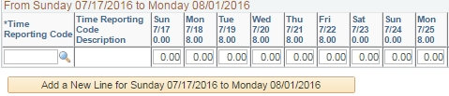
ANLVT
- Commonly used TRCs
ADMLT | Administrative Leave Taken | May be awarded for outstanding performance
ANLVT | Annual Leave Taken | Vacation Leave Taken
COMPT | Compensatory Time Taken | Use when you take Regular Comp Time
REGHR | Regular Hours Worked | Use when you work over your scheduled hours
REGHW | Reg Hours Worked on Holiday | Use to record hours worked on a holiday (8 hrs max)
SICKT | Sick Leave Taken | Use when you take Sick Leave

- Click to save the entry. Your time will be submitted for approval.
HINT: You will receive an email notification when your time has been approved or denied.

View/Print Employee Monthly Time Report
The Employee Monthly Time Report displays the following information for a particular month: a) beginning/ending leave balances; b) leave accrued/earned; c) leave expiring; d) current annual balances; e) projected accruals; f) carry over maximum.
- Click on the My Time & Leave button from the CAPPS main menu.
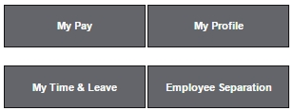

- Click on
- The As of Date defaults to the last day of the current month, but it can be changed if needed.
HINT: Select the last day of the month you wish to view.
- Click and the following message will display:
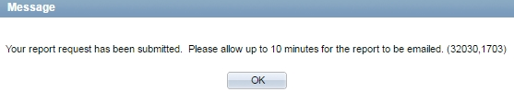

- Click
HINT: This report will be emailed to you and usually does not take that long to generate.
Sample Monthly Time Report Email
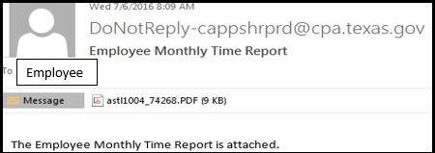

- Double-click on the attached PDF, as shown above.
- Click the button to print the report.
HINT: The Report will only display the month you chose for the As of Date, but you can always run the report again for a different month.

Print your Earnings Statement Online
- Click on the My Pay button from the CAPPS main menu.
- Click on
- Click on the Check Date for the earnings statement you wish to print.
- Press the Ctrl and A keys to select all text.
- Right-click anywhere on the earnings statement, and choose Print.
HINT: If you want the print to be a little larger, change your Layout option from Portrait to Landscape. It will print on 2 pages.
- Click the Print button.

Time Certification
Time Certification is the digital equivalent of signing a paper timesheet to verify that you have submitted time and leave for the previous month.
- Click on the My Time & Leave button from the CAPPS main menu.

- Click on
- When you certify time, you agree to the following:
As of this date and time, by clicking on the "E-Sign & Certify" button, I (NAME, EMPLID) certify that, for the month immediately prior to the date of this certification: I have physically worked all my scheduled hours except those hours accounted for by leave; and I have entered all leave requests. I acknowledge the Court requires and, I received, prior written approval from my supervisor before I worked additional hours outside my regular work schedule. Additionally, for federal compliance any deviation from my regular work schedule has been reflected.

Time Certification Page
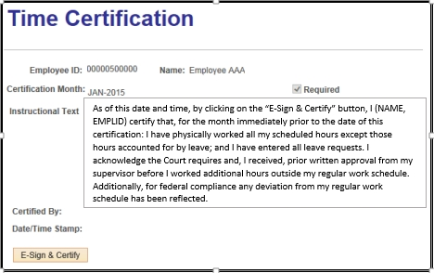
- Click to certify the time you entered for the previous month.
HINT: You can also certify your time by using the Time Certification link at the bottom of your timesheet.

