CAPPS 1st Time Login and Password Setup

Initial CAPPS Login Emails

HINT: On August 8, 2016, you will receive 2 emails from the CAPPS system.

- The 1st email will contain your User ID.
- This User ID is an 11-digit number, but it is NOT the same as your Employee ID.
- The sign-on URL is not included in these system-generated e-mails for security purposes.

Example: 1st CAPPS Email with User ID
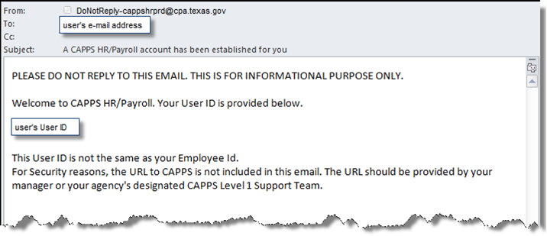
- The 2nd email will contain your initial temporary CAPPS Password.
- The temporary password email will contain a generic subject line such as “Information.”
- This temporary password will expire after 72 hours.

HINT: Please check your JUNK folder, if you don’t receive these initial emails on August 8.

For Help
Contact the following resource if you don’t receive the initial login emails from CAPPS or if have trouble signing on:

Insert your agency-specific instructions here, including your security administrator’s contact information xxx-xxx-xxxx.

Logging in
- Enter the URL https://entprtlprd.cpa.texas.gov in a browser window.
- Click on the Authorized Use Disclaimer page.
Restricted Government System Warning Page
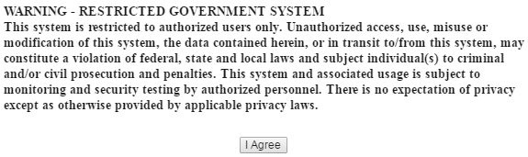

- Enter your User ID (from 1st email) and temporary password (from 2nd email).
HINT: Be sure to keep your User ID for later reference.
- Click

CAPPS Login Screen
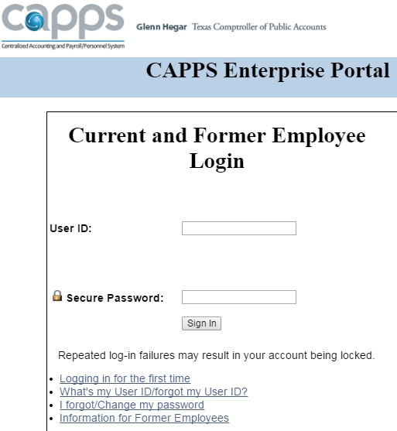

HINT: You will be prompted to change your password. See the next page for Password rules.

Changing Password
- Click on the link to change your password to something only you would know.
Change Password Link
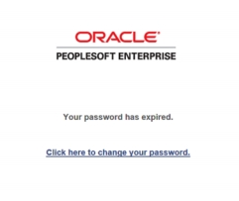
Password Rules
- Must be at least 8 characters long.
- Must contain an uppercase letter.
- Must contain at least one number.
- Must contain at least one special character such as ! @ # $ % & *
- Passwords cannot be reused.

- Enter the temporary password (from the 2nd e-mail) as the *Current Password.
- Enter and confirm a new secret password of your choosing.
- Click button.
Change Password Screen
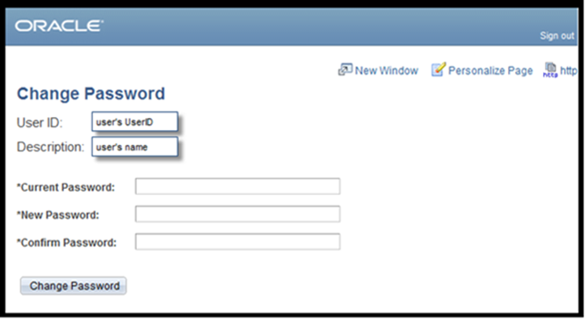
HINT: You will receive a message that your password has saved successfully.
- Click

Setting up a Password Hint
HINT: Setting up a Password Hint helps if you ever forget your Password.
HINT: Once you set up a Password Hint, then you can click on I Forgot/Change My Password from the CAPPS login page.
- Select and then
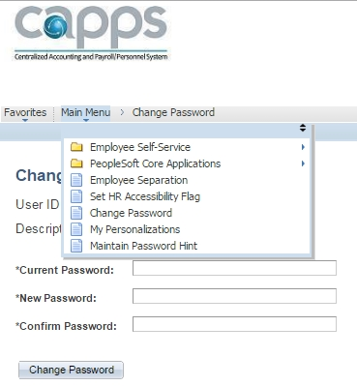

- Click the Question dropdown arrow to choose a question for the forgot password function:
Set Up Password Hint
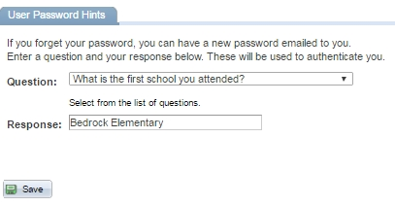
- Enter a Response that only you will know.
- Click
Congratulations! You have successfully logged into CAPPS, changed your Password and set up a Password Hint. Now you’re ready to use CAPPS!

