Enroll in 457 Catch Up
Navigation: Main Menu>CAPPS Interfaces>Benefits>Inquire>Texas Saver Results
This is the Texa$aver file load (viewed on the inquiry page)
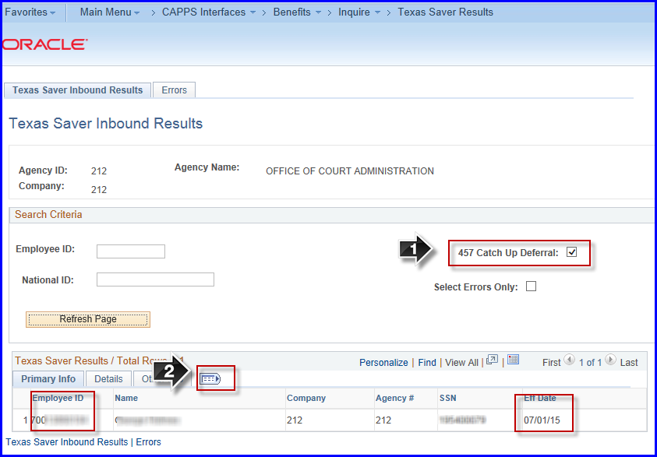
- Check to find Catch Up Deferrals
- Click to open all tabs
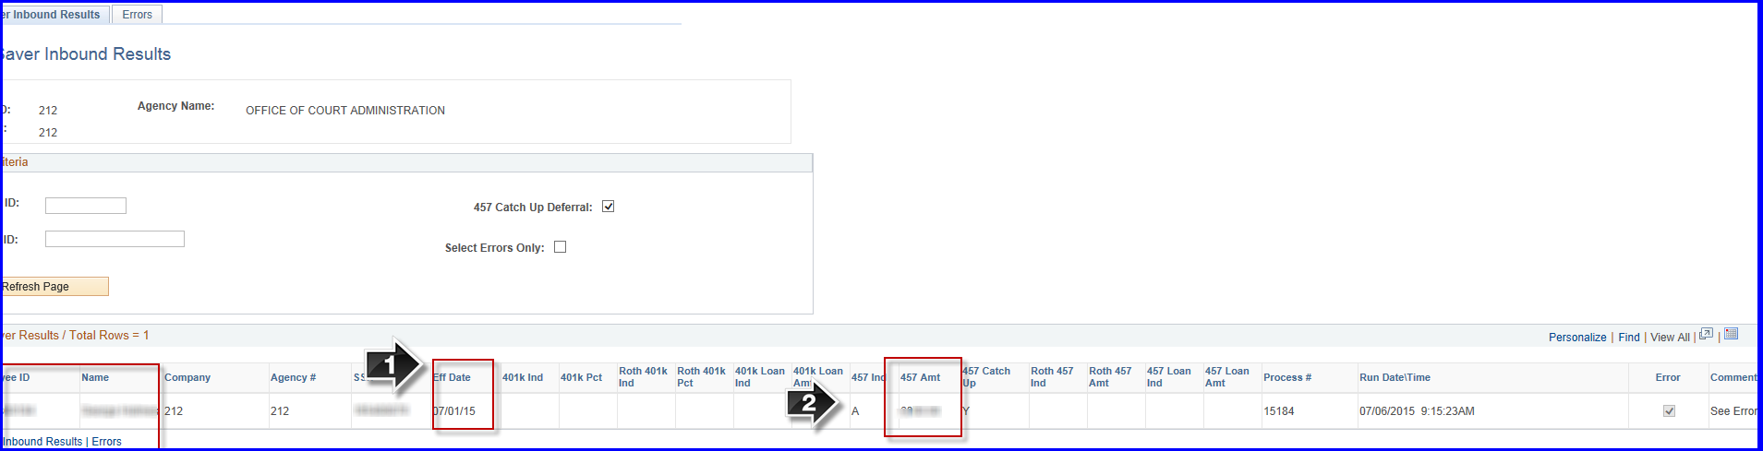
- Note the Effective Date from the file
- Note the Catch up amount

Navigate to Base Benefit to add to Savings Management: Main Menu>Benefits>Enroll in Benefits>Savings Management
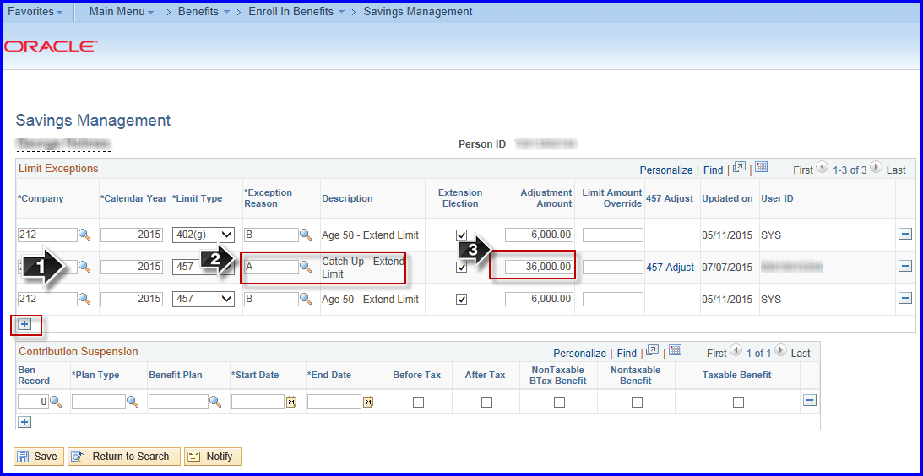
- Add a new row
  - Limit Type = 457
- Exception Reason = ‘A’
- Limit Amount = 36,000.00 (for 2016)

NOTE: If the limit amount changes for the New Year, repeat these steps with the exception of the amount field. Use the new limit amount.
NOTE: Confirm employee is enrolled in 457 savings plan in addition to savings management (see below)